



[](http://www.google.co.uk/url?sa=i&rct=j&q=&esrc=s&source=images&cd=&ved=0ahUKEwjrkfvnorDQAhWDNxQKHZasBwUQjRwIBw&url=http://cliparts.co/cartoon-friendship&psig=AFQjCNG6qKMzyZUKOk_Eq-9q5ywgEEZk4g&ust=1479488611204762)

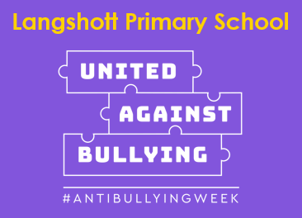

Please read our Anti-Bullying and Behaviour Policies for more information. Both can be found on our school website **www.langshott-surrey.co.uk**

Bullying can be:

* Emotional – someone is

unfriendly, leaves others out, teases or threatens to hurt others.

* Physical – pushing, kicking, hitting, punching or any other hurtful act of physical behaviour.
* Verbal – name-calling, teasing or spreading rumours.

Bullying is NEVER your fault and is always WRONG!

What should you do if you see bullying or you are being bullied?

* Tell a grown up in school.
* Talk to someone at home.
* Tell a friend or the school council.

[](http://www.google.co.uk/url?sa=i&rct=j&q=&esrc=s&source=images&cd=&cad=rja&uact=8&ved=0ahUKEwi4rbiE6rTQAhXDiRoKHVCrBeAQjRwIBw&url=http://littlewhizzkid.com/say-bullying-everyday/&psig=AFQjCNH5t6_LXwA1UImnQaiKElJr215cOg&ust=1479645117158988)

Anti-bullying Week  
Anti-bullying Week 2021 was launched with a special assembly and

Odd Socks Day!

<https://www.youtube.com/watch?v=e8e7NRIk4AA&feature=youtu.be>

In class, we have been talking about the actions we can take to prevent or respond to bullying.   
We do understand that friends fall out and in some cases this can develop into bullying.

What is a friendship fall out?

A friendship fall out is when we have a disagreement with a friend, we might say or do hurtful things BUT we apologise and do not do them again. This is not bullying.

What is bullying?

Bullying is when somebody constantly

hurts someone else,

Several

Times

On

Purpose

Bullies want to make you feel bad, it is often done in secret. Bullying is NOT a falling out between friends or something that happens once or twice.

Bullying can also take place on social websites such as ‘Facebook’, online gaming, through messages received on a phone or photos.

This called Cyber-Bullying.

Bullying goes on and on and is often a secret.

[](http://www.google.co.uk/url?sa=i&rct=j&q=&esrc=s&source=images&cd=&cad=rja&uact=8&ved=0ahUKEwjknrnB7LTQAhXLyRoKHe4mCPsQjRwIBw&url=http://home-education.org.uk/support-bullying.htm&bvm=bv.139250283,d.ZGg&psig=AFQjCNGe8YwIgqoaV4fUWUzNpych4kKjhA&ust=1479645811920562)