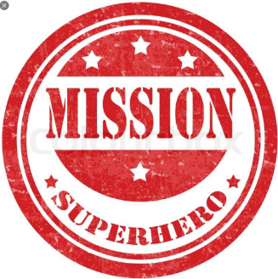

Dear Emeralds and Sapphires,

We have heard that you are all doing a super job of keeping healthy and safe.
All the superheroes are so proud of you!
There is a problem here at Superhero Headquarters. The Hulk has forgotten some of the ways to stay healthy. Batman saw him eat a chocolate cake for dinner and he forgot to wash his hands!
We NEED your help!

Please write to him and tell him about all the ways you are staying healthy and safe.

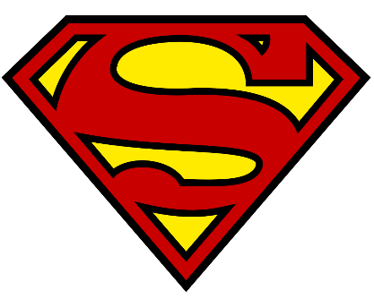
From Superman and Supergirl

