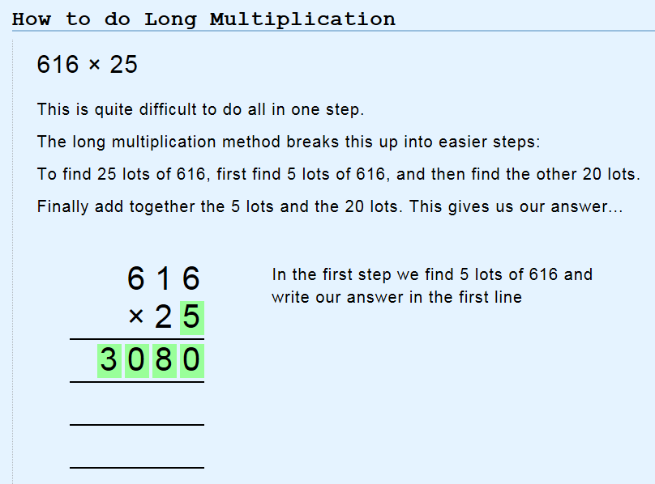
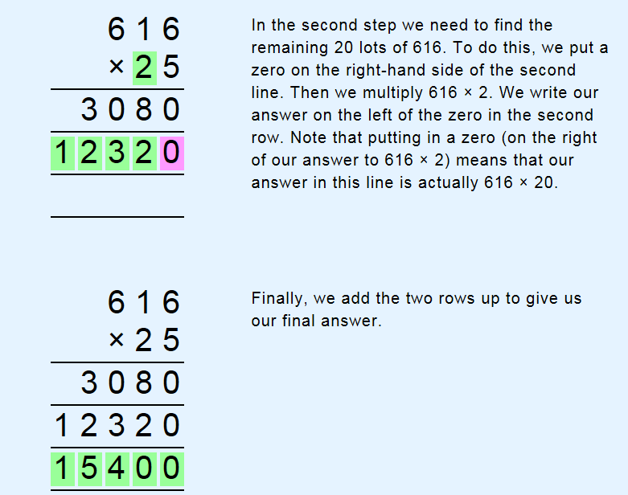
https://www.mathsisfun.com/numbers/multiplication-long.html
https://www.khanacademy.org/math/arithmetic/arith-review-multiply-divide/arith-review-multi-digit-mult/v/multiplying-2-digit-numbers

