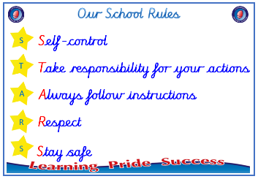
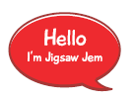


Year 6

PSHE – Celebrating Difference
Outcome: Admiration Accolades. Research an inspirational
Paralympian and explain why they deserve the admiration
accolade award.

:



Prior skills
Prior skills from Year 5
     | - Understand how rumour spreading and name-calling can be bullying behaviours.
 | - Understand a different culture from my own.
 | - Understand that cultural differences sometimes cause conflict.
 | - Understand what racism is.
 | - Compare my life with people in the developing world.
 | - Explain the differences between direct and indirect bullying.

Vocabulary:
achievement, accolade, admiration, argument, assumption, banter, belonging, bullying, bullying behaviour, celebration, community, conflict, control, difference, direct, disability, discrimination, empathy, quality, equality act, harassment, imbalance, indirect, misunderstanding, normal, Paralympian, perception, perseverance, power, prejudice, protected characteristics, racism, recipient, respect, rights, sport, stamina, struggle, stereotype

Ideas and inspiration

Admiration Accolades

Trophy of Celebration
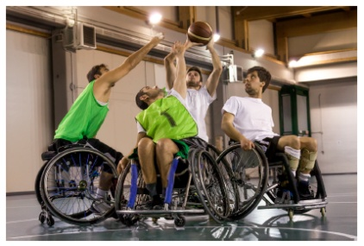
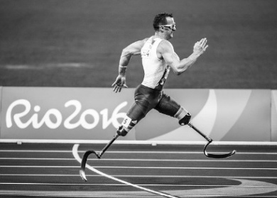

Take responsibility for your actions
 |  | Below | Just At | At | Above
 | - To explain how one person or a group can have power over another.
Respect
 |  | Below | Just At | At | Above
 | - To explain ways in which differences can be a cause of conflict and celebration.
 | - To understand there are different perceptions about what normal means.
 | - To understand how being different can affect someone’s life.
 | - To be able to give examples of people with disabilities who lead amazing lives.
Safe
 |  | Below | Just At | At | Above
 | - To understand some of the reasons why people use bullying behaviours.

Understanding bullying behaviours will help me as I grow up because _______________________________________
________________________________________________________________________________________________
What have I learnt? _______________________________________________________________________________________
________________________________________________________________________________________________

