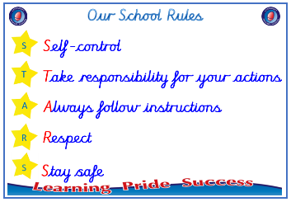
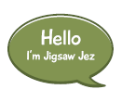


Year 5

PSHE – Celebrating Difference
Outcome: Culture Display. Research a culture in a developing
country and appreciate the value of happiness regardless of
material wealth.

:

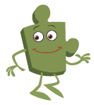

Prior skills
Prior skills from Year 4
     | - To understand what influences me to make assumptions based on how people look.
 | - Know that sometimes bullying is hard to spot know what to do if I think it is going on but I’m not sure.
 | - Know what to do if I think bullying is going on but I am not sure.
 | - Say a time when my first impression of a person changed once I got to know them.
 | - Understand that sometimes we make assumptions based on what people look like.
 | - Identify what is special about me and value the ways I am unique.
 | - Explain why witnesses sometimes join in with bullying and sometimes don’t tell.

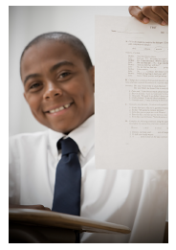
Ideas and inspiration

Culture Wheel

Trophy of Celebration
Vocabulary:
Culture, difference, similarities, racism, colour, race, discrimination, rumour, name-calling, racist, homophobic, cyber-bullying, indirect, direct, happiness, difference, continuum, developing world, appearance, assumptions, banter, bullying, community, disability, fair, included, respect, sexist, stereotype, texting
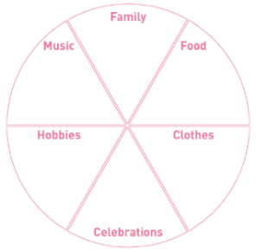
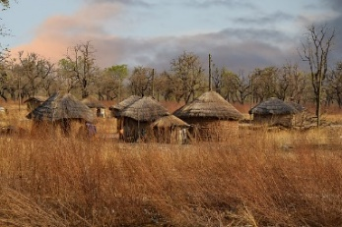

Take responsibility for your actions
 |  | Below | Within | At | Above
 | - To understand how rumour spreading and name-calling can be bullying behaviours.
Respect
 |  | Below | Within | At | Above
 | - To understand a different culture from my own.
 | - To understand that cultural differences sometimes cause conflict.
 | - To understand what racism is.
 | - To compare my life with people in the developing world.
Safe
 |  | Below | Within | At | Above
 | - To explain the differences between direct and indirect bullying.

My learning from previous years about celebrating differences has helped me because _________________________
________________________________________________________________________________________________
What have I learnt? _______________________________________________________________________________________
________________________________________________________________________________________________
Learning about differences in _______________________________________________________________________

