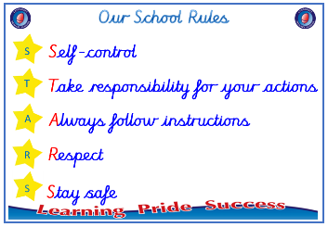
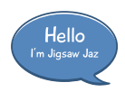


Year 4

PSHE – Celebrating Difference
Outcome: Picture Frames Demonstrate special features
of myself.

:



Prior skills
Prior skills from Year 3
     | - Know what it means to be a witness to bullying.
 | - Discuss a time when my words affected someone’s feelings and what the consequences were.
 | - Understand that everybody’s family is different but important to them.
 | - Understand that differences and conflict sometimes happen among family members.
 | - Recognise that some words are used in hurtful ways.
 | - Know that a witness can be a situation better or worse by what they do.

Vocabulary:
Character, assumption, bullying, bystander, witness, empathy, friend, hurtful, impression, kindness, manners, physical features, problem solve, respect, unique, witness, judgement, surprised, appearance, accept, influence, secret, deliberate, on purpose, bystander, witness, problem solve, cyber bullying, troll, characteristics, protected characteristics,
Ideas and inspiration

Picture frames

Trophy of Celebration



Take responsibility for your actions
 |  | Below | Just at | At | Above
 | - To understand what influences me to make assumptions based on how people look.
 | - To know that sometimes bullying is hard to spot and I know what to do if I think it is going on but I’m not sure.
 | - To be able to tell you of a time when my first impression of a person changed once I got to know them.
Respect
 |  | Below | Just at | At | Above
 | - To understand that sometimes we make assumptions based on what people look like.
 | - To identify what is special about me and value the ways I am unique.
Safe
 |  | Below | Just at | At | Above
- To explain why witnesses sometimes join in with
bullying and sometimes don’t tell.

I can help other people celebrate differences by ________________________________________________________
________________________________________________________________________________________________
What have I learnt? _______________________________________________________________________________________
________________________________________________________________________________________________

