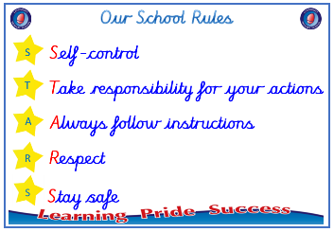
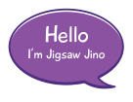


Year 3

PSHE – Celebrating Difference
Outcome: Conflict Kite Reflect on the conflict.

:



Prior skills
Prior skills from Year 2
     | - Understand that bullying is sometimes about difference.
 | - Say some ways I am different to my friends.
 | - Understand that sometimes people make assumptions about boys and girls (stereotypes).
 | - Understand that it is OK to be different to other people and to be friends with them.
 | - Recognise right from wrong and to look after myself.

Vocabulary:
Banter, bullying, family, loving, caring, safe, connected, difference, special, conflict, solve it together, resolve, witness, bystander, gay, unkind, feelings, tell, consequences, hurtful, include, incident, isolate, kindness, lonely, love, protection, compliment, rights, security, self-regulation, similarity, stability, stereotype, support, unique

Ideas and inspiration

Conflict Kite

Trophy of Celebration
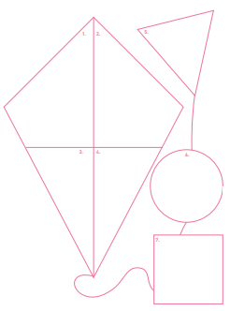
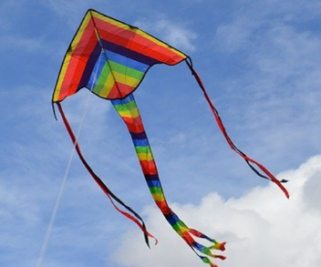

Take responsibility for your actions
 |  | Below | Just at | At | Above
 | - To know what it means to be a witness to bullying.
 | - To be able to tell you about a time when my words affected someone’s feelings and what the consequences were.
Respect
 |  | Below | Just at | At | Above
 | - To understand that everybody’s family is different but important to them.
 | - To understand that differences and conflict sometimes happen among family members.
Safe
 |  | Below | Just at | At | Above
 | - To recognise that some words are used in hurtful ways.
 | - To know that a witness can make a situation better or worse by what they do.
If I see somebody being unkind, I can _________________________________________________________________
________________________________________________________________________________________________
What have I learnt? _______________________________________________________________________________________
________________________________________________________________________________________________

