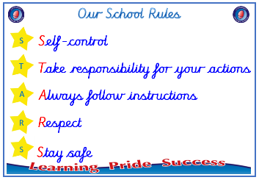
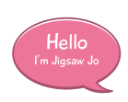


Year 2

PSHE – Celebrating Difference
Outcome: Trophy of Celebration. Reflect on differences,
similarities and friendship.

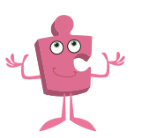

Prior skills
Prior skills from Year 1
     | - Explain what a bully is.
 | - Explain how I am different to my friends.
 | - Identify similarities and differences between people in my class.
 | - Know how to make new friends.
 | - Know who to talk to if I am unhappy or being bullied.


Vocabulary:
- assumptions, stereotypes
- shield
- bully
- difference, belonging
- feelings, sad, lonely
- help, kindness
- on purpose
- stand up for
- male, female
- difference, diversity
- fairness, friends
- disability
- unique, respect
- value, inclusive, culture

Ideas and inspiration

Trophy of Celebration


Take responsibility for your actions
 |  | Below | Just at | At | Above
 | - To understand that bullying is sometimes about difference.
Respect
 |  | Below | Just at | At | Above
 | - To be able to tell you some ways I am different to my friends.
 | - To understand that it is OK to be different from other people and to be friends with them.
 | - To understand that sometimes people make assumptions about boys and girls (stereotypes).
Safe
 |  | Below | Just at | At | Above
 | - To recognise right from wrong and to look after myself.
If I see someone being unkind, I can help them by _______________________________________________________
________________________________________________________________________________________________
What have I learnt? _______________________________________________________________________________________ ________________________________________________________________________________________________

