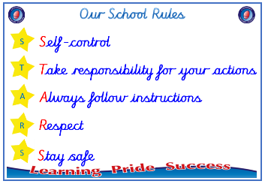
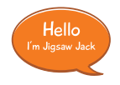


Year 1

PSHE – Celebrating Difference
Outcome: Gingerbread People. Reflect on differences, similarities
and looking after ourselves.

Prior skills
Prior skills from EYFS
   | - To know the names of some emotions.
 | - To know why having friends is important.
 | - To know some qualities of a positive friendship.
 | - To know ways of making friends.
 | - To know what being unique means.
 | - To know that they don’t have to be “the same as” someone to be a friend.
 | - To know what being proud means, and that people can be proud of different things.
 | - To know that people can be good at different things.
 | - To know that families can be different.
 | - To know that people have different homes and why they are important to them.


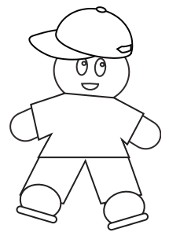
Ideas and inspiration

Gingerbread People
Vocabulary:
- Similar, same as
- different from
- difference
- bullying
- bullying behaviour
- deliberate, on purpose
- unfair
- included
- celebration
- special, unique

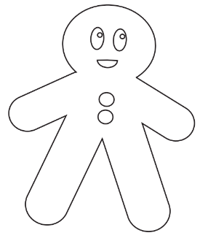
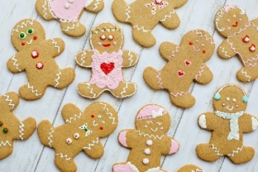

Take responsibility for your actions
 |  | Below | Just at | At | Above
 | - To be able to tell you what bullying is.
Respect
 |  | Below | Just at | At | Above
 | - To be able to explain how I am different to my friends.
 | - To identify similarities and differences between people in my class.
Safe
 |  | Below | Just at | At | Above
 | - To know how to make new friends.
 | - To know who to talk to if I am unhappy or being bullied.
If I feel lonely at school, I can _______________________________________________________________________
________________________________________________________________________________________________
What have I learnt? _____________________________________________________________________________________
________________________________________________________________________________________________

