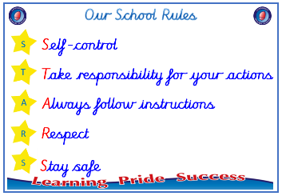
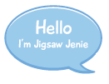


EYFS

PSHE – Celebrating Difference
Outcome: Paper chains Describe what makes us all special.



Vocabulary:
- similarities, difference
- special
- kind, unkind, sad
- home
- friendship
- frightened
- family
- friends
- happy
- proud
- similarities
- unique

Ideas and inspiration

Paper chains




 |  | Emerging | Expected
 | - To know the names of some emotions.
 | - To know why having friends is important.
 | - To know some qualities of a positive friendship.
 | - To know ways of making friends.
 |  | Emerging | Expected
 | - To know what being unique means.
 | - To know that they don’t have to be “the same as” someone to be a friend.
 | - To know what being proud means, and that people can be proud of different things.
 | - To know that people can be good at different things.
 | - To know that families can be different.
 | - To know that people have different homes and why they are important to them.

