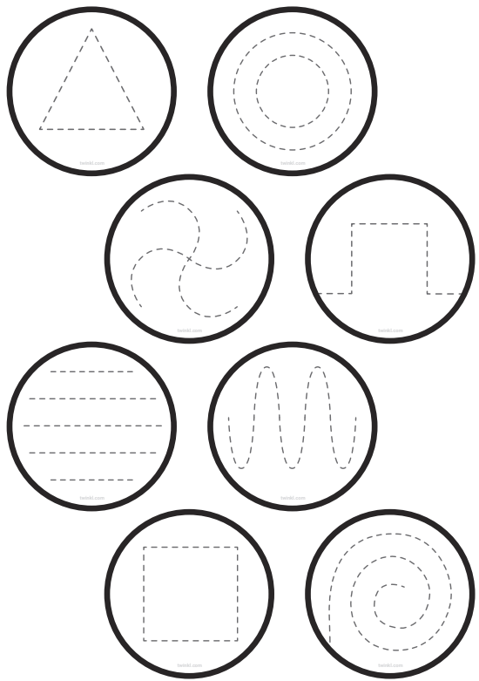
For this week’s home learning, we want you to practise your pencil control. Make sure you have a good pencil grip. Remember ‘nip, flip, grip’!



