Physics | 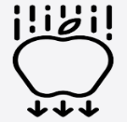
Prior Knowledge and Skills
- Explore how things work. (EYFS)
- Talk about the differences in materials and changes they notice. (EYFS)
- Describe what they see, hear and feel whilst outside. (EYFS)
- Identify, name, draw and label the basic parts of the human body and say which part of the body is associated with each sense. (Y1 - Animals, including humans)
- Describe the simple physical properties of a variety of everyday materials. (Y1 - Materials)


Science – Light (Year 3)
Outcome: Use my knowledge of light and shadow to create a sundial.

Ideas and inspiration: |  | Vocabulary:  light, light source, dark, absence of light, reflect,  reflection, reflective, ray, sunlight, torch,  shadow, sundial, transparent, translucent, opaque, eye, pupil, retina  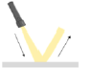  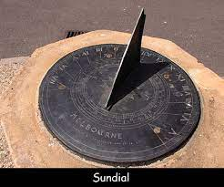
  Enquiries
  Identifying, grouping    and classifying  Classify light sources (leading to man-made/ natural).  Classify materials (leading to reflective/ non-reflective, transparent/ translucent/ opaque). |   Comparative/fair testing  Test materials for reflectiveness.  Test materials for transparency.  Investigate shadows (size of shadows, shape of shadows).

Developing Knowledge and Skills
Scientific Knowledge: |  | Working Towards | Within | Securely Within | Above
 | - Recognise that they need light in order to see things, and that dark is the absence of light.
 | - Notice that light is reflected from surfaces.
 | - Recognise that light from the sun can be dangerous and that there are ways to protect their eyes.
 | - Recognise that shadows are formed when the light from a light source is blocked by an opaque object.
 | - Find patterns in the way that the size of shadows change.
Working Scientifically (Skills): Plan: |  | Working Towards | Within | Securely Within | Above
 | - Gather, record, classify and present data in a variety of ways to help in answering questions. Begin to look for naturally occurring patterns and relationships and decide what data to collect to identify them.
 | - Set up simple practical enquiries, comparative and fair tests. Recognise when a simple fair test is necessary and help to decide how to set it up.
Working Scientifically (Skills): Record: |  | Working Towards | Within | Securely Within | Above
 | - Record findings using simple scientific language, drawings, labelled diagrams, keys, bar charts, and tables.
Working Scientifically (Skills): Review: |  | Working Towards | Within | Securely Within | Above
 | - Report on findings from enquiries, including oral and written explanations, displays or presentations of results and conclusions.
What have I learnt? ___________________________________________________________________________________________________
___________________________________________________________________________________________________

