Physics |     Science – Forces and magnets (Year 3)  Outcome: Conduct an investigation to identify magnetic objects in the environment.
Prior Knowledge and Skills
- Find out how the shapes of solid objects made from some materials can be changed by squashing, bending, twisting and stretching. (Y2 - Uses of everyday materials)
Ideas and inspiration: |  |  |  |  | Vocabulary:  forces, friction, surface, magnet, magnetic, magnetic field, poles, north, south, attract, repel, push, pull, metal  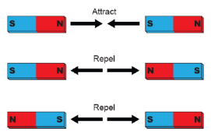
  Enquiries
    Identifying, grouping  and classifying  Sort materials (leading towards metal/non-metal and magnetic/not magnetic).  Sort toys (leading to what makes them move e.g. push/pull). |   Comparative/fair testing  Test how objects move on different surfaces (e.g. cars, spinning tops, wind-up/ clockwork toys).  Test the strength of different magnets. | Researching    Find out how magnets are used in everyday life.
 | Developing Knowledge and Skills
 | Scientific Knowledge: |  | Working Towards |  |  | Within | Securely Within | Above
 | 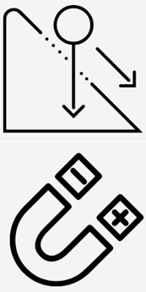 | - Compare how things move on different surfaces.
 |  | - Notice that some forces need contact between two objects, but magnetic forces can act at a distance
 |  | - Observe how magnets attract or repel each other and attract some materials and not others.
 |  | - Compare and group together a variety of everyday materials on the basis of whether they are attracted to a magnet, and identify some magnetic materials.
 |  | - Describe magnets as having two poles.
 |  | - Predict whether two magnets will attract or repel each other, depending on which poles are facing.
 | Working Scientifically (Skills): Plan:  : |  | Working Towards |  |  | Within | Securely Within | Above
 |  | - Set up simple practical enquiries, comparative and fair tests.
 | Working Scientifically (Skills): Do: |  | Working Towards |  |  | Within | Securely Within | Above
 |  | - Make systematic and careful observations and, where appropriate, take accurate measurements using standard units, using a range of equipment.
 | Working Scientifically (Skills): Record: |  | Working Towards |  |  | Within | Securely Within | Above
 |  | - Gather, record, classify and present data in a variety of ways to help in answering questions.
 | Working Scientifically (Skills): Review: |  | Working Towards |  |  | Within | Securely Within | Above
 |  | - Report on findings from enquiries, including oral and written explanations, displays or presentations of results and conclusions.
 | What have I learnt? ___________________________________________________________________________________________________

