Chemistry | 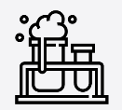


Science – Everyday materials (Year 1)

Outcome: Investigate a range of materials and understand their properties.

Prior Knowledge and Skills
- Use all their senses in hands-on exploration of natural materials. (EYFS)
- Explore collections of materials with similar and/or different properties. (EYFS)
- Talk about the differences between materials and changes they notice. (EYFS)

Ideas and inspiration: |  | 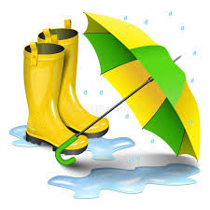  Vocabulary:  object, material, hard, soft, stretchy, shiny, dull, rough, smooth, bendy, waterproof, absorbent, transparent, opaque (see-through), plastic, wood, metal, water, glass, rock, brick, paper, fabric
  Enquiries
    Identifying, grouping  and classifying  Classify objects made from the same material (e.g. lots of things made from plastic).  Classify one object made from different materials (e.g. cups made of different materials).  Classify different fabrics based on texture.  Classify paper/plastics/fabrics. |   Comparative/fair testing  Test objects made of different materials to see how effective they are e.g. umbrellas/hats/coats for waterproofness, cloths/nappies for absorbency, socks for elasticity, bounciness of balls

Developing Knowledge and Skills
Scientific Knowledge: |  | Working Towards | Within | Securely Within | Above
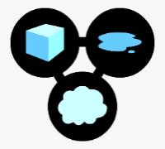 | - Distinguish between an object and the material from which it is made.
 | - Identify and name a variety of everyday materials, including wood, plastic, glass, metal, water, and rock.
 | - Describe the simple physical properties of a variety of everyday materials.
 | - Compare and group together a variety of everyday materials on the basis of their simple physical properties.
Working Scientifically (Skills): Do: |  | Working Towards | Within | Securely Within | Above
 | - Perform simple tests.
Working Scientifically (Skills): Record: |  | Working Towards | Within | Securely Within | Above
 | - Gather and record data to help in answering questions.
Working Scientifically (Skills): Review: |  | Working Towards | Within | Securely Within | Above
 | - Use observations and ideas to suggest answers to questions.
What have I learnt?

___________________________________________________________________________________________________

