Biology | 


Science – Animals, including humans (Year 6)
Outcome: Explain the functions of the heart, blood vessels and blood, recognising the impact of external features on these parts.

Prior Learning
- Describe the importance for humans of exercise, eating the right amounts of different types of food, and hygiene. (Y2 - Animals, including humans).
- Identify that animals, including humans, need the right types and amount of nutrition, and that they cannot make their own food; they get nutrition from what they eat. (Y3 - Animals, including humans).
- Describe the simple functions of the basic parts of the digestive system in humans. (Y4 - Animals, including humans).
- Identify the different types of teeth in humans and their simple functions. (Y4 - Animals, including humans).

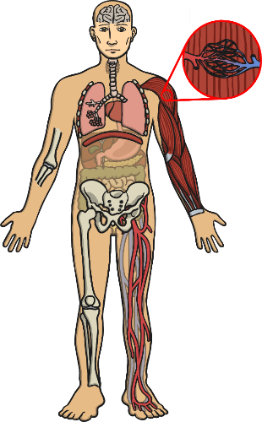  Ideas and inspiration: |  | Vocabulary:  circulatory system, heart, blood vessels, oxygenated, deoxygenated, pulse, veins, artery, capillaries, lungs, pulmonary, plasma, platelets, white blood cells, red blood cells  drugs, alcohol, nutrients, water, diet, exercise, lifestyle
  Enquiries
    Observing over time  Observe pulse rates before, during and after exercise. |   Pattern seeking  Generate questions for investigation, such as:  Do older people have lower pulse rates?  Do boys have higher pulse rates?
  Comparative/    fair testing  Complete various activities to compare impact on their own heart rate. |   Researching  Generate questions to research about the human circulatory system.

Developing Knowledge and Skills
Scientific Knowledge: |  | Working Towards | Within | Securely Within | Above
 | - Identify and name the main parts of the human circulatory system, and describe the functions of the heart, blood vessels and blood.
 | - Recognise the impact of diet, exercise, drugs and lifestyle on the way their bodies function.
 | - Describe the ways in which nutrients and water are transported within animals, including humans.
Working Scientifically (Skills): Plan:  : |  | Working Towards | Within | Securely Within | Above
 | - Plan different types of scientific enquiries to answer questions, including recognise and controlling variables where necessary.
Working Scientifically (Skills): Record:
 | - Record data and results of increasing complexity using scientific diagrams and labels, tables, bar and line graphs.
What have I learnt? ___________________________________________________________________________________________________
___________________________________________________________________________________________________
___________________________________________________________________________________________________
___________________________________________________________________________________________________

