Biology | 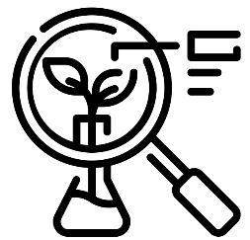


Science – Animals, including humans (Year 5)
Outcome: Understand the human life cycle and apply this knowledge in RSE week to explain changes in body.

Prior Knowledge and Skills
- Notice that animals, including humans, have offspring which grow into adults. (Y2 - Animals, including humans)
- Being unique. (PSHE – Y4, Changing Me)
- Girls and puberty. (PSHE – Y4, Changing Me)

Ideas and inspiration:  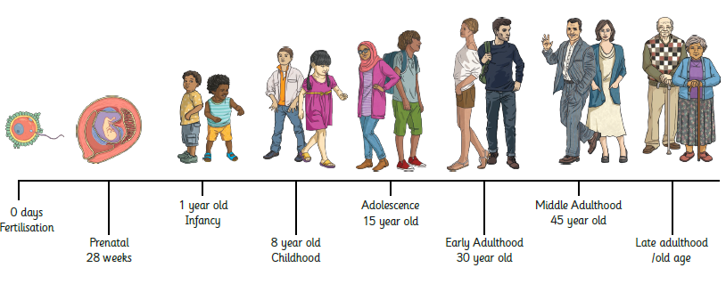 |  | Vocabulary:  life cycle, reproduce, asexual reproduction, sexual reproduction, fertilisation, prenatal, gestation, foetus, baby, infant, toddler, childhood, teenage,  adolescence, puberty, menstruation,  adult, elderly, life expectancy

Developing Knowledge and Skills
Scientific Knowledge: |  | Working Towards | Within | Securely Within | Above
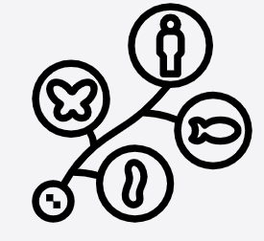 | - Describe the changes as humans develop to old age.
Working Scientifically (Skills): Review: |  | Working  Towards | Within | Securely Within | Above
 | - Use relevant scientific language and illustrations to discuss, communicate and justify their scientific ideas.
What have I learnt? ___________________________________________________________________________________________________

___________________________________________________________________________________________________

___________________________________________________________________________________________________

___________________________________________________________________________________________________

___________________________________________________________________________________________________

