Biology | 


Science – Plants (Year 2)
Outcome: Plant seeds and make observations providing evidence about what plants need to survive.

Prior learning
- Identify and name a variety of common wild and garden plants, including deciduous and evergreen tree. (EYFS/Y1)
- Identify and describe the basic structure of a variety of common flowering plants, including trees. (EYFS/Y1)

Ideas and inspiration:
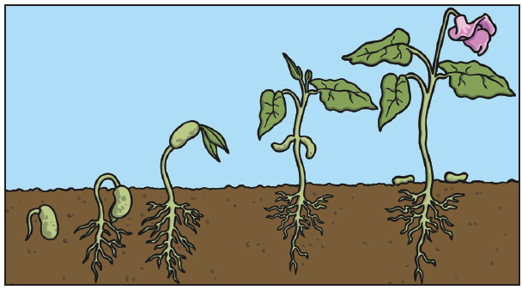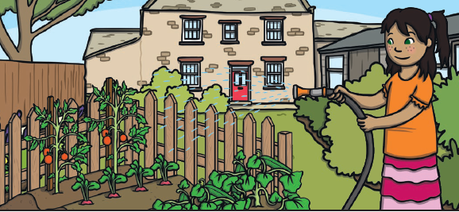
Enquiries:
Identifying, grouping and classifying  -Classify seeds and bulbs   | Observing over time  -Observe how a plant grows from a seed or a bulb over time. | Pattern seeking  -Generate questions  for investigation such as:  - What do seeds/bulbs need to grow?  - Does it matter which way round you plant a bulb or seed?  - Which comes first, the root or the shoot? | Researching  - Look at packets to decide how to plant and care for seeds/bulbs e.g. How much water do they need? Do they need shade/full sun?

Vocabulary:
Growth of plants: germination, shoot, seed dispersal, grow, life cycle, die, wilt, seedling.
Needs of plants: sun, light, sunlight, nutrition, water, temperature, healthy.

Name different types of plant: e.g. broad bean, daffodils.

Previously introduced vocabulary: water, warm, hot, cold, roots, leaves, flowers, fruit, seed, bulb.

Developing Knowledge and Skills
Scientific Knowledge: |  | Working Towards | Within | Securely Within | Above
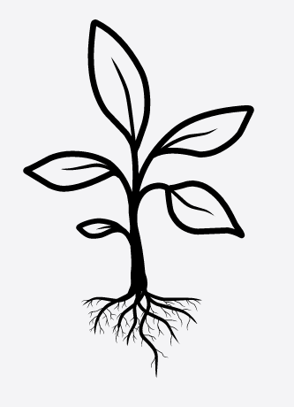 | - Observe and describe how seeds and bulbs grow into mature plants.
 | - Find out and describe how plants need water, light and a suitable temperature to grow and stay healthy.
Working Scientifically: Do |  | Working Towards | Within | Securely Within | Above
 | - Observe closely, using simple equipment.
 | - Use simple features to compare living things.
 | - With help, decide how to sort and group features, observe changes over time, and, with guidance, notice patterns and relationships.
Working Scientifically: Record |  | Working Towards | Within | Securely Within | Above
   | - Gather and record data to help in answering questions.
Working Scientifically: Review |  | Working Towards | Within | Securely Within | Above
     | - Use observations and ideas to suggest answers to questions.
What have I learnt? __________________________________________________________________________________________________





