Biology | 


Science – Plants (Year 1)
Outcome: Understand the basic structure of a plant and identify common plants on a plant hunt.

Prior learning
- Understand the key features of the life cycle of a plant and an animal.
- Know what plants need to grow.
- Name a variety of vegetables.
- Explore the natural world around them.

Vocabulary:
wild plant, garden plant, evergreen tree, deciduous tree, common flowering plant, weed, grass, daisy, dandelion, ivy, rose, sunflower, lavender, cedar, horse chestnut, oak, flower, vegetable, fruit, berry, leaf/leaves, blossom, petal, stem, trunk, branch, root, seed, bulb, soil.

Ideas and inspiration:
Maria Sibylla Merian (German artist, scientific illustrator, and naturalist)

Enquiries
Identifying, grouping and classifying  -Classify  leaves, flowers, and seeds, choosing their own criteria. | Observing over time  -Observe a trail/patch  to identify how plants change through the year. | Pattern seeking  -Based on observations, identify  Patterns  e.g. after comparing the size of leaves on different plants. | Researching  - Use secondary sources to  name plants (including  trees) based on observations of leaves, seeds, flowers, buds, and bark

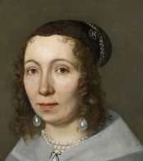
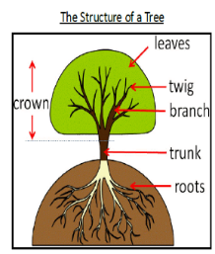
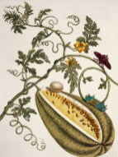
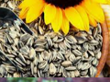



Developing Knowledge and Skills
Scientific Knowledge: |  | Working Towards | Within | Securely Within | Above
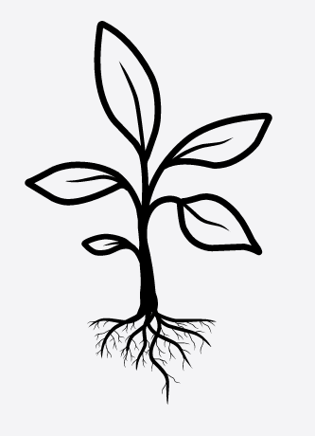 | - Identify and name a variety of common wild and garden plants, including deciduous and evergreen tree.
 | - Identify and describe the basic structure of a variety of common flowering plants, including trees.
Working Scientifically: Do |  | Working Towards | Within | Securely Within | Above
 | - Identify and classify.
 | - Perform simple tests by using simple features to compare living things and decide how to sort and group them.
 | - Observe changes over time, using simple equipment.
 | - Begin to notice (with support) patterns and relationships.
What have I learnt? __________________________________________________________________________________
__________________________________________________________________________________________________




