Physics | 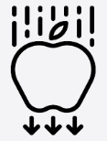


Science – Electricity (Year 6)
Outcome: Create a guide for various electrical systems and ‘how to’ instructions for creating a circuit.

Prior learning
- Identify common appliances that run on electricity. (Year 4)
- Construct a simple series electrical circuit, identifying and naming its basic parts, including cells, wires, bulbs, switches and buzzers.(Year 4)
- Identify whether or not a lamp will light in a simple series circuit, based on whether or not the lamp is part of a complete loop with a battery. (Year 4)
- Recognise that a switch opens and closes a circuit and associate this with whether or not a lamp lights in a simple series circuit. (Year 4)
- Recognise some common conductors and insulators, and associate metals with being good conductors. (Year 4)

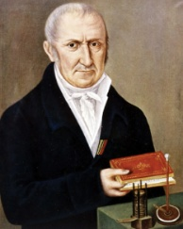  Ideas and inspiration:  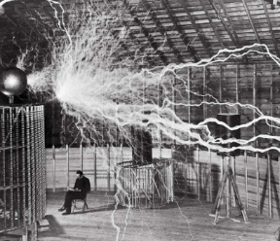  Nikola Tesla (Electrical & Mechanical Engineer who developed the AC electrical system and made important advances in technologies such as x-rays, neon lights and robotics)  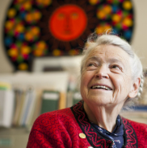  Alessandro Volta (Physicist who developed the electric battery)  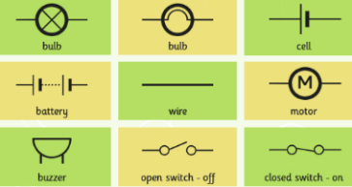  Mildred S Dresselhaus (Materials Scientist whose research led to the development of the rechargeable batteries in all modern electronic equipment) |  | Vocabulary:  Flow and measure of electricity: voltage, amps, resistance, electrons, volts (V), current.  Circuits: symbol, cell, battery, circuit, diagram, component, function, lamp, bulb, wire, switch, motor, buzzer, filament  Variations: dimmer, brighter, louder, quieter.  Types of electricity: natural electricity, human-made electricity, solar panels, power station.  Other: positive, negative
  Enquiries:
  Comparative/ fair testing
  
  -Investigate the effect of adding more bulbs, cells, buzzers or motors to a circuit.

Developing Knowledge and Skills
Scientific Knowledge: |  | Working Towards | Within | Securely Within | Above
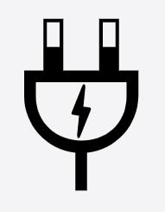 | - Associate the brightness of a lamp or the volume of a buzzer with the number and voltage of cells used in the circuit
 | - Compare and give reasons for variations in how components function, including the brightness of bulbs, the loudness of buzzers and the on/off position of switches
 | - Use recognised symbols when representing a simple circuit in a diagram.
Working Scientifically (Skills): Plan:  : |  | Working Towards | Within | Securely Within | Above
 | - Plan different types of scientific enquiries to answer questions, including recognise and controlling variables where necessary .
Working Scientifically (Skills): Do: |  | Working Towards | Within | Securely Within | Above
 | - Take measurements, using a range of scientific equipment, with increasing accuracy and precision, take repeat readings when appropriate.
Working Scientifically (Skills): Record: |  | Working Towards | Within | Securely Within | Above
 | - Record data and results of increasing complexity using scientific diagrams and labels, classification keys, tables, scatter graphs, bar and line graphs.
Working Scientifically (Skills): Review: |  | Working Towards | Within | Securely Within | Above
 | - Report and present findings from enquiries, including conclusions, causal relationships and explanations of and degree of trust in results, in oral and written forms such as displays and other presentations.
What have I learnt? ___________________________________________________________________________________________________
___________________________________________________________________________________________________
___________________________________________________________________________________________________

