Biology | 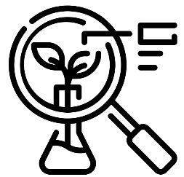


Science – Livings things and their habitats (Year 5)
Outcome: Understand a variety of lifecycles.

Prior learning
- Identify and describe the functions of different parts of flowering plants (Y3 -Plants)
- Explore the part that flowers play in the life cycle of flowering plants, including pollination, seed formation and seed dispersal. (Y3 - Plants)
- Recognise that living things can be grouped in a variety of ways. (Y4 – Living things and their habitats)
- Explore and use classification keys to help group, identify and name a variety of living things in their local and wider environment.(Y4 – Living things and their habitats)
- Recognise that environments can change and that this can sometimes pose dangers to living things. (Y4 – Living things and their habitats)

Ideas and inspiration:
Sir David Attenborough (Naturalist & TV Presenter)
Jane Goodall (Wildlife Researcher & Conservationist
who studied chimpanzees)

Enquiries
Identifying, grouping and classifying  -Classify animals according to their life cycle   | Observing over time  -Grow from cuttings and observe whether they grow roots/ stem/ leaf/ flower | Pattern seeking  -Generate questions,  such as:  Do larger mammals have longer gestation periods?  Do larger animals live longer? | Researching  -Generate questions to research the life cycle of a chosen animal

Vocabulary:
Reproduction: asexual reproduction, sexual reproduction, gestation, embryo, adolescent, egg, cell, sperm, pregnancy, gestation
Previously introduced vocabulary: male, female, stem, bulb, roots, life cycle, pollen, petal, pollination, sepal, filament, anther, stamen, stigma, style, ovary, carpel, ovule offspring, metamorphosis, mammal, adult, baby, live young, fertilise, fertilisation.
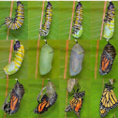
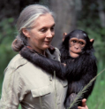





Developing Knowledge and Skills
Scientific Knowledge: |  | Working Towards | Within | Securely Within | Above
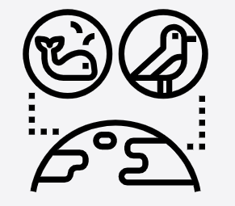 | - Describe the differences in the life cycles of a mammal, an amphibian, an insect and a bird.
 | - Describe the life process of reproduction in some plants and animals.
Working Scientifically: Do |  | Working Towards | Within | Securely Within | Above
 | - Use and develop keys and other information records to identify, classify and describe living things.
 | - Identify patterns that might be found in the natural environment
Working Scientifically: Record |  | Working Towards | Within | Securely Within | Above
 | - Record data and results of increasing complexity using scientific diagrams and labels, classification keys, tables.
Working Scientifically: Review |  | Working Towards | Within | Securely Within | Above
 | - Report and present findings from enquiries, in oral and written forms such as displays and other presentations.
 | - Use relevant scientific language and illustrations to discuss, communicate and justify scientific ideas.
What have I learnt? __________________________________________________________________________________
__________________________________________________________________________________________________

