Biology



Science – Animals (EYFS)
Outcome: To know what animals live in Kenya and polar regions and understand how these animals are different because of where they live.
The natural world - ELG
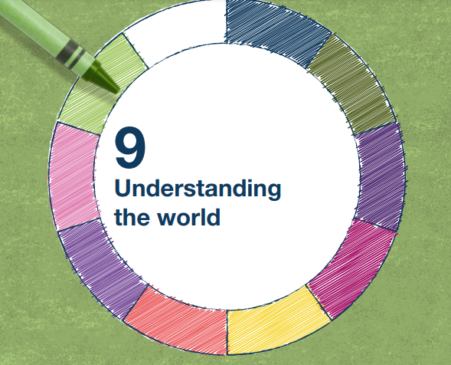 | - Explore the natural world around them, making observations and drawing pictures of animals and plants
 | - Know some similarities and differences between the natural world around them and contrasting environments, drawing on their experiences and what has been read in class

Vocabulary:
animals
Kenya – leopard, lion, zebra
polar regions - polar bear, artic fox, snowy owl
environment
habitat
climate
camouflage

Ideas and inspiration:
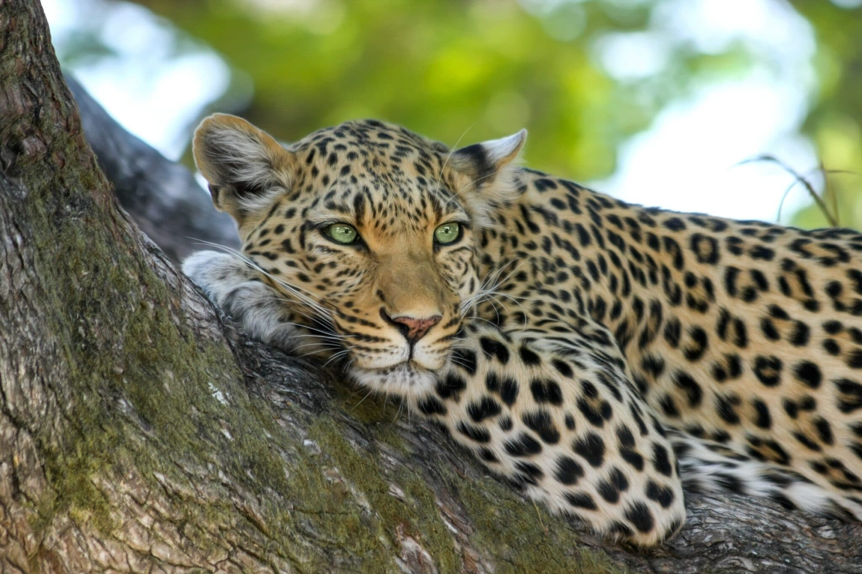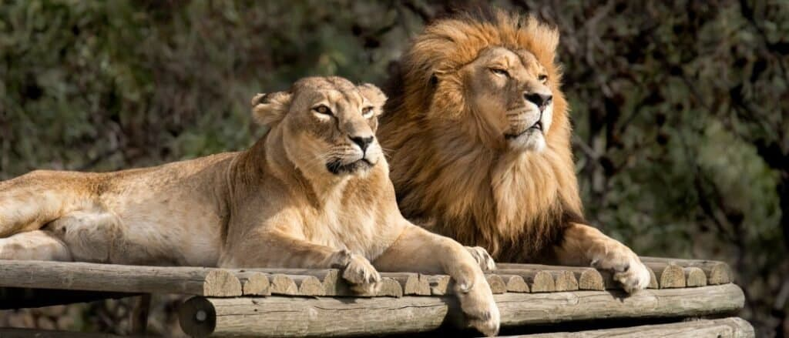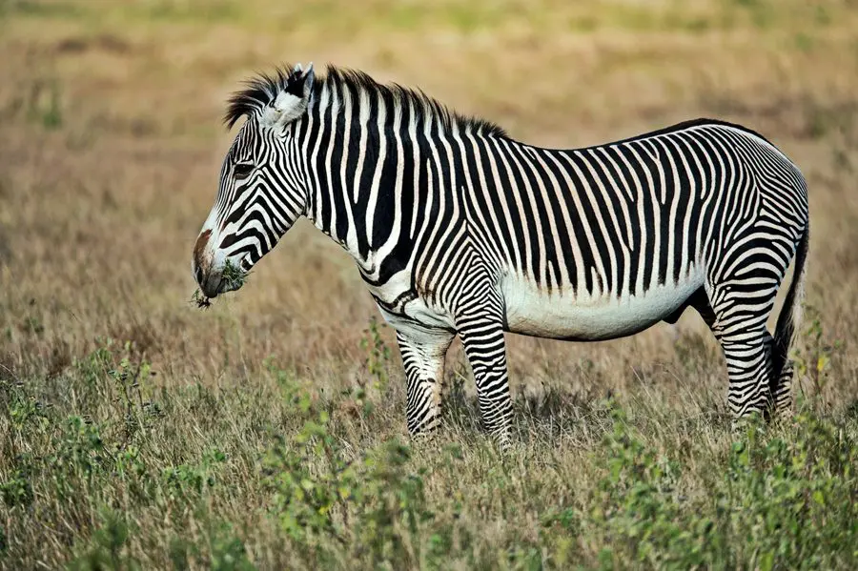
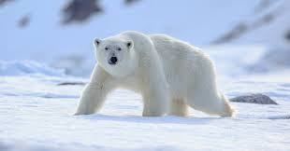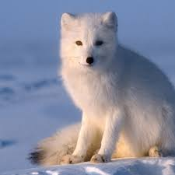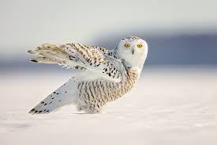

Scientific Knowledge: Animals |  | Emerging | Expected
   | - Know some animals live in different places and are suited to their habitat and climate.
 | - Know that animals are hard to find if they are camouflaged.
 | - Know why being camouflaged can be helpful to animals.
Working Scientifically: |  | Emerging | Expected
   | - Ask and raise questions.
 | - Make observations of animals, recognising similarities and differences.
 | - Categorise animals based on where they live.

