Physics  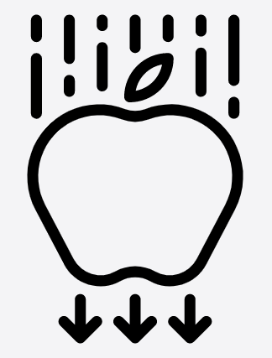 | Chemistry  


Science – Three Little Pigs: Materials (EYFS)
Outcome: Identify suitable materials for building a house.

The natural world - ELG
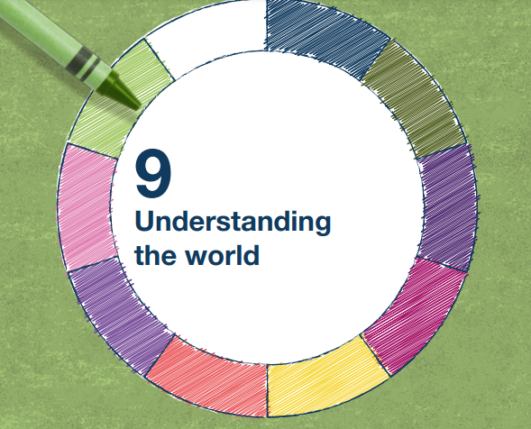 | - Know some similarities and differences between the natural world around them and contrasting environments, drawing on their experiences and what has been read in class
 | - Understand some important processes and changes in the natural world around them, including the seasons and changing states of matter.

Vocabulary:
Materials – straw, sticks, bricks, plastic, paper, metal, fabric
Properties of materials – waterproof, strong, stable, rigid, bendy, flexible, wind, breeze, blow, flutter, air, move, bend, weather, force
Ideas and inspiration:
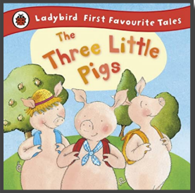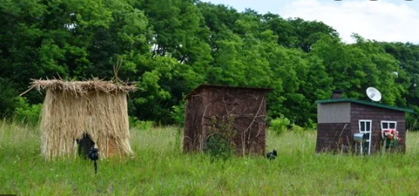

Scientific Knowledge: Materials |  | Emerging | Expected
 | - Use all senses in hands-on exploration of natural materials. (Nursery)
 | - Explore collections of materials with similar and/or different properties. (Nursery)
 | - Describe the properties of some materials.
 | - Talk about the differences between materials and changes they notice. (Nursery)
 | - Some materials are waterproof.
 | - Some materials are flexible/bendy.
Scientific Knowledge: Forces |  | Emerging | Expected
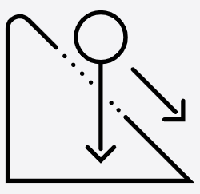 | - Objects can be moved by blowing on them.
 | - The wind can change the appearance and position of things.
Working Scientifically: |  | Emerging | Expected
   | - Ask and answer questions.
 | - Decide which materials to test.
 | - Make predictions.
 | - Compare the suitability of different materials for a particular purpose (building a house).

