Biology  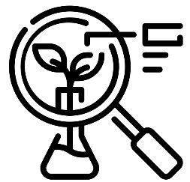 | Chemistry  


Science – Plants and Materials (EYFS)
Outcome: Observe the lifecycles of different plants (potatoes and cress).

The natural world - ELG
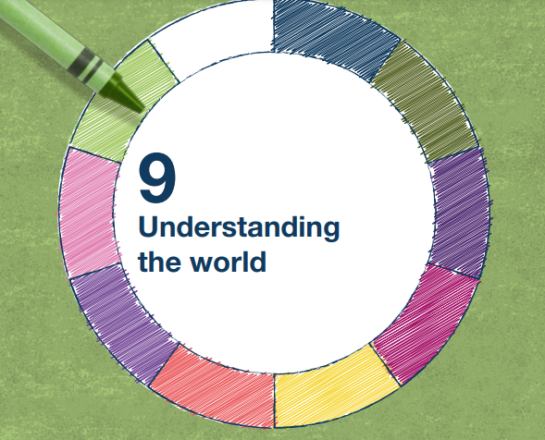 | - Explore the natural world around them, making observations and drawing pictures of animals and plants
 | - Understand some important processes and changes in the natural world around them, including changing states of matter.

Vocabulary:
names of vegetables - potato, cabbage, carrot, celery, cress, etc. texture, mash, cut properties of materials - rough, smooth, soft, hard, sticky, slippery, spiky ice, water, freeze, frozen, melt, salt plant, stem, leaf, root, flower, tuber, seed, shoot, grow

Ideas and inspiration:

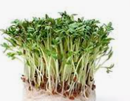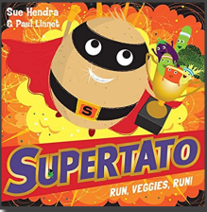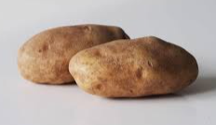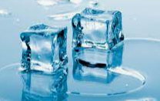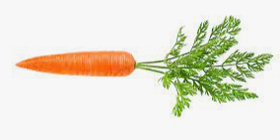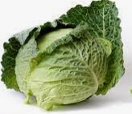

Scientific Knowledge: Plants |  | Emerging | Expected
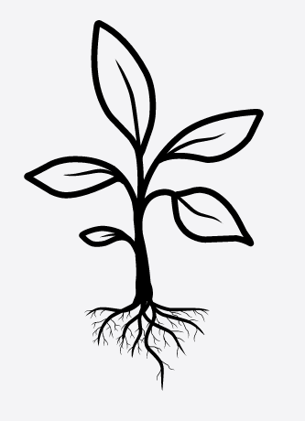   | - Plant seeds and care for growing plants. (Nursery)
 | - Understand the key features of the life cycle of a plant. (Nursery)
 | - Know what plants need to grow.
 | - Name a variety of vegetables.
 | - Record observations of growth over time.
Scientific Knowledge: Materials |  | Emerging | Expected
 | - Describe some materials that can change texture e.g. when vegetables are cooked.
 | - To know that ice melts when it gets warmer (Rescue frozen vegetables!)
Working Scientifically: |  | Emerging | Expected
   | - Ask and raise questions.
 | - Make observations of plants and talk about changes.
 | - Notice and describe textures of vegetables.
 | - Notice and discuss the amount of time it takes different seeds to grow.

