Biology
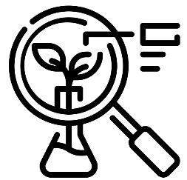


Science – Ourselves – Humans (EYFS)

Outcome: To label the parts of the human body.

The natural world - ELG
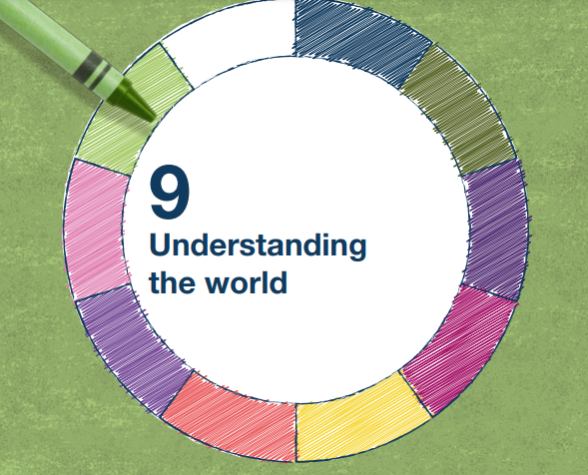 | - Explore the natural world around them, making observations and drawing pictures of animals.

Ideas and inspiration:

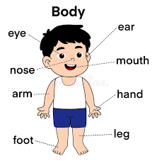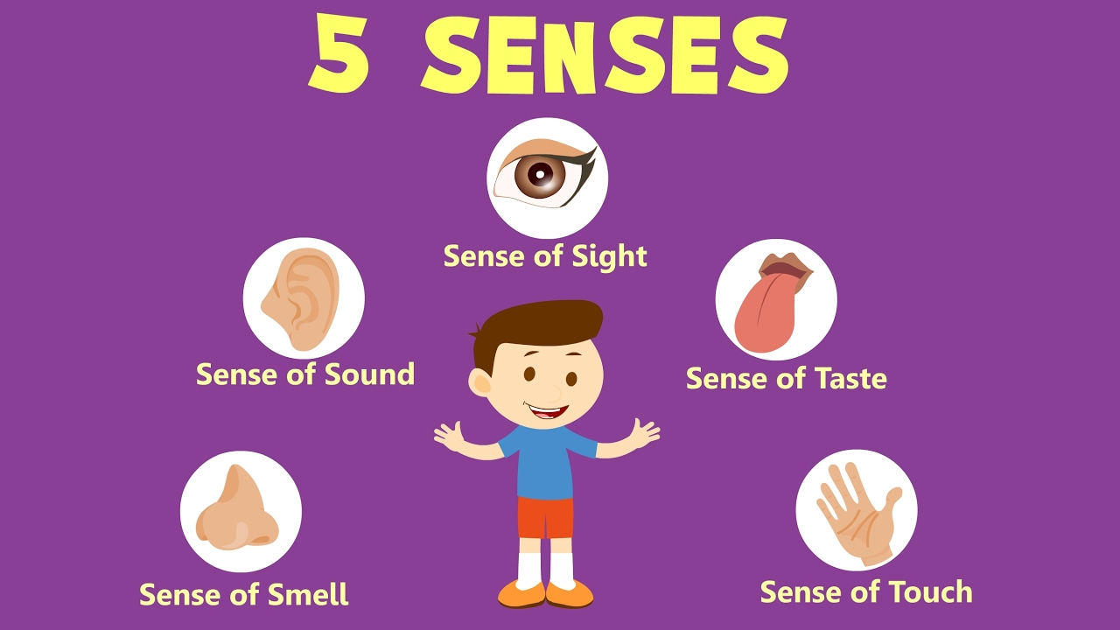

Vocabulary:
humans, people, animals

body parts – head, eyes, nose, arms, hands, legs, ears, mouth, chest, belly, feet.

senses – smell, taste, see, hear, listen, touch, feel

differences and similarities – skin, hair, eyes, height

lifecycle – grow, change, baby, toddler, child, teenager, adult, elderly

Scientific Knowledge: Humans |  | Emerging | Expected
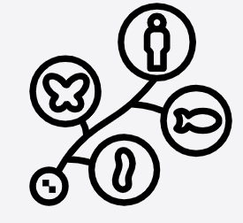 | - Name and describe people who are familiar to them.
 | - Continue developing positive attitudes about the differences between people.
 | - Name body parts that are similar (have same body parts) and different (different heights).
 | - Explain how humans change as they grow up.
Working Scientifically: |  | Emerging | Expected
   | - Observe and describe faces.
 | - Notice and describe different smells and tastes
 | - Notice and describe how objects feel.
 | - Notice and describe different sounds.

