Chemistry | 


Science – Uses of everyday materials (Year 2)
Outcome: Know the properties of a variety of materials and understand why different materials are chosen for different uses.

Prior Knowledge and Skills
- distinguish between an object and the material from which it is made
- identify and name a variety of everyday materials, including wood, plastic, glass, metal, water, and rock
- describe the simple physical properties of a variety of everyday materials
- compare and group together a variety of everyday materials on the basis of their simple physical properties.

Vocabulary:
suitable/unsuitable, use/useful, object, material, property, fabrics, elastic, foil, card/cardboard, rubber, wool, clay, hard/soft, stretchy, rigid, flexible, waterproof, absorbent, strong/weak, rough/smooth, reflective, transparent, opaque, translucent, push/pushed, pull/pulling, twist/twisting, squash/squashing, bend/bending, stretch/stretching, roll/rolling squeeze/squeezing

Ideas and inspiration:

Charles Macintosh (Chemist and inventor of waterproof clothing)
https://bpes.bp.com/super-scientists-charles-macintosh-primary

Victoria Callaghan (Develops sustainable packaging for BASF plc)
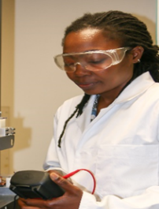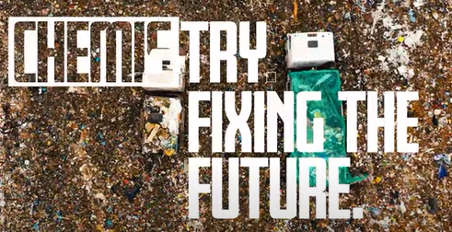
Dr Pearl Agyakwa (Materials scientist who studies why some materials wear out and other don’t) https://pstt.org.uk/application/files/1116/2851/6355/Materials_scientist_-_Pearl_Agyakwa.pdf



Developing Knowledge and Skills
Scientific Knowledge: |  | Working Towards | Within | Securely Within | Above
 | - Identify and compare the suitability of a variety of everyday materials, including wood, metal, plastic, glass, brick, rock, paper and cardboard for particular uses
 | - Find out how the shapes of solid objects made from some materials can be changed by squashing, bending, twisting and stretching.
Working Scientifically (Skills): Do: |  | Working Towards | Within | Securely Within | Above
 | - Identify and classify
 | - Use simple features to compare objects, materials and living things and, with help, decide how to sort and group them, observe changes over time, and, with guidance, they should begin to notice patterns and relationships.
Working Scientifically (Skills): Record: |  | Working Towards | Within | Securely Within | Above
 | - Gather and record data to help in answering questions.
Working Scientifically (Skills): Review: |  | Working Towards | Within | Securely Within | Above
 | - Use observations and ideas to suggest answers to questions.
 | - With help, record and communicate their findings in a range of ways and begin to use simple scientific language.
Working Scientifically (Enquiries): Identifying, grouping, and classifying: |  | Working Towards | Within | Securely Within | Above
 | - Use own criteria to classify materials
Working Scientifically (Enquiries): Comparative/ fair testing: |  | Working Towards | Within | Securely Within | Above
 | - Test materials for different uses.
What have I learnt? _________________________________________________________________________________________
___________________________________________________________________________________________________

