Biology | 
Prior Knowledge and Skills
- Name and describe people who are familiar to them.
- Continue developing positive attitudes about the differences between people.
- Name body parts that we are similar (have same body parts) and different (different heights).
- Understand that humans change as they grow up.

Science – Animals, including humans (Year 1)
Outcome: To be able to identify and classify animals into different groups.


Ideas and inspiration: |  | Vocabulary:  pets  fish – goldfish, tuna, shark, eel  amphibians – frog, toad, newt, salamander  reptiles – snake, tortoise, lizard, alligator  birds – penguin, chicken, flamingo, robin  mammals – human, mouse, dog, cow  carnivore herbivore omnivore diet teeth  senses – taste, tongue, sight, eyes, smell, nose, touch, hands, hearing, ears  parts of the body – head, elbow, thumb, knee, toes, foot, leg, fingers, shoulder, mouth  body, structure
  Enquiries
  Identifying, grouping  and classifying    Classify animals they have seen/have first-hand experience of, choosing their own criteria to do so. | Comparative/fair testing    Carry out taste tests | Researching    Use secondary sources to name animals seen in the local environment.

Developing Knowledge and Skills
Scientific Knowledge: |  | Working Towards | Within | Securely Within | Above
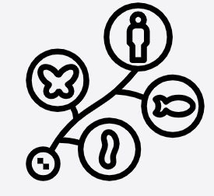 | - Identify and name a variety of common animals including fish, amphibians, reptiles, birds and mammals.
 | - Identify and name a variety of common animals that are carnivores, herbivores and omnivores.
 | - Describe and compare the structure of a variety of common animals (fish, amphibians, reptiles, birds and mammals, including pets).
 | - Identify, name, draw and label the basic parts of the human body and say which part of the body is associated with each sense.
Working Scientifically (Skills): Plan: |  | Working Towards | Within | Securely Within | Above
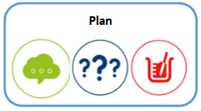 | - Ask simple questions and recognise that they can be answered in different ways.
Working Scientifically (Skills): Do: |  | Working Towards | Within | Securely Within | Above
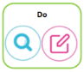 | - Observe closely, using simple equipment.
 | - Identify and classify.
What have I learnt?

_____________________________________________________________________________________________

_____________________________________________________________________________________________

