Physics | 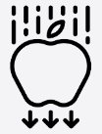


Science – Light (Year 6)
Outcome: explain how light travels and use this knowledge to make a working periscope.

Prior Knowledge and Skills
- Recognise that they need light in order to see things and that dark is the absence of light. (Y3 - Light)
- Notice that light is reflected from surfaces. (Y3 - Light)
- Recognise that light from the sun can be dangerous and that there are ways to protect their eyes. (Y3 - Light)
- Recognise that shadows are formed when the light from a light source is blocked by an opaque object. (Y3 - Light)
- Find patterns in the way that the size of shadows change. (Y3 - Light)
- Compare and group together everyday materials on the basis of their properties, including their hardness, solubility, transparency, conductivity (electrical and thermal), and response to magnets. (Y5 - Properties and changes of materials)

Vocabulary:

reflection:
periscope.

seeing light:
visible spectrum, prism.

how light travels: light waves, wavelength, straight line, refraction.

previously introduced vocabulary:
names and properties of materials, absorb.
Ideas and inspiration:
Euclid (Mathematician who predicted that light travels in straight lines and we only see things that light falls on)
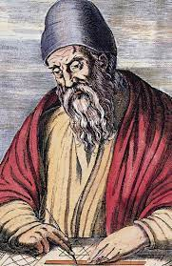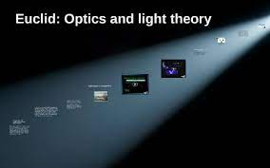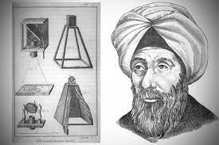
Ibn al-Haytham (Alhazen) (Physicist & Mathematician who
developed a theory that light travels in a straight line, and
proved it by carrying out the first scientific experiment)
Enquiries types:
Comparative and fair tests
Investigate: shape of shadows;
light travelling in straight lines;
effects of refraction.

light puppet show
periscope

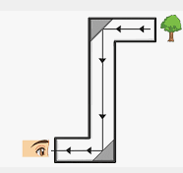

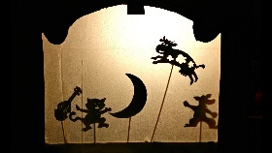
Developing Knowledge and Skills
Scientific Knowledge: |  | Working Towards | Within | Securely Within | Above
 | - Recognise that light appears to travel in straight lines.
 | - Use the idea that light travels in straight lines to explain that objects are seen because they give out or reflect light into the eye.
 | - Explain that we see things because light travels from light sources to our eyes or from light sources to objects and then to our eyes.
 | - Use the idea that light travels in straight lines to explain why shadows have the same shape as the objects that cast them.
Working Scientifically (Skills): Plan: |  | Working Towards | Within | Securely Within | Above
   | - Plan different types of scientific enquiries to answer questions, make predictions, recognise and control variables where necessary.
 | - Make their own decisions about what observations to make, what measurements to use and how long to make them for, and whether to repeat them.
 | - Choose the most appropriate equipment to make measurements and explain how to use it accurately.
Working Scientifically (Skills): Do:
 | - Take measurements, using a range of scientific equipment, with increasing accuracy and precision, taking repeat readings when appropriate.
Working Scientifically (Skills): Review: |  | Working Towards | Within | Securely Within | Above
 | - Use test results to make predictions to set up further comparative and fair tests.
 | - Report and present findings from enquiries, including conclusions, causal relationships and explanations of and degree of trust in results, in oral and written forms such as displays and other presentations.
 | - Use relevant scientific language and illustrations to discuss, communicate and justify their scientific ideas
What have I learnt? _________________________________________________________________________________________
___________________________________________________________________________________________________

