Physics | 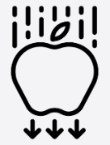


Science – Earth and Space (Year 5)
Outcome: Explain the movement of Earth around the sun through the use of a researched model.

Prior Knowledge and Skills
- Explore the natural world around them. (EYFS)
- Describe what they see, hear and feel whilst outside. (EYFS)
- Observe changes across the four seasons. (Y1 – Seasonal changes)
- Observe and describe the weather associated with the seasons and how day length varies. (Y1 – Seasonal changes)

Vocabulary:
Solar system, sun, moon, star, planet, satellite
Mercury, Venus, Earth, Mars, Jupiter, Saturn, Uranus, Neptune, Pluto (dwarf planet)
sphere, spherical body, celestial body
rotate, orbit, axis, revolve, day, night
geocentric model, heliocentric model
astronomer

Ideas and inspiration:

Enquiries:
Observing over time  Measure shadows throughout the day   | Researching  Generate questions to research about the Earth and Space.  

Developing Knowledge and Skills
Scientific Knowledge: |  | Working Towards | Within | Securely Within | Above
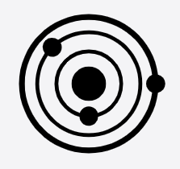 | - Describe the movement of the Earth, and other planets, relative to the Sun in the solar system.
 | - Describe the movement of the Moon relative to the Earth.
 | - Describe the Sun, Earth and Moon as approximately spherical bodies.
 | - Use the idea of the Earth’s rotation to explain day and night and the apparent movement of the sun across the sky.
Working Scientifically (Skills): Review: |  | Working Towards | Within | Securely Within | Above
 | - Recognise which secondary sources will be most useful to research their ideas and begin to separate opinion from fact.
 | - Identify scientific evidence that has been used to support or refute ideas or arguments.
 | - Report and present findings from enquiries, including conclusions, causal relationships and explanations of and degree of trust in results, in oral and written forms such as displays and other presentations.
 | - Use relevant scientific language and illustrations to discuss, communicate and justify their scientific ideas
What have I learnt? ___________________________________________________________________________________________________

___________________________________________________________________________________________________

___________________________________________________________________________________________________

___________________________________________________________________________________________________

