Forest School Curriculum 2026-2027 – ½ term per child
Aut 1 | Aut 2 | Spr 1 | Spr 2 | Sum 1 | Sum 2
  Monday AM  Year 2    Start of year activities  PSHE – transition    Geography – map skills  English – Stick man  History – Great Fire of London    DT – Tudor houses/food technology |  |  | Monday AM  Year 3  History – Stone Age    Art – Cave painting  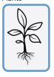    Science – Animals and Plants    RE- Easter cross | Monday AM  Year 5  Science – Lifecycles (Spr 2) and changing materials    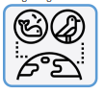  English/PSHE – sustainability/recycling (Sum 2)  History (Vikings) | Wednesday AM  Year 6  History - Victorians  Science – Classification (Spr 2)  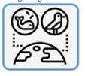
Monday PM  Year 1    Start of year activities  PSHE – transition  Geography – map skills  Science – seasonal change (Summer and Autumn) and animals  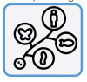    Art – nature Art |  |  | Monday – PM Reception  Forest School introduction  Rules Ethos Skills      Minibeasts (Sum 1)    Lifecycles (Sum 1) | Wednesday AM  Year 4  Science – Classification (Spr 2) and States of Matter (Spr 1)    History – Roman roads    Art – mosaics

