Weekly Plan – Spring 1 Reception W.B. 12.01.26 Week A
Sapphire | Emerald | MONDAY | TUESDAY | WEDNESDAY | THURSDAY | FRIDAY
8:45 – 9.00 |  | Register /  Name recognition | Register /  Name recognition | Register /  Name recognition | Register /  Name recognition | Register /  Name recognition
9:00 – 9:30 |  | Handwriting – model letter formation ‘n’ ‘m’  WCR - Goldilocks and the Three Bears Vocabulary  Porridge making – whole class and tasting | Dough Morning Challenge  Dough Disco: Goldilocks Story  Handwriting – model letter formation ‘n’ ‘m’  Phonics Level 3 – v | Handwriting – morning challenge etter formation ‘n’ ‘m’  Ribbon Dance – Steps 5,6,7,8  Drawing club L1 Character – Goldilocks and the Three Bears | Handwriting – morning challenge letter formation ‘n’ ‘m’  Maths – Conceptual subitising to 5  Drawing club L2 Setting – Goldilocks and the Three Bears | Handwriting – morning challenge letter formation ‘n’ ‘m’  Phonics Level 3 recap  Ribbon Dance – Steps 5,6,7,8
9.30 – 9.35
9.30 -11.30 |  | PSHE Dreams and Goals - input 2  Discovery  BS – Fine Motor & Discovery  MM – Phonics Intervention  CS – Discovery  JP – Discovery & daily reads  JT – Hear Readers  Phonics Level 3 – y | Goldilocks Whole Class Attention Bucket  Discovery  BS – Fine Motor & Name Writing Intervention  MM – Discovery & Phonics Intervention  CS – Hear Readers  JT – Hear Readers & daily reads  RM – outside / inside discovery | Carousel  BS & MM – Phonics blending  JP & CS - Writing  Maths - Composition | Carousel  BS & MM – Writing  JP & CS – Maths  Phonics Level 3 – ch | PE 9:30- 10:15  WCR – Goldilocks Retrieval and Inference  PSED – Puppets  Model Afternoon Challenge | WCR – Goldilocks Retrieval and Inference  PSED – Puppets  PE 10:15 – 11:00  Model Afternoon Challenge
11.30 – 12:30 |  | Go to lunch hall @ 11.30 Lunch | Go to lunch hall @ 11.30 Lunch | Go to lunch hall @ 11.30 Lunch | Go to lunch hall @ 11.30 Lunch | Go to lunch hall @ 11.30 Lunch
12:30 – 12:35 |  | Register / afternoon challenge | Register / afternoon challenge | Register / afternoon challenge | Register / afternoon challenge | Register / afternoon challenge
12:35 – 12:50 |  | Maths – 1 more  Flipper Flappers – Steps 5,6,7,8 | Maths – 1 less | Phonics Level 3 – qu | Music – Guess the Instrument | Phonics Level 1 – Week 7  Recap phonics game ppt
 |  | Discovery  BS – Discovery  MM – Attention Bucket Intervention  CS – Hear Readers  JT – Hear Readers  Assembly 2:30pm | Discovery  BS – Discovery  MM – Welcomm Intervention  CS – Hear Readers  JT – Hear Readers & daily reads | Discovery  BS – Name Writing Intervention  MM – Discovery & Phonics Intervention  CS – Hear Readers  JP – Hear Readers | Discovery  BS – Discovery  MM – Attention Bucket Intervention & Phonics Intervention  Library Slot  Dough Disco: Goldilocks Story | Discovery  BS – Comprehension Pre-Teach Intervention & Discovery  MM – Welcomm Intervention & Discovery  Assembly 2:30pm
2:15 |  | Snack / Story  BS – Comprehension Intervention  Home things | Tidy up  Snack / Story  CL – Surprise Gift | Tidy up  Snack / Story  Phonics Level 1 – Week 7 | Tidy up  Snack / Story /  Phonics Level 1 – Week 7 | Tidy up  Snack / Story
2:25 – 3.15 |  | Story Time / End of Day | Story Time / End of Day | Story Time / End of Day | Story Time / End of Day | Story Time / End of Day

 | Afternoon Challenges
 | Bumblebees | Snails | Caterpillars | Ladybirds | Butterflies
Monday | Whiteboard Letter Formation ‘m’ and ‘n’ | Whiteboard Letter Formation ‘m’ and ‘n’ | Adult led letter formation ‘m’ and ‘n’ writing sheet | Adult led letter formation ‘m’ and ‘n’ writing sheet | Adult led letter formation ‘m’ and ‘n’ writing sheet
Tuesday | Adult led letter formation ‘m’ and ‘n’ writing sheet | Adult led letter formation ‘m’ and ‘n’ writing sheet | Whiteboard Letter Formation ‘m’ and ‘n’ | Whiteboard Letter Formation ‘m’ and ‘n’ | Whiteboard Letter Formation ‘m’ and ‘n’
Wednesday | Maths – how many ways can children represent 5?  Resources - mulitlink
Thursday | Maths – Make a tower and compare to your talk partner. Who has more? Who has less?  Resources - mulitlink
Friday | Maths – Can you make a repeating pattern?  Resources - mulitlink

Outdoor Provision Enhancements Plan
Tuff tray 1 – Scales with scoops and oats. Support children to notice whether the balance scales are balanced, even, higher, lower etc. | Tuff tray 2 - Prompt children to explore filling a container with different loose parts, such as pine cones, stones and corks. Support children to notice whether the container can hold more of one object than another object. | Tuff tray 3 - Provide a selection of containers of different shapes and sizes and ask children to investigate which holds the most water. Place the containers in order from the smallest to the greatest capacity. | Tuff tray 4 – porridge messy play – bear masks, saucepans, spoons, oats and water. | Sandpit – containers ranging of different sized. Children to wear waterproofs and wellies.
Mud kitchen – different containers. Children wear waterproofs and wellies. | Bikes  Chalk

Area to enhance | Indoor Provision Enhancements Plan
Area to enhance | Monday | Tuesday | Wednesday |  | Thursday |  | Friday
Mark Making  Focus children: | Cut the pictures accurately and stick these in a sequential order to create a book.
Phonics  Focus children: | Yolk matching game  Blend to read words containing ‘y’  Put the words face down, choose two and read them. If they match, put them in your frying pan. | Initial sounds I spy – ‘z’  Circle all of the things that begin with ‘z’. | Quick, quack, queen game  A game of pairs using word cards with ‘qu’ in them. |  | Help the farmer word sort  Sound out and blend the words. If they contain a ‘ch’, post them into the barn. |  | Tricky word game  Read the tricky words.  Roll the dice, subitise the amount, move that many spaces.
Physical – Fine Motor  Focus children: | Porridge sort:  Children use selection of tweezers to pick out sequins, beans and pom poms from porridge oats and sort into three different sized bowls.  Resources:  Porridge oats, sequins, pom poms, beans, three different sized bowls, different sized tweezers.  Challenge:  Choice of difficulty in tweezers provided. | Numicon Marbles:  Use fingers to pick up a marble and fill the numicon pieces. Find correct number card to match.  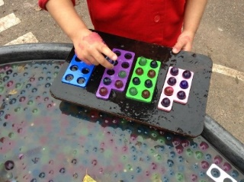  Resources:  Marbles  Number Cards.  Numicon  Challenge:  Isolate hand on hand mat then swap over.  Keep elbow tucked into body. | Pipettes and rainbow patterns:  Use pipettes and water coloured with food colouring. Roll two dice - add together and put the correct number of water drops onto your piece of kitchen roll.  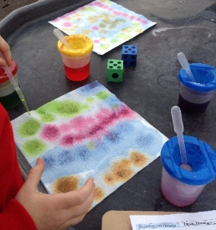  What happens? Could dry these out and stick in books.  Resources:  Pipettes.  Coloured water.  Kitchen Roll.  Hand isolating mats.  Challenge:  Can you keep your elbows tucked into your body?  Can you swap hands? |  | Winter themed cotton bud painting    Resources:  Cotton buds  Paint  Sheets |  | Popping bubbles in bubble wrap  Use a pincer grip to pop the bubbles.  Resources:  Bubble wrap
Physical/EAD –  Focus children: | Mould the playdough to make a snowman.  Resources:  White playdough, buttons, sticks, visual prompt.
EAD – Art / Craft | Use a range of resources to make a character from the story of Goldilocks.  Resources:  Paper plates, googly eyes, paint, string, material.
Maths | 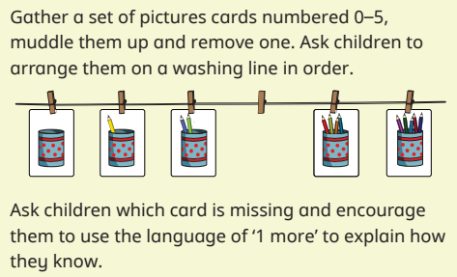 |  |  | 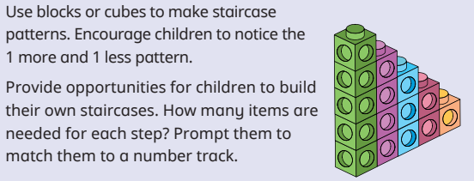 |  | Numberblocks - stampolines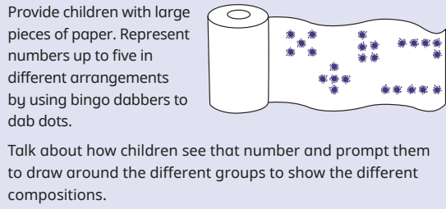

Carousel Thursday
Drawing Club – adult led setting | Maths – Alive in 5 adult led activity | Number formation and matching the representation cutting and sticking | Maths puzzles - dominoes | IWB game – maths

Carousel Wednesday
Drawing Club – adult led character | CVC winter themed writing – adult led | Winter themed cutting | Construction | IWB game – phonics blending

