Weekly Plan – Autumn 1 Reception W.B. 24.11.25 Week A
Sapphire | Emerald | MONDAY |  | TUESDAY | WEDNESDAY | THURSDAY | FRIDAY
8:45 – 9.00 |  | Register /  Name recognition |  | Register /  Name recognition | Register /  Name recognition | Register /  Name recognition | Register /  Name recognition
9:00 – 9:30 |  | Flipper Flappers – Celebration Kool and the Gang |  | Dough Morning Challenge Dough  Disco – Celebration Kool and the Gang  Phonics Level 2 – Recap Week 7 | Handwriting – model letter formation ‘j’  Phonics Level 2 – Recap Week 7  Ribbon Dance – Celebration Kool and the Gang | Handwriting – model letter formation ‘j’  Phonics Level 2 – Recap Week 7  Flipper Flappers – Celebration Kool and the Gang  Writing - Celebration input | INSET DAY
9.30 – 9.35
9.30 -11.30 |  | PE 9:30- 10:00  Phonics Level 2 – Recap Week 7  WCR Pre Teach – Chocolate Cake Pre Teach L1  Write a whole class list  UOW – Talk about Different Celebrations  (cbeebies vids)  Handwriting – model letter formation ‘j’  Model Afternoon Challenge | Phonics Level 2 – Recap Week 7  PE 10:00 – 10:30  WCR Pre Teach – Chocolate Cake Pre Teach L1  Write a whole class list  UOW – Talk about Different Celebrations  (cbeebies vids)  Handwriting – model letter formation ‘j’  Model Afternoon Challenge | Celebration Bucket – Whole Class Attention Bucket  Discovery  BS – Fine Motor & Name Writing Intervention  MM – Discovery & Phonics Intervention  PSHE – Celebrating Difference L2  UOW - Talk about Different Celebrations  (cbeebies vids) | Discovery  BS – Fine Motor & Discovery  MM – Attention Bucket Intervention  CS – Hear Readers  JP – Hear Readers  PSED – Mystery Bottle  UOW - Talk about Different Celebrations  (cbeebies vids) | Discovery  BS – Fine Motor & Name Writing Intervention  MM – Discovery  CS – Draw Favourite Celebration  JP – Draw Favourite Celebration  PSHE – Celebrating Difference L4  UOW - Talk about Different Celebrations  (cbeebies vids)
11.30 – 12:30 |  | Go to lunch hall @ 11.20 Lunch |  | Go to lunch hall @ 11.20 Lunch | Go to lunch hall @ 11.20 Lunch | Go to lunch hall @ 11.20 Lunch
12:30 – 12:35 |  | Register / afternoon challenge |  | Register / afternoon challenge | Register / afternoon challenge | Register / afternoon challenge
12:35 – 12:50 |  | Maths – 1, 2, 3, 4, 5 L1 |  | Maths – 1, 2, 3, 4, 5 L2 | WCR Pre Teach – Chocolate Cake Retrieval and Inference L2 | Maths – 1, 2, 3, 4, 5 L1
 |  | Christmas play rehearsal in hall 1.20 – 2.10  PSHE – Celebrating Difference L1 & paperchain what makes them special |  | Christmas play rehearsal in hall 1.20 – 2.10  Discovery  BS – Discovery  MM – Welcomm Intervention | Discovery  BS – Name Writing Intervention  MM – Discovery & Welcomm  CS – Hear Readers  JP – Hear Readers | Discovery  BS – Discovery, Comprehension Pre Teach  MM – Attention Bucket Intervention  CS – Draw Favourite Celebration  JP – Draw Favourite Celebration  Party  Library Slot
2:15 |  | Snack / Story  BS – Comprehension Intervention  Home things |  | Tidy up  Snack / Story  CL – Guess the Emotion | Tidy up  Snack / Story  PSHE – Celebrating Difference L3 | Tidy up  Snack / Story
2:25 – 3.15 |  | Story Time / End of Day |  | Story Time / End of Day | Story Time / End of Day | Story Time / End of Day

Daily Rotational Afternoon Challenges
Bumblebees | Snails | Caterpillars | Ladybirds | Butterflies
Handwriting letter ‘j’  3 bug groups on table  2 on whiteboards | Handwriting letter ‘j’  3 bug groups on table  2 on whiteboards | Make a tower of 10 multilink cubes  Challenge:  1 more  1 less

Outdoor Provision Enhancements Plan
Role play – party dressing up | Tea party  Resources:  Tea party  Tables and chairs  Teddies | Party food in the mud kitchen

Area to enhance | Indoor Provision Enhancements Plan
Area to enhance | Monday | Tuesday | Wednesday |  |  | Thursday |  |  | Friday
Mark Making |  | Write an invitation for a party  Resources:  Envelopes  Mark making tools  Template for invitations |  |  | Write a party list  Write a birthday card
Phonics |  | Pictures to write a word underneath  S, a, t, p, i  N, m, d, g, o | Pictures to write a word underneath  C, k, ck, e, u, r |  |  | Pictures to write a word underneath  H, b, f, l, ff, ll, ss
Physical – Fine Motor |  | Paperchains – make a decoration  Resources:  Strips of paper |  |  |  | Decorate a cake  Resources:  Pre-printed cakes  Decorations for cakes
Physical – Playdough | Make party food  Resources:  Visuals for menu stand of party food
EAD – Art / Craft |  |  |  | Make a party hats  Resources:  Sponges  Crowns  Strips of paper with zig zag lines to cut |  |  | Wrap up their Diva Lamps in tissue paper
Maths | Provide a range of picture cards showing different representations of 4 and 5 and 2 hoops.  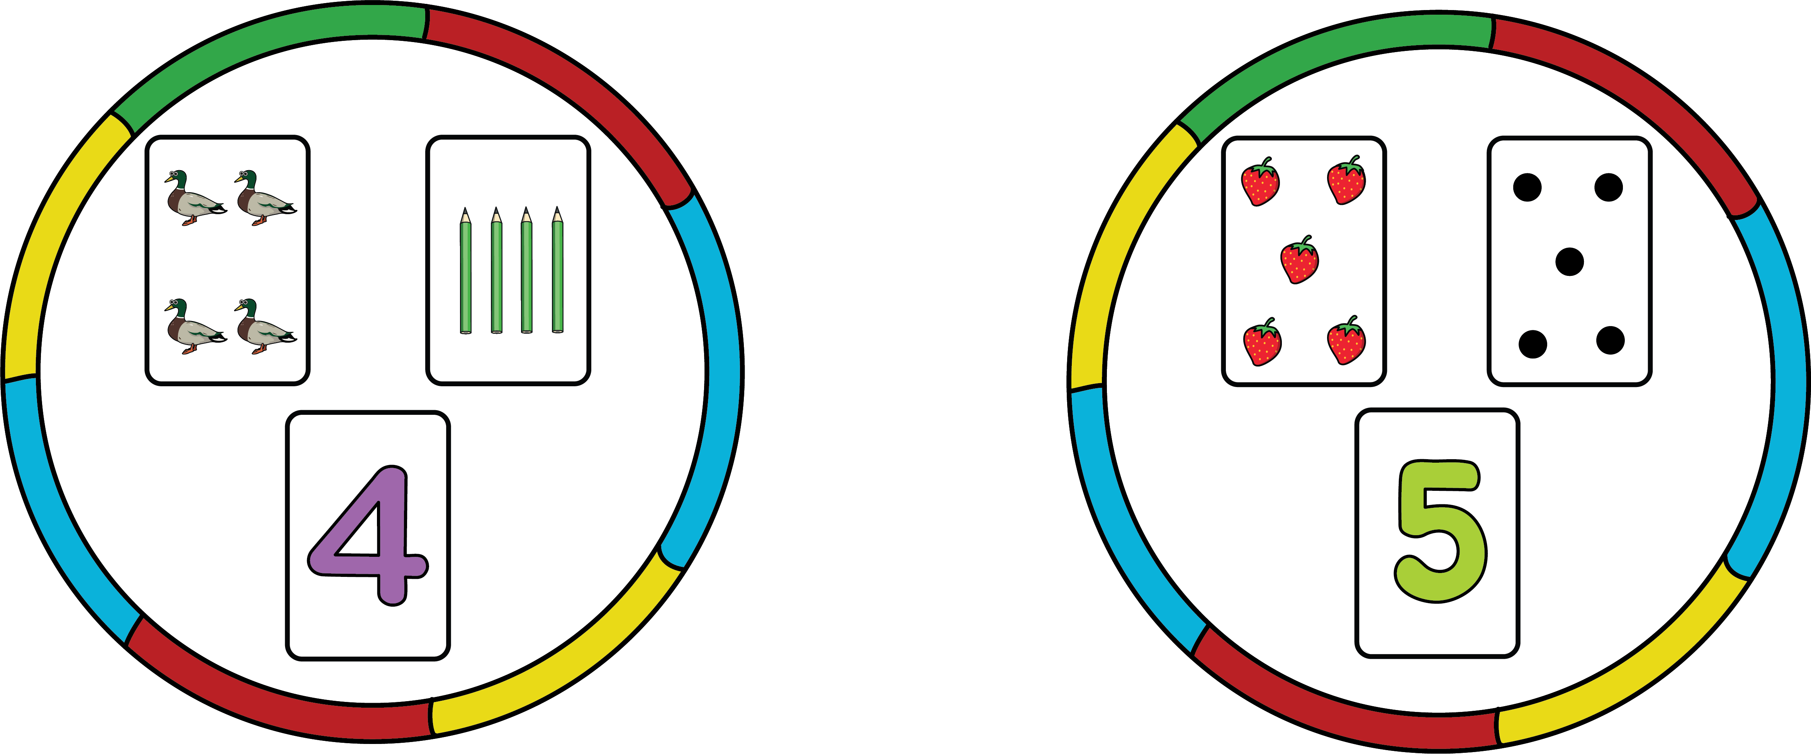  Prompt children to sort the cards and place them in the correct hoop. |  |  | Give children a dot plate each and encourage them to find someone with the same arrangement as them.  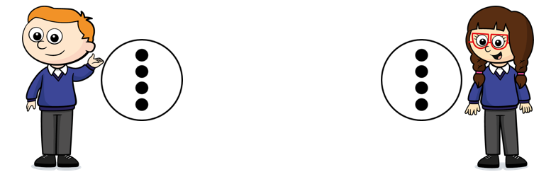  You could extend this to finding the same number but in a different arrangement. |  |  | Encourage children to arrange 4 or 5 objects in different patterns.  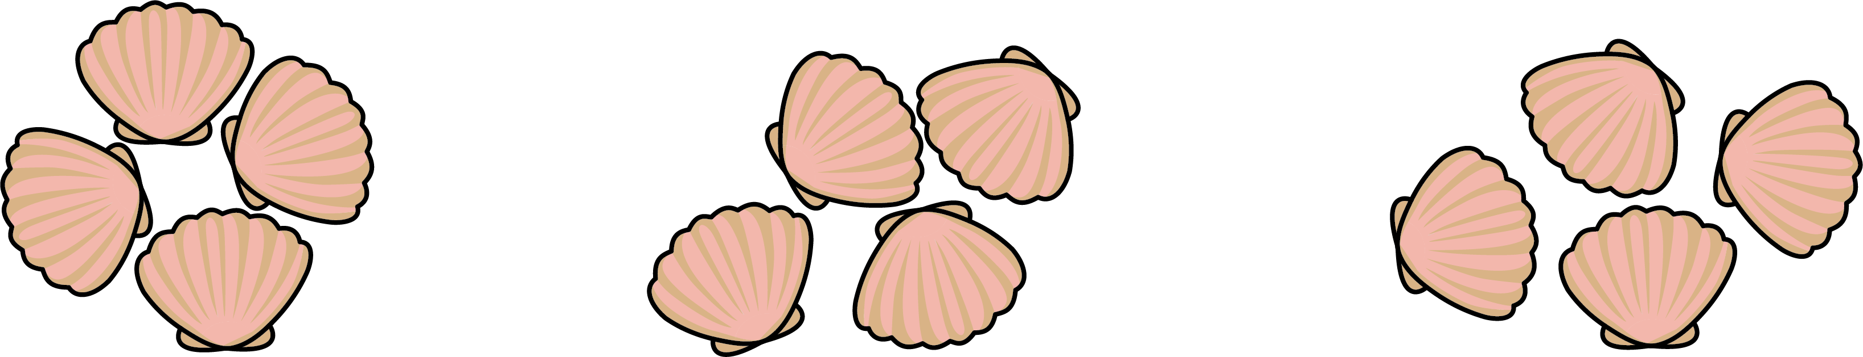  How many are there altogether?  Does your group of 4 look the  same as mine?
EAD / Role Play |  |  |  |  |  |  | Home Corner  Resources:  Party dressing up  Tea party food

CL - Guess the emotion
Resources | Emotion picture cards.
Intent | Talk about and recognise different emotions, begin to understand emotions and recognise that it is ok to express emotions.
Implement | Turn the pack of emotion cards upside down and start by modelling taking one from the top. Look at the card and act out the emotion, e.g., produce an angry face. What is my emotion? What am I showing? Extend by asking the children Have you ever felt like this before? When did you feel like this? Encourage children to take turns and act out an emotion on the card.
Impact | Can children recognise different emotions?  Can children act out different emotions?  Can children talk about different emotions?

PSED | Mystery Bottle
Resources | Discover an empty bottle with a question mark on!
Development Matters Statements | Confident in group situations, see themselves as a valuable individual (PSED), articulates their ideas and thoughts in well-formed sentences, develop social phrases (COMM & LANG).
Characteristics of Effective Learning | Making links to ideas, make independent choices, feel confident about coming up with their own ideas.
Plan | Ask whoever the bottle lands on... What is the one thing you enjoy and are good at?
Success Criteria: Can children say one thing that they are good at? |  | Key vocabulary: enjoy, good, succeed, bottle, question mark

