Weekly Plan – Autumn 1 Reception W.B. 17.11.25 Week B
Sapphire | Emerald | MONDAY |  | TUESDAY | WEDNESDAY | THURSDAY | FRIDAY
8:45 – 9.00 |  | Register /  Name recognition |  | Register /  Name recognition | Register /  Name recognition | Register /  Name recognition | Register /  Name recognition
9:00 – 9:30 |  | Flipper Flappers – One Republic - Run |  | Dough Morning Challenge Dough  Disco – One Republic - Run  Handwriting – model letter formation ‘t’  Phonics Level 2 – ll | Handwriting – model letter formation ‘t’  Phonics Level 2 – s  Ribbon Dance – One Republic - Run | Dough Morning Challenge  Dough Disco – One Republic - Run  Handwriting – model letter formation ‘t’  Phonics Level 2 – ss | Handwriting – model letter formation ‘t’  Phonics Level 2 - recap  Ribbon Dance – One Republic - Run
9.30 – 9.35
9.30 -11.30 |  | PE 9:30- 10:00  Phonics Level 2 – ff  WCR Pre Teach – The Gingerbread Man  Drawing Club – L1  Handwriting – model letter formation ‘t’  Model Afternoon Challenge | Phonics Level 2 – ff  PE 10:00 – 10:30  WCR Pre Teach – The Gingerbread Man  Drawing Club – L1  Handwriting – model letter formation ‘t’  Model Afternoon Challenge | Gingerbread Man Bucket – Whole Class Attention Bucket  Discovery  BS – Fine Motor & Name Writing Intervention  MM – Discovery & Phonics Intervention  Phonics Level 1 – Week 9 | Discovery  BS – Fine Motor & Discovery  MM – Attention Bucket Intervention  CS – Hear Readers  JP – Hear Readers  Maths – Circles and Triangles L2 | Discovery  BS – Fine Motor & Name Writing Intervention  MM – Discovery  CS – Gingerbread making  JP – Gingerbread making  PSED – Which Animals | PSHE Relationships - input 3  Discovery  BS – Fine Motor & Discovery  MM – Phonics Intervention  Music – Copy that
11.30 – 12:30 |  | Go to lunch hall @ 11.20 Lunch |  | Go to lunch hall @ 11.20 Lunch | Go to lunch hall @ 11.20 Lunch | Go to lunch hall @ 11.20 Lunch | Go to lunch hall @ 11.20 Lunch
12:30 – 12:35 |  | Register / afternoon challenge |  | Register / afternoon challenge | Register / afternoon challenge | Register / afternoon challenge | Register / afternoon challenge
12:35 – 12:50 |  | Maths – Position |  | Maths – Circles and Triangles L1 | WCR Retrieval – The Gingerbread Man | Maths – Circles and Triangles L3 | Phonics Level 1 – Week 9
 |  | Christmas play rehearsal in hall 1.20 – 2.10 |  | Christmas play rehearsal in hall 1.20 – 2.10  Discovery  BS – Discovery  MM – Welcomm Intervention | Discovery  BS – Name Writing Intervention  MM – Discovery & Phonics Intervention  CS – Hear Readers  JP – Hear Readers | Discovery  BS – Discovery  MM – Attention Bucket Intervention & Phonics Intervention  Library Slot | Christmas play rehearsal in hall 1.20 – 2.10  Discovery  BS – Comprehension Pre-Teach Intervention & Discovery  MM – Welcomm Intervention & Discovery
2:15 |  | Snack / Story  BS – Comprehension Intervention  Home things |  | Tidy up  Snack / Story  CL – Song Swap | Tidy up  Snack / Story  Phonics Level 1 – Week 9 | Tidy up  Snack / Story / eat gingerbread biscuits | Tidy up  Snack / Story  WCR Inference Pre Teach – The Gingerbread Man
2:25 – 3.15 |  | Story Time / End of Day |  | Story Time / End of Day | Story Time / End of Day | Story Time / End of Day | Story Time / End of Day

Daily Rotational Afternoon Challenges
Bumblebees | Snails | Caterpillars | Ladybirds | Butterflies
1 - Cutting sheets  Resources:  Gingerbread man sheet | 2 – Writing Adult led Gingerbread man drawing club lesson 1  “run, run, run”  “the man is ____”  Resources:  Sheet  Sound mats  Pencils | 3 – Role play retelling the story  Resources:  Stick puppets or masks for characters to retell the story | 4 – Pencil Control & Handwriting letter formation ‘t’ - Adult support  Resources:  ‘t’ sheet  Pencil control sheet | 5 - Maths phonics IWB game  Gingerbread man – topmarks
5 - Maths phonics IWB game  Gingerbread man – topmarks | 1 - Cutting sheets  Resources:  Gingerbread man sheet | 2 – Writing Adult led dictated sentence (Gingerbread man)  “run, run, run”  “the man is ____”  Resources:  Sheet  Sound mats  Pencils | 3 – Role play retelling the story  Resources:  Stick puppets or masks for characters to retell the story | 4 – Pencil Control & Handwriting letter formation ‘t’ - Adult support  Resources:  ‘t’ sheet  Pencil control sheet
4 – Pencil Control & Handwriting letter formation ‘t’ - Adult support  Resources:  ‘t’ sheet  Pencil control sheet | 5 - Maths phonics IWB game  Gingerbread man – topmarks | 1 - Cutting sheets  Resources:  Gingerbread man sheet | 2 – Writing Adult led dictated sentence (Gingerbread man)  “run, run, run”  “the man is ____”  Resources:  Sheet  Sound mats  Pencils | 3 – Role play retelling the story  Resources:  Stick puppets or masks for characters to retell the story
3 – Role play retelling the story  Resources:  Stick puppets or masks for characters to retell the story | 4 – Pencil Control & Handwriting letter formation ‘t’ - Adult support  Resources:  ‘t’ sheet  Pencil control sheet | 5 - Maths phonics IWB game  Gingerbread man – topmarks | 1 - Cutting sheets  Resources:  Gingerbread man sheet | 2 – Writing Adult led dictated sentence (Gingerbread man)  “run, run, run”  “the man is ____”  Resources:  Sheet  Sound mats  Pencils
2 – Writing Adult led dictated sentence (Gingerbread man)  “run, run, run”  “the man is ____”  Resources:  Sheet  Sound mats  Pencils | 3 – Role play retelling the story  Resources:  Stick puppets or masks for characters to retell the story | 4 – Pencil Control & Handwriting letter formation ‘t’ - Adult support  Resources:  ‘t’ sheet  Pencil control sheet | 5 - Maths phonics IWB game  Gingerbread man – topmarks | 1 - Cutting sheets  Resources:  Gingerbread man sheet

Whole Class Reading online ebook -
https://www.twinkl.co.uk/go/resource/level-1-unit-2-reading-scheme-book-the-gingerbread-man-t-e-1681913667

Outdoor Provision Enhancements Plan
Gingerbread man tuff tray – role play maks etc | Mud kitchen – making recipes for gingerbread men/other treats

Area to enhance | Indoor Provision Enhancements Plan
Area to enhance | Monday | Tuesday | Wednesday |  | Thursday |  | Friday
Mark Making | Create your own ‘The Gingerbread Man’ book  Resources:  Pre folded books  Pictures from the story  Range of writing tools  Joining tools to create books
Phonics | Glow in the Dark Sounds, Words, Pictures  Practise segmenting and blending CVC words containing ‘f’ and ‘ff’. | Bell Bowling  Practise orally segmenting and blending VC and CVC words  containing ‘ll’. | Don’t Miss the ‘ss’  Practise blending CVC words  containing ‘ss’. |  | Read and Match  Practise reading words  containing ‘s’ saying /z/ and  writing a caption/sentence. |  | Catch Him!  Leave the Catch Him! Character Cards in the role-play area and encourage children to create their own voice sounds as they act out the story.
Physical – Fine Motor | Zig Zags:  Children are to cut along the zig zag lines.  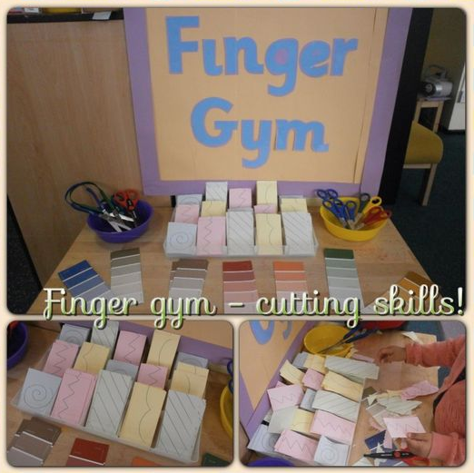  Resources:  Scissors.  Paper with zig zags lines on to cut along |  | 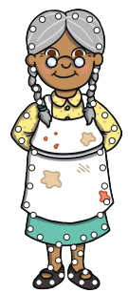  Gingerbread man themed threading  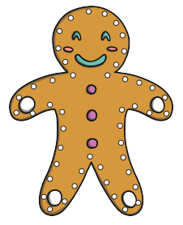  Resources:  Laminated threading sheets  Laces |  | Pipette Bricks:  Children are to use pipettes to fill up Duplo bricks with water.  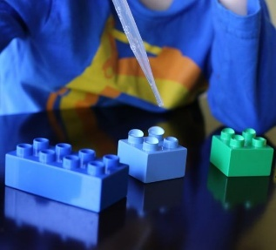  Resources:  Pipettes, water, Duplo bricks  Challenge:  Use hand mats to isolate first one hand and then the other. |  | Plaiting pipe cleaners:  Children are to plait three pipe cleaners together.    Resources:  Pipe cleaners, masking tape to stick to table.
Physical – Playdough | Make gingerbread men/people out of play-doh  Resources:  Brown play doh  Gingerbread men cutters  Later on in the week, add play doh mats as well
EAD – Art / Craft | Design a gingerbread man  Resources:  Gingerbread man template  Different coloured pens/paints/collage bits
Maths | Gingerbread man match the number to the buttons  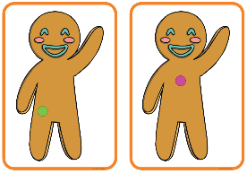  Resources:  Gingerbread man cards  Number cards to match |  |  | Sorting triangles and circles  Resources:  Circle and triangle cut outs  Table to sort |  | Kandinsky inspired Art using triangle and circles  What picture can you create using the different shapes?  Resources:  Triangle and circle cut outs

CL - Song swap
Resources | Instruments
Intent | To learn new vocabulary, to recognise rhyme, to listen carefully to rhymes and songs paying attention to how they sound and the changes that occur.
Implement | Take a song or rhyme the children know well and invent new words to suit the children’s interests. For example, Mary had a little puppy, a little puppy….’. Use percussion instruments to accompany the new lyrics.
Impact | Can children think of new words?  Can children say words that rhyme?  Can children spot a word that rhymes?

PSED | Which Animal?
Resources | Discover a giant bag of soft animals!
Development Matters Statements | Confident in group situations, see themselves as a valuable individual (PSED), articulates their ideas and thoughts in well-formed sentences, develop social phrases (COMM & LANG), talk about similarities and differences (UTW).
Characteristics of Effective Learning | Making links to ideas, make independent choices, feel confident about coming up with their own ideas.
Plan | Which animal is most like you? Why is this animal like you? What can the animal do that you can do? What can you do that the animal cannot do?
Success Criteria: Can talk about similarities and differences between themselves and animals? |  | Key vocabulary: similar, different, fly, walk, run, talk, swim, good, can do, can’t do, animal, human

Music | Copy that!
Resources | Chime bars or other instruments
Development Matters Statements | Sing in a group or on their own, increasingly matching the pitch and following the melody (EAD), understand how to listen carefully and why listening is important, learn rhymes/poems/songs (COMM & LANG)
Skills | Listening, controlling body movements, dancing to music, vocabulary and sentence construction, memory - repetition
Plan | Sing hello song together while clapping - Hello (child’s name), hello (child’s name) hello everyone it’s time to say hello (wave). Repeat until you have said all the child’s names.  Sing the following song to the children whilst only clapping to the beat 4 times on the last phrase (claps shown by underlining the relevant syllable). Hey, hey look at me! (GEGGE) I am clapping can you see?(GGEEGGE) Vary the actions, e.g. stamping, jumping, hopping and blinking. 1. Children to echo your singing and copy the actions 2 .A child chooses an action, and then as you sing child joins in actions on second phrase. Then everyone copies. 3. A child sings song and performs actions as the leader and the rest of the children repeat This song can be done with instruments as well (tapping, shaking, scraping)  Is there another action we could add?  Goodbye song – Goodbye, so long my friends, goodbye, so long, farewell, we’ll see you soon my friends again, so goodbye, so long, farewell.
Success Criteria: Can children sing a song using repetition? |  | Key vocabulary: instrument, clap, stamp, jump, hop, blink, copy, action, sing, leader, shaking, tapping, scraping

