Weekly Plan – Autumn 1 Reception W.B. 10.11.25 Week A
Sapphire | Emerald | MONDAY |  | TUESDAY | WEDNESDAY | THURSDAY | FRIDAY
8:45 – 9.00 |  | Register /  Name recognition |  | Register /  Name recognition | Register /  Name recognition | Register /  Name recognition | Register /  Name recognition
9:00 – 9:30 |  | Flipper Flappers – The Big Bad Wolf |  | Dough Morning Challenge Dough  Disco – The Big Bad Wolf  Handwriting – model letter formation ‘l’  Phonics Level 2 – b | Handwriting – model letter formation ‘l’  Phonics Level 2 – f  Ribbon Dance – The Big Bad Wolf | Dough Morning Challenge  Dough Disco – The Big Bad Wolf  Handwriting – model letter formation ‘l’  Phonics Level 2 – l | Handwriting – model letter formation ‘l’  Phonics Level 2 - recap  Ribbon Dance – The Big Bad Wolf
9.30 – 9.35
9.30 -11.30 |  | PE 9:30- 10:00  Phonics Level 2 – h  WCR Pre Teach – The Three Little Pigs  Handwriting – model letter formation ‘l’  Model Afternoon Challenge | Phonics Level 2 –  PE 10:00 – 10:30  WCR Pre Teach – The Three Little Pigs  Handwriting – model letter formation ‘l’  Model Afternoon Challenge | Three Little Pig Bucket – Whole Class Attention Bucket  Discovery  BS – Fine Motor & Name Writing Intervention  MM – Discovery & Phonics Intervention  Phonics Level 1 – Week 10 | Discovery  BS – Fine Motor & Discovery  MM – Attention Bucket Intervention  CS – Hear Readers  JP – Hear Readers  Maths – It’s Me 1,2,3 L5 | Discovery  BS – Fine Motor & Name Writing Intervention  MM – Discovery  PSED – Magic Wand | PSHE Celebrating Difference - input 2  Discovery  BS – Fine Motor & Discovery  MM – Phonics Intervention
11.30 – 12:30 |  | Go to lunch hall @ 11.20 Lunch |  | Go to lunch hall @ 11.20 Lunch | Go to lunch hall @ 11.20 Lunch | Go to lunch hall @ 11.20 Lunch | Go to lunch hall @ 11.20 Lunch
12:30 – 12:35 |  | Register / afternoon challenge |  | Register / afternoon challenge | Register / afternoon challenge | Register / afternoon challenge | Register / afternoon challenge
12:35 – 12:50 |  | Science - Materials |  | Maths – It’s Me 1,2,3 L4 | WCR Retrieval – The Three Little Pigs | Maths – It’s Me 1,2,3 L6 | Phonics Level 1 – Week 10
 |  | Science – materials predictions, house building and experiment |  | Discovery  BS – Discovery  MM – Welcomm Intervention | Discovery  BS – Name Writing Intervention  MM – Discovery & Phonics Intervention  CS – Hear Readers  JP – Hear Readers | Discovery  BS – Discovery  MM – Attention Bucket Intervention & Phonics Intervention  Library Slot | Discovery  BS – Comprehension Pre-Teach Intervention & Discovery  MM – Welcomm Intervention & Discovery
2:15 |  | Tidy up 2:00  Snack / Story  BS – Comprehension Intervention  Home things  Assembly 2:30 |  | Tidy up  CL – Jack in a Box  UOW - Remembrance Day Powerpoint | Tidy up  Phonics Level 1 – Week 10 | Tidy up  Music – Name that Tune | Tidy up  WCR Inference – The Three Little Pigs
2:25 – 3.15 |  | Story Time / End of Day |  | Story Time / End of Day | Story Time / End of Day | Story Time / End of Day | Story Time / End of Day

Daily Rotational Afternoon Challenges
Bumblebees | Snails | Caterpillars | Ladybirds | Butterflies
1 - Cutting sheets  Resources:  Three Little Pig Sheet | 2 – Writing Adult led dictated sentence (Three Little Pigs) | 3 – Build three little pig houses  Resources:  Construction materials e.g. geoboards, magnetic tiles, blocks etc. | 4 – Pencil Control & Handwriting letter formation ‘l’ - Adult support  Resources:  Sheet | 5 – Level 2 phonics IWB game
5 – Level 2 phonics IWB game | 1 - Cutting sheets  Resources:  Three Little Pig Sheet | 2 – Writing Adult led dictated sentence (Three Little Pigs) | 3 – Build three little pig houses  Resources:  Construction materials e.g. geoboards, magnetic tiles, blocks etc. | 4 – Pencil Control & Handwriting letter formation ‘l’ - Adult support  Resources:  Sheet
4 – Pencil Control & Handwriting letter formation ‘l’ - Adult support  Resources:  Sheet | 5 – Level 2 phonics IWB game | 1 - Cutting sheets  Resources:  Three Little Pig Sheet | 2 – Writing Adult led dictated sentence (Three Little Pigs) | 3 – Build three little pig houses  Resources:  Construction materials e.g. geoboards, magnetic tiles, blocks etc.
3 – Build three little pig houses  Resources:  Construction materials e.g. geoboards, magnetic tiles, blocks etc. | 4 – Pencil Control & Handwriting letter formation ‘l’ - Adult support  Resources:  Sheet | 5 – Level 2 phonics IWB game | 1 - Cutting sheets  Resources:  Three Little Pig Sheet | 2 – Writing Adult led dictated sentence (Three Little Pigs)
2 – Writing Adult led dictated sentence (Three Little Pigs) | 3 – Build three little pig houses  Resources:  Construction materials e.g. geoboards, magnetic tiles, blocks etc. | 4 – Pencil Control & Handwriting letter formation ‘l’ - Adult support  Resources:  Sheet | 5 – Level 2 phonics IWB game | 1 - Cutting sheets  Resources:  Three Little Pig Sheet

Outdoor Provision Enhancements Plan
Three Little Pigs Houses with construction blocks | Remembrance Day Tuff Tray – maths – make poppies out of different shapes | Waterproof materials – experimenting with a range of materials and the water tray

Area to enhance | Indoor Provision Enhancements Plan
Area to enhance | Monday | Tuesday | Wednesday |  | Thursday |  | Friday
Mark Making | Books:  Making their own version of the story of The Three Little Pigs  Resources:  Pre-folded plain books  Story picture prompts
Phonics
Physical – Fine Motor |  |  | Pencil Control:  Children to hold pencil with a secure grip and accurately follow the dotted lines.  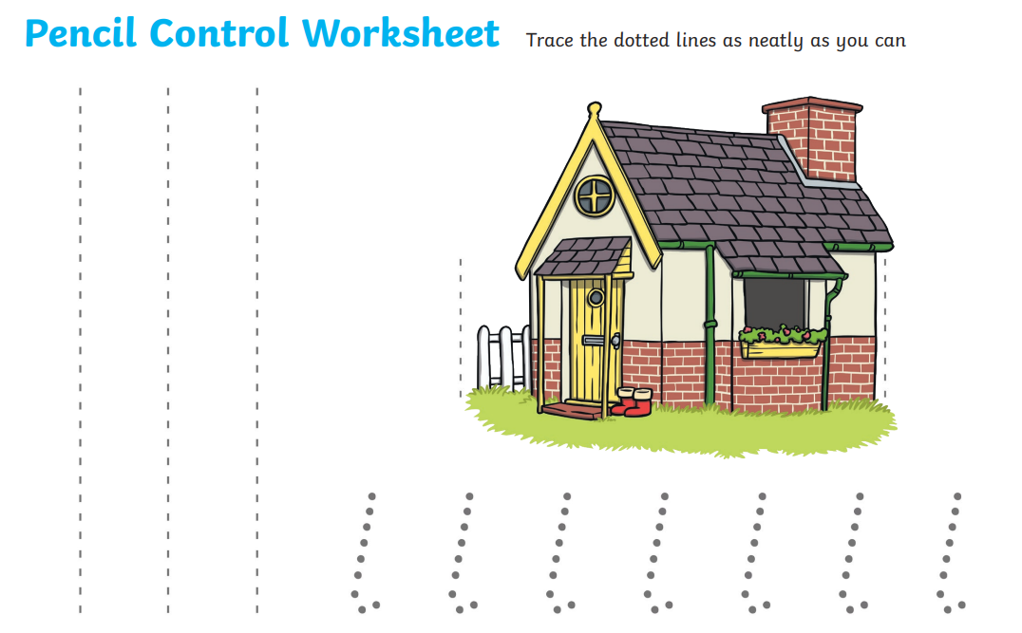 |  | Fringing:  Children to cut accurately along the lines to create fringing around the edge of their paper.  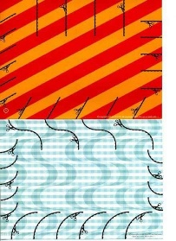  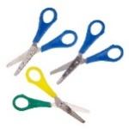  Resources:  Paper to cut snips into.  Scissors |  | Cutting:  Cut accurately and make a home for the three little pigs.
Physical – Playdough | Manipulating the dough to form Poppies  Resources:  Red playdough  Loose part items for centre of poppy e.g. conkers, buttons |  |  | Make the pigs houses out of playdough
EAD – Art / Craft | Using the Colour Red  Painting and finger printing Poppies using colour for purpose  Resources:  Poppy outline |  |  | Recycled Materials Pigs Houses  Using recycled materials to create houses for the Three Little Pigs that are waterproof.  Resources:  Range of materials  Waterproof and non-waterproof  Menu stand with science
Maths

