Weekly Plan – Autumn 1 Reception W.B. 03.11.25 Week B
Sapphire | Emerald | MONDAY |  | TUESDAY | WEDNESDAY | THURSDAY | FRIDAY
8:45 – 9.00 |  | Register /  Name recognition |  | Register /  Name recognition | Register /  Name recognition | Register /  Name recognition | Register /  Name recognition
9:00 – 9:30 |  | Ribbon Dance – Katy Perry - Firework  Change for PE |  | Dough Morning Challenge  Ribbon Dance – Katy Perry - Firework  Handwriting – model letter formation ‘i’  Phonics Level 2 – e, to, the | Dough Disco – Katy Perry - Firework  Handwriting – model letter formation ‘i’  Phonics Level 2 – u, to, the | Dough Morning Challenge  Dough Disco – Katy Perry – Firework  Handwriting – model letter formation ‘i’  Phonics Level 2 – r, to, the | Ribbon Dance – Katy Perry - Firework  Handwriting – model letter formation ‘i’  Phonics Level 2 - recap
9.30 – 9.35 |  |  |  | UOW L2 - Movement Break | UOW L2 - Movement Break | Movement Break | Movement Break
9.30 -11.30 |  | PE 9:30- 10:00  Phonics Level 2 – ck to, the  UOW – Bonfire Night L1  Handwriting – model letter formation ‘i’  Model Afternoon Challenge | Phonics Level 2 – ck to, the  PE 10:00 – 10:30  UOW – Bonfire Night L1  Handwriting – model letter formation ‘i’  Model Afternoon Challenge | Fireworks – Whole Class Attention Bucket  Discovery  WCR Fox’s Favourite Autumn – Pre Teach  UOW – Bonfire Night - L2 | Discovery  Maths – It’s Me 1,2,3 L2 | Discovery  PSED – feelings apples | PSHE Celebrating Difference - input 1  Discovery
11.30 – 12:30 |  | Go to lunch hall @ 11.20 Lunch |  | Go to lunch hall @ 11.20 Lunch | Go to lunch hall @ 11.20 Lunch | Go to lunch hall @ 11.20 Lunch | Go to lunch hall @ 11.20 Lunch
12:30 – 12:35 |  | Register / afternoon challenge |  | Register / afternoon challenge | Register / afternoon challenge | Register / afternoon challenge | Register / afternoon challenge
12:35 – 12:50 |  | Level 1 – Week 7 |  | Maths – It’s Me 1,2,3 L1 | WCR Fox’s Favourite Autumn – Retrieval | Maths – It’s Me 1,2,3 L3 | Level 1 – Week 7
 |  | UOW – Bonfire’s Burning Poem |  | Discovery | Discovery | Discovery  Library Slot | Discovery
2:15 |  | Tidy up 2:00  Snack  Home things  Assembly 2:30 |  | Tidy up  Music – 3 tapping teddies | Tidy up  Level 1 – Week 7 | Tidy up  CL – find the bear | Tidy up  WCR Fox’s Favourite Autumn – Inference
2:25 – 3.15 |  | Story Time / End of Day |  | Story Time / End of Day | Story Time / End of Day | Story Time / End of Day | Story Time / End of Day

Daily Rotational Afternoon Challenges
Bumblebees | Snails | Caterpillars | Ladybirds | Butterflies
1 - Cutting sheets  Resources:  Diwali cutting sheets | 2 – Maths Adult led cardinal/numeral – find the correct amount of conkers and match to numeral. | 3 – Bonfire picture  Resources:  Black card  Sticks  Orange/yellow/red leaves | 4 – Pencil Control & Handwriting letter formation ‘i’ Adult led  Resources:  Sheet | 5 – Level 2 phonics IWB game
5 – Level 2 phonics IWB game | 1 - Cutting sheets  Resources:  Diwali cutting sheets | 2 – Maths Adult led cardinal/numeral – find the correct amount of conkers and match to numeral. | 3 – Bonfire picture  Resources:  Black card  Sticks  Orange/yellow/red leaves | 4 – Pencil Control & Handwriting letter formation ‘i’ Adult led  Resources:  Sheet
4 – Pencil Control & Handwriting letter formation ‘i’ Adult led  Resources:  Sheet | 5 – Level 2 phonics IWB game | 1 - Cutting sheets  Resources:  Diwali cutting sheets | 2 – Maths Adult led cardinal/numeral – find the correct amount of conkers and match to numeral. | 3 – Bonfire picture  Resources:  Black card  Sticks  Orange/yellow/red leaves
3 – Bonfire picture  Resources:  Black card  Sticks  Orange/yellow/red leaves | 4 – Pencil Control & Handwriting letter formation ‘i’ Adult led  Resources:  Sheet | 5 – Level 2 phonics IWB game | 1 - Cutting sheets  Resources:  Diwali cutting sheets | 2 – Maths Adult led cardinal/numeral – find the correct amount of conkers and match to numeral.
2 – Maths Adult led cardinal/numeral – find the correct amount of conkers and match to numeral. | 3 – Bonfire picture  Resources:  Black card  Sticks  Orange/yellow/red leaves | 4 – Pencil Control & Handwriting letter formation ‘i’ Adult led  Resources:  Sheet | 5 – Level 2 phonics IWB game | 1 - Cutting sheets  Resources:  Diwali cutting sheets

Outdoor Provision Enhancements Plan
Bonfire with sticks in the woodlands  Resources:  Sticks from woodlands | Autumn dishes  Resources:  Pictures of autumn dishes e.g. soup, hot choc etc. | EAD / UOW / physical / Literacy – Chalk firework patterns on the floor.  Resources:  chalk | Fireworks playing on CD player  Resources:  CD player  Firework CD | Paint splatting on the easel  Resources:  Powder paint  easel

Area to enhance | Indoor Provision Enhancements Plan
Area to enhance | Monday | Tuesday |  | Wednesday |  |  | Thursday |  |  | Friday
Mark Making | Firework mark making  Resources:  Mark making pattern cards  Trays with sand/glitter in with a coloured background
Phonics | Hook a duck  Resources:  Duck cut outs with different sounds/ck words on.  Magnets  Paperclips  Children ‘hook a duck’ using the magnet and paperclip. If they read the sound/word correctly then they can keep the duck. | I spy the letter /e/ sheet |  | Design an umbrella  Children use umbrella template, practice writing u and U and decorate. |  |  | Robot initial sounds game.  Children robot talk various pictures. If it begins with /r/ then they can post it in the robots mouth. |  |  | To/the??
Physical – Fine Motor | Fringing:  Children are to cut along the lines to create fringing around the edge of their paper.  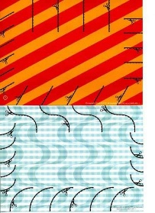  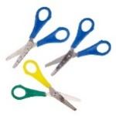  Resources:  Paper to cut snips into.  Scissors |  |  | Cherrio towers:  Children are to roll a dice and then thread the correct number of cherrios onto spaghetti towers.  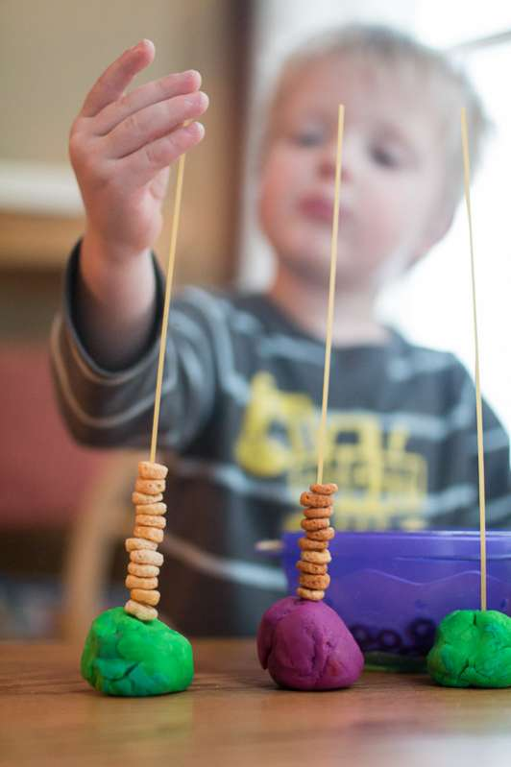  Resources:  Cherrios.  Spaghetti/pipe cleaners  Dice  Challenge:  Use hand mats to isolate first one hand and then the other. |  |  | Autumn Leaves:  Children are hole punch paper or real leaves and then if time thread wool through the holes. Keep these safe to go in children funky fingers books.  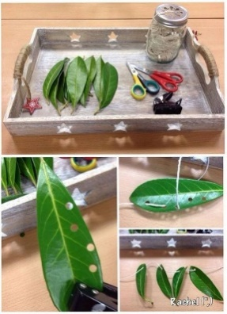  Resources:  Paper or real leaves.  Hole punches.  String or wool.  Challenge:  To thread through holes made. |  |  | Pegs onto cards:  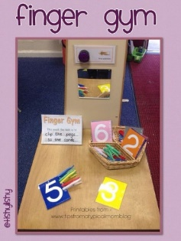  Children are to peg the correct number of pegs (large - easier, small trickier onto each number card.  Resources:  Number cards or tiles. Pegs large and small  Challenge:  Choice of size peg used.
Physical – Playdough | 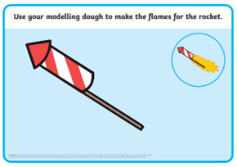  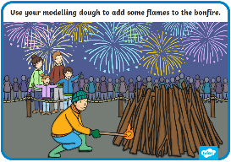  Resources: Firework/bonfire play doh mats |  |  |  |  | Making poppies with play doh?
EAD – Art / Craft | Painting diva lamps  Resources:  Clay diva lamps  Paintbrushes  Different coloured paints  Glitter |  | 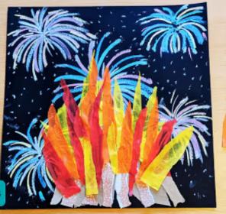  Tissue paper bonfires  Resources:  Black paper/card  Red/orange/yellow tissue paper  Brown strips of paper  Chalks |  |  |  |  | 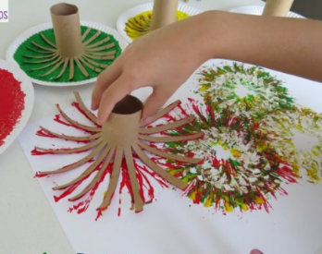  Toilet roll firework painting  Resources:  Toilet rolls  Different coloured paints  Paper – white/black  Glitter
Maths | 1, 2, 3 Maths sorting activity  Resources:  Sorting grid and cards to sort |  |  |  | Subitising game on board |  |  |  | Dominoes
kt

CL Find the bear
Resources | Teddy Bear
Intent | Develop listening skills, develop pronunciation, take turns, understand why questions, use longer sentences.
Implement | Take one child aside while a teddy bear is hidden somewhere in the room. Tell the other children they are going to guide the child to the teddy by singing louder as the child gets closer to, or quietly as the child moves further away from the teddy until the child finds the Teddy, taking turns to find the bear. Did you find that easy or hard, why?
Impact | Did children sing high and low to guide the child who was looking for the bear?  Do children understand short sentences?

PSED | Feelings Apples
Resources | 2 Apples (1 bruised inside), knife
Development Matters Statements | Express their feelings and consider the feelings of others, identify and moderate their own feelings socially and emotionally, think about the perspectives of others (PSED), develop social phrases, articulate their ideas and thoughts in well-formed sentences (COMM & LANG).
Characteristics of Effective Learning | Finding out and exploring; playing with what they know; being willing to ‘have a go’; being involved and concentrating; keep on trying; enjoying achieving what they set out to do; having their own ideas; making links; choosing ways to do things.
Plan | Show the children 2 apples. We are going to say mean things to one of the apples. Pick the one that you know is bruised and ask the children to take turns to say a mean thing to the apple. Cut open the apples and show how the hurtful things that they have said have hurt the apple inside. Explain that is called bullying and is just as bad as hitting someone.
Success Criteria: Can children recognise that mean words have a negative effect on others? |  | Key vocabulary: sad, hurt, bullying, bully, poor, bad, mean, choice, consequence, negative

UOW | Bonfire Night L1
Resources | Vocabulary to go through – link to pdf and also printout
Plan | Watch video about Bonfire Night - https://www.bbc.co.uk/cbeebies/watch/my-first-festivals-bonfire-night  https://www.youtube.com/watch?v=Uw5S40nf5UM
 |  | Key vocabulary: firework, explode, whoosh, fire, bang, whistle, crackle, pop, fire, sparkle, sparkler, bonfire, oooh, aaah, wow, zoom, fizz

UOW | Bonfire Night L2
Resources | Vocabulary to go through – link to pdf and also printout
Plan | Do the movement breaks  https://www.bbc.co.uk/teach/school-radio/articles/zvvht39
 |  | Key vocabulary: firework, explode, whoosh, fire, bang, whistle, crackle, pop, fire, sparkle, sparkler, bonfire, oooh, aaah, wow, zoom, fizz

UOW | Seasonal Changes
Resources | Vocabulary to go through the seasonal vocabulary  Sheet
Plan
 |  | Key vocabulary:

Name | 3 Tapping Teddies
Resources | Drum or tambour, 2 different sized teddies
Development Matters Statements | Sing in a group or on their own, increasingly matching the pitch and following the melody (EAD), understand how to listen carefully and why listening is important, learn rhymes/poems/songs (COMM & LANG)
Skills | Concentration and listening, sound awareness
Plan | Sing hello song together while clapping - Hello (child’s name), hello (child’s name) hello everyone it’s time to say hello (wave). Repeat until you have said all the child’s names.  In a very quiet voice (whisper) and tap the drum very lightly and chant: “Are you ready, are you steady, here’s a tiny tapping teddy. Tap, tap, tap, tap, tiny tapping teddy.” Ask the children to sing along with you repeating.  Progress to a louder voice and tap louder on the drum (for the middle-sized teddy). “Are you ready, are you steady here’s a bigger tapping teddy. Tap, tap, tap, tap, bigger tapping teddy” Ask the children to sing along with you repeating.  Progress to a louder, booming voice and make loud bangs on the drum ““Are you ready, are you steady here’s a huge tapping teddy. Tap, tap, tap, tap, huge tapping teddy” Ask the children to sing along with you repeating.  Hold up each bear and tap according to size  Tap, tap, tap, tap tiny tapping teddy  Tap, tap, tap, tap, bigger tapping teddy  Tap, tap, tap, tap, huge tapping teddy (changing voices and volume of taps on drums. Children can participate with one finger tapping, 2 fingers tapping and whole hand claps.  What did you notice about the way the song was sung each time? Why did my taps change each time?  Goodbye song – Goodbye, so long my friends, goodbye, so long, farewell, we’ll see you soon my friends again, so goodbye, so long, farewell.
Success Criteria: Can children pitch-match and follow a melody? |  | Key vocabulary: quiet, loud, slow, fast, high, low, tiny, bigger, huge, tapping, clapping

