Weekly Plan – Autumn 1 Reception W.B. 20.10.25 Week A
Sapphire | Emerald | MONDAY |  | TUESDAY | WEDNESDAY | THURSDAY | FRIDAY
8:45 – 9.00 |  | Register /  Name recognition |  | Register /  Name recognition | Register /  Name recognition | Register /  Name recognition | Register /  Name recognition
9:00 – 9:30 |  | Ribbon Dance – Katy Perry - Firework  Change for PE |  | Dough Morning Challenge  Ribbon Dance – Katy Perry - Firework  Phonics Level 2 - o | Dough Disco – Katy Perry - Firework  Phonics Level 2 – c | Dough Morning Challenge  Dough Disco – Katy Perry - Firework  Phonics Level 2 - k | Ribbon Dance – Katy Perry - Firework  Phonics Level 2 - recap
9.30 – 9.35 |  |  |  | Movement Break | Movement Break | Movement Break | Movement Break
9.30 -11.30 |  | PE 9:30- 10:00  Phonics Level 2 – g  Rama and Sita Story  Model Afternoon Challenge | Phonics Level 2 – g  PE 10:00 – 10:30  Rama and Sita Story  Model Afternoon Challenge | Diwali – Whole Class Attention Bucket  Discovery  WCR The Best Diwali Ever – Pre Teach  UOW - Diwali - L2 | Discovery  Maths – Talk about measure and pattern L5 | Mark Making – Watch Firework Display and Draw Firework Patterns  Discovery  PSED – Hula Hoop Pass | PSHE - input 6  Discovery
11.30 – 12:30 |  | Go to lunch hall @ 11.20 Lunch |  | Go to lunch hall @ 11.20 Lunch | Go to lunch hall @ 11.20 Lunch | Go to lunch hall @ 11.20 Lunch | Go to lunch hall @ 11.20 Lunch
12:30 – 12:35 |  | Register / afternoon challenge |  | Register / afternoon challenge | Register / afternoon challenge | Register / afternoon challenge | Register / afternoon challenge
12:35 – 12:50 |  | Level 1 – Week 6 All About Me |  | Maths – Talk about measure and pattern L4 | WCR The Best Diwali Ever – Retrieval | Maths – Talk about measure and pattern L6 | Level 1 Phonics - Week 5 Things I like to Do Weekly
 |  | UOW – Diwali L1 |  | Discovery | Discovery | Discovery  Library Slot | Discovery
2:15 |  | Tidy up 2:00  Snack  Home things  Assembly 2:30 |  | Tidy up  Mrs Mehta – Mehndi pattern  Music – Different Voices | Tidy up  Level 1 Phonics - Week 5 Things I like to Do Weekly | Tidy up  CL – Duck Duck Goose | Tidy up  WCR The Best Diwali Ever – Inference
2:25 – 3.15 |  | Story Time / End of Day |  | Story Time / End of Day | Story Time / End of Day | Story Time / End of Day | Story Time / End of Day

Daily Rotational Afternoon Challenges
Bumblebees | Snails | Caterpillars | Ladybirds | Butterflies
1 - Cutting sheets  Resources:  Diwali cutting sheets | 2 – Colouring Rangoli Patterns  Resources:  Rangoli pattern sheet | 3 – Retell the story of Rama and Sita (Adult Led)  Resources:  Character cut outs stick puppets | 4 – Pencil Control  Resources:  Diwali Sheet | 5 – Maths – create a repeating pattern (Adult Led)  Resources:  Range of shapes and jewels.  Questions:  Can you add to your friends pattern?
5 – Maths – create a repeating pattern (Adult Led)  Resources:  Range of shapes and jewels.  Questions:  Can you add to your friends pattern? | 1 - Cutting sheets  Resources:  Diwali cutting sheets | 2 – Colouring Rangoli Patterns  Resources:  Rangoli pattern sheet | 3 – Retell the story of Rama and Sita (Adult Led)  Resources:  Character cut outs stick puppets | 4 – Pencil Control  Resources:  Diwali Sheet
4 – Pencil Control  Resources:  Diwali Sheet | 5 – Maths – create a repeating pattern (Adult Led)  Resources:  Range of shapes and jewels.  Questions:  Can you add to your friends pattern? | 1 - Cutting sheets  Resources:  Diwali cutting sheets | 2 – Colouring Rangoli Patterns  Resources:  Rangoli pattern sheet | 3 – Retell the story of Rama and Sita (Adult Led)  Resources:  Character cut outs stick puppets
3 – Retell the story of Rama and Sita (Adult Led)  Resources:  Character cut outs stick puppets | 4 – Pencil Control  Resources:  Diwali Sheet | 5 – Maths – create a repeating pattern (Adult Led)  Resources:  Range of shapes and jewels.  Questions:  Can you add to your friends pattern? | 1 - Cutting sheets  Resources:  Diwali cutting sheets | 2 – Colouring Rangoli Patterns  Resources:  Rangoli pattern sheet
2 – Colouring Rangoli Patterns  Resources:  Rangoli pattern sheet | 3 – Retell the story of Rama and Sita (Adult Led)  Resources:  Character cut outs stick puppets | 4 – Pencil Control  Resources:  Diwali Sheet | 5 – Maths – create a repeating pattern (Adult Led)  Resources:  Range of shapes and jewels.  Questions:  Can you add to your friends pattern? | 1 - Cutting sheets  Resources:  Diwali cutting sheets

Outdoor Provision Enhancements Plan
EAD / UOW – Powder painting outside on tuff tray to create their own Rangoli Pattern.  Resources:  Powder paints – variety of colours.  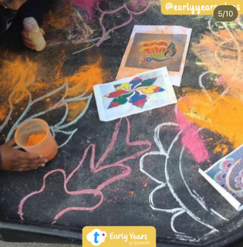 | EAD / UOW – Tuff tray of rice and sand to create their own Rangoli Pattern.  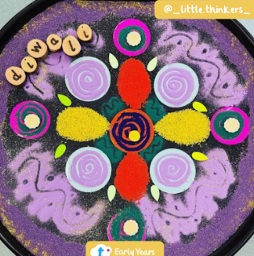 | EAD / UOW / physical / Literacy – Chalk markings to make patterns on the floor. | Physical – Rangoli tuff tray, with pasta and poms poms. Children to put these on the pre-drawn pattern.  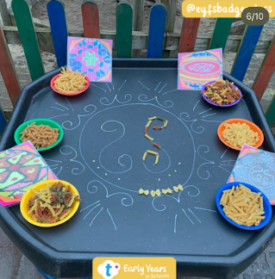 | EAD / UOW – Cottage Jewellery Shop  What ideas can the children come up with from this… create a shop, make jewellery.  Resources:  Provide lots of colourful scarfs for dressing up.  Pasta with holes  String
Physical / UOW – Look at traditional buildings in India and talk about what you like about them. Use construction blocks to build the temples.  Questions to ask:  What do you notice? Can you work in groups to build some of these buildings? | Mud kitchen – sweet shop  Resources:  Pictures of Hindu sweets that are eaten at Diwali time. | Physical – Brooms at the ready and sweeping – adults modelling cleaning in preparation for Diwali.

Area to enhance | Indoor Provision Enhancements Plan
Area to enhance | Monday | Tuesday | Wednesday |  | Thursday | Friday
Mark Making | Write invitations to the celebration and thank you cards for gifts.  Resources:  Writing template for invitation  Mark Making tools  Stickers |  |  |  | Make ‘Happy Diwali’ cards to share with family and friends.  Resources:  Scissors  Range of writing tools  Happy Diwali Templates  Folded paper – model this
Phonics | Sorting objects  Objects or toys beginning with 'g', e.g. goat, gorilla, gull, glasses, green, gate, grass, glue sticks, goose, gloves, grasshopper, grapes, globe, placed in tray.  ‘What is this? Can you hear the sound ‘g’ anywhere in this word?’  ‘Robot-talk this word slowly to hear if it has ‘g’ at the beginning or at the end.’  ‘Can we help Gabi gather and sort the things from her garden? | Orange Juice ‘Gloop’ letter formation  Practise writing the sound ‘o’ on its own and in words. | Curly Caterpillar Chains  Invite the children to write the ‘c’ on the strips using different coloured pencils. Encourage them to use the correct tripod pencil grip. Can they say “c, c, c,” as they write on the strips?  Once the children have completed their strips (they can make as many as they want), stick the strips together to make a curly caterpillar paper chain.  The children can decorate the head to finish it off.  Who will make the longest c, c, c curly caterpillar? |  | Kites  Make a kite  Children to practise letter formation ‘k’ | Game including this weeks sounds ‘g,o,c,k’. Both capital and lowercase letters. 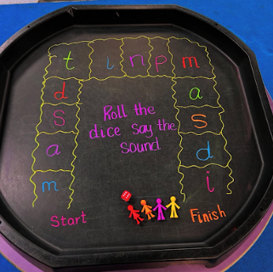
Physical – Fine Motor | Diva Lamps  Children to make a diva lamps  Resources:  Clay  Clay tools  Tea lights to ensure they make a Diva Lamp fit for purpose. | Mehndi Patterns Pencil Control  Resources:  Control sheet for them to follow | Spiral Dabbers  Children use a dabber to dab around a pre drawn spiral shape.  Resources:  Dabbers.  Pre drawn spirals.  Challenge:  Try swapping hands  that the dabber is held  in. |  | Gift Wrapping  Set up a gift-wrapping station for children to practise using fine motor skills to wrap up some Diwali gifts.  Resources:  boxes, paper, tape, ribbons, and scissors | Pattern Dice  Children roll pattern dice and then draw the pattern onto their paper.  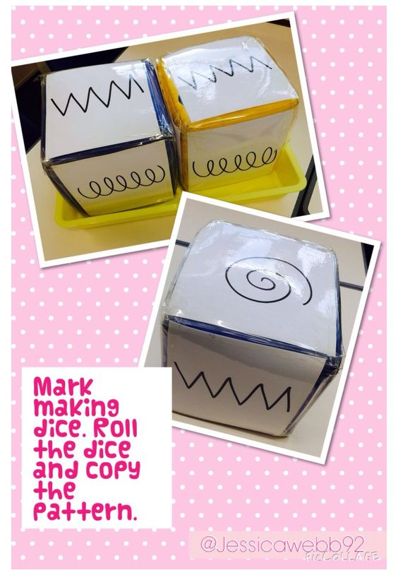  Resources:  Pattern dice, paper, crayons.
Physical – Playdough | Diva lamps  Resources:  White playdough , Clay tools, Beads, Example of real Diva lamps  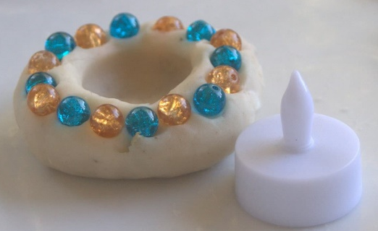
EAD – Art / Craft | Create a collaborative firework pattern.  Resources:  Paint  Tinfoil  Paintbrushes  Dab sponges |  |  | Create a collaborative Rangoli pattern  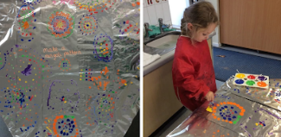  Resources:  Paint  Tinfoil  Paintbrushes  Dab sponges
Maths | Rangoli Shape Pattern Sorting and Matching  Resources:  Shapes 2D  Printout of Rangoli Pattern |  |  | Diwali Rangoli Patterns  Resources:  Numicon  Printout of Rangoli Pattern
EAD – Role play | Home corner – Diwali decorated  Resources:  Diwali & Hindu props, decorations, dressing up.

CL - Duck duck goose
Resources | None
Intent | Develop listening skills, take turns, develop pronunciation, understand why questions, use longer sentences, represent a point of view, hold a conversation.
Implement | All the players, except the first person who is ‘goose’, sit in a circle. The first person walks around the circle, tapping each player on the head, saying ‘duck’ each time until he decides to tap someone and say “goose.” That person then becomes the goose and runs after the first person, trying to tag him before he can take his seat. Did you like being the goose? Why/Why not?
Impact | Can children say duck and goose?  Can children hear when the goose says goose?

PSED | Hula Hoop Pass
Resources | Hula hoop
Development Matters Statements | Build constructive and respectful relationships (PSED), develop overall body strength and co-ordination (PD), use language of position, route and location (M).
Characteristics of Effective Learning | Keep trying when things are difficult, begin to correct mistakes, show goal-directed behaviour, respond to new experiences.
Plan | All stand in a circle, have a large hula hoop rested in yours and the child next to hand. The idea of the game is to move the hoop around the circle, without letting go of hands.
Success Criteria: Can children follow instructions? Can children work together to achieve a common goal? |  | Key vocabulary: towards, forwards, backwards, left, right, around, over, through, down, face, hula hoop, go, touch, move, pass, circle, next, before, after, turn

Music | Different voices
Resources | None
Development Matters Statements | Listen attentively, move to and talk about music, expressing their feelings and responses, sing in a group increasingly matching the pitch and following the melody (EAD), understand how to listen carefully and why listening is important (COMM & LANG)
Skills | Body awareness, listening
Plan | Sing hello song together while clapping - Hello (child’s name), hello (child’s name) hello everyone it’s time to say hello (wave). Repeat until you have said all the child’s names.  Chant: Have you got your talking voice? The teacher says the phrase (to the rhythm “tete, tete, tete, ta”), and the children reply using their talking voices, Yes I Have, Yes I Have! (“tete, ta , tete, ta”). Get the children to explore different voices by changing yours. E.g. “grumpy voice”, “whispering voice”, “quiet voice”, “loud voice”, (ensure children loud but NOT shouting voice….make sure they can distinguish between loud and shouting, “posh voice”, “Daddy Bear voice”, “Mummy Bear voice”, Baby Bear voice” “singing voice”.  What is your idea/suggestion? How can we change our voice?  Goodbye song – Goodbye, so long my friends, goodbye, so long, farewell, we’ll see you soon my friends again, so goodbye, so long, farewell.
Success Criteria: Can children copy voice sounds? Can children begin to make up their own sounds? |  | Key vocabulary: listen, hear, choice, up, down, quiet, soft, loud, talk, sing, whisper

UOW | Diwali L1
Resources | Clay, clay tools
Plan | Watch Preparing for Diwali - https://www.bbc.co.uk/cbeebies/watch/lets-celebrate-diwali  Model making Diva Lamps
 |  | Key vocabulary: light, festival, lantern, gifts, Diva lamp, Hindus, jewellery, fireworks, mehndi, rangoli, celebration

UOW | Diwali L2
Resources | Clay, clay tools
Plan | Watch this to see what India looks like at Diwali https://www.youtube.com/watch?v=mPwmXRws7FA  Explain to the children that the cottage will be a Jewellery Shop and the Mud Kitchen will be a Sweet Shop. Model how to use the areas.
 |  | Key vocabulary: light, festival, lantern, gifts, Diva lamp, Hindus, jewellery, fireworks, mehndi, rangoli, celebration

