Weekly Plan – Autumn 1 Reception W.B. 13.10.25 Week A
Sapphire | Emerald | MONDAY |  | TUESDAY | WEDNESDAY | THURSDAY  Library | FRIDAY
8:45 – 9.00 |  | Register /  Name recognition |  | Register /  Name recognition | Register /  Name recognition | Register /  Name recognition | Register /  Name recognition
9:00 – 9:30 |  | Dough Disco – Spooky Scary Skeletons  Change for PE |  | Dough Morning Challenge  Ribbon Dance – Spooky Scary Skeletons  Level 2 - n | Dough Disco – Spooky Scary Skeletons  Level 2 - m | Dough Morning Challenge  Ribbon Dance – Spooky Scary Skeletons  Level 2 - d | Dough Disco – Spooky Scary Skeletons  Level 2 - recap
9.30 – 9.35 |  |  |  | Movement Break | Movement Break | Movement Break | Movement Break
9.30 -11.30 |  | PE 9:30- 10:00  Level 2 – i  Story  Model Afternoon Challenge | Level 2 – i  PE 10:00 – 10:30  Story  Model Afternoon Challenge | Discovery  WCR Funnybones – Pre Teach | Discovery  Level 1 Phonics - Week 5 Things I like to Do Weekly | Discovery  PSED – Story Hats | PSHE - input 5  Discovery
11.30 – 12:30 |  | Go to lunch hall @ 11.20 Lunch |  | Go to lunch hall @ 11.20 Lunch | Go to lunch hall @ 11.20 Lunch | Go to lunch hall @ 11.20 Lunch | Go to lunch hall @ 11.20 Lunch
12:30 – 12:35 |  | Register / afternoon challenge |  | Register / afternoon challenge | Register / afternoon challenge | Register / afternoon challenge | Register / afternoon challenge
12:35 – 12:50 |  | Level 1 Phonics - Week 5 Things I like to Do Weekly |  | Maths – Talk about measure and pattern L1 | Maths – Talk about measure and pattern L2 | Maths – Talk about measure and pattern L3 | Level 1 Phonics - Week 5 Things I like to Do Weekly
 |  | Discovery |  | Discovery | Discovery | Discovery | Discovery
2:15 |  | Tidy up 2:00  Snack  Home things  Assembly 2:30 |  | Tidy up  Music – Classical Drawing | Tidy up  WCR Funnybones – Retrieval | Tidy up  CL – Guess the Instrument | Tidy up  WCR Funnybones – Inference  Try pumpkin soup
2:25 – 3.15 |  | Story Time / End of Day |  | Story Time / End of Day | Story Time / End of Day | Story Time / End of Day | Story Time / End of Day

Daily Rotational Afternoon Challenges
Bumblebees | Snails | Caterpillars | Ladybirds | Butterflies
1 - Cutting sheets - funnybones | 2 - Autumnal painting  Resources:  Cotton buds  Autumnal coloured paint | 3 – Make an autumn tree  Resources:  Pre made sheet. | 4 – Puzzles and board games | 5 – Connecting construction parts together.  Resources:  Construction e.g. straws, stickle bricks, clixi
5 – Connecting construction parts together.  Resources:  Construction e.g. straws, stickle bricks, clixi | 1 - Cutting sheets - funnybones | 2 - Autumnal painting  Resources:  Cotton buds  Autumnal coloured paint | 3 – Make an autumn tree  Resources:  Pre made sheet. | 4 – Puzzles and board games
4 – Puzzles and board games | 5 – Connecting construction parts together.  Resources:  Construction e.g. straws, stickle bricks, clixi | 1 - Cutting sheets - funnybones | 2 - Autumnal painting  Resources:  Cotton buds  Autumnal coloured paint | 3 – Make an autumn tree  Resources:  Pre made sheet.
3 – Make an autumn tree  Resources:  Pre made sheet. | 4 – Puzzles and board games | 5 – Connecting construction parts together.  Resources:  Construction e.g. straws, stickle bricks, clixi | 1 - Cutting sheets - funnybones | 2 - Autumnal painting  Resources:  Cotton buds  Autumnal coloured paint
2 - Autumnal painting  Resources:  Cotton buds  Autumnal coloured paint | 3 – Make an autumn tree  Resources:  Pre made sheet. | 4 – Puzzles and board games | 5 – Connecting construction parts together.  Resources:  Construction e.g. straws, stickle bricks, clixi | 1 - Cutting sheets - funnybones

https://www.youtube.com/watch?v=LHtlvxIoxn4
Pattern Tracing

Outdoor Provision Plan
UOW - Set up a doctor’s role play with stethoscopes, bandages and models of bones – cottage. | UOW/PSED - Build a giant shared skeleton sculpture outdoors using crates, pipes, logs and tyres. Children can work in teams and choose parts to build. | PD- Use tweezers to move small bones or cotton buds in trays. Masking tape over tuff tray. | Sand Pit - Hide bones, pasta, or x-rays in black sand or dyed rice—add brushes to excavate Use sieves and tweezers for a spooky ‘dig site’ experience | “Wash the bones” activity using toothbrushes and trays of bubbles. By the sandpit!

Area to enhance | Indoor Provision Plan
Area to enhance | Monday | Tuesday | Wednesday |  | Thursday | Friday
Mark Making | Make a Funnybones book  Resources:  Pre made books  Pictures from story  Range of writing tools
Phonics | i’ Izzy the Insect in Indigo Ink Practise forming ‘i’ and orally segmenting words containing ‘i’.  ‘i’ Izzy Insect’s Busy Blending Practise blending for reading. | I Spy the letter ‘n’ / sound ‘n’ | ‘m’ Meatball Mountain Practise forming ‘m’ and orally segmenting words containing ‘m’.  ‘m’ Meatball Memory Match Practise blending to read CVC words to match to pictures. |  | ‘d’ bingo dabber letter formation | Pot of conkers  Write inmd on conkers and sort them into the matching letter pot.
Physical – Fine Motor | Threading:  Children are to thread either wooden or plastic beads onto a lace or cut up straws onto string (trickier as finer).  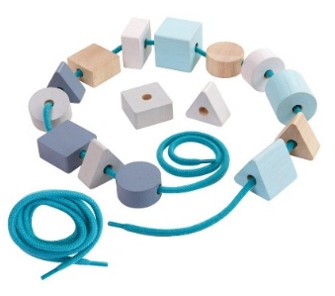  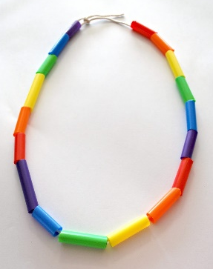  Resources:  Wooden or plastic beads and laces.  Cut up straws and string.  Challenge:  Choice of resource used. | Threading:  Children are to thread either wooden or plastic beads onto a lace or cut up straws onto string (trickier as finer).  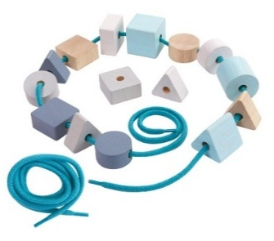  Resources:  Wooden or plastic beads and laces.  Cut up straws and string.  Challenge:  Choice of resource used. | Threading:  Children are to thread either wooden or plastic beads onto a lace or cut up straws onto string (trickier as finer).  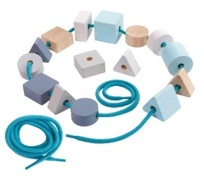  Resources:  Wooden or plastic beads and laces.  Cut up straws and string.  Challenge:  Choice of resource used. |  | Monster Feeding:  Children are to each have a tennis ball with a slit inside they are to feed their monster ball pieces of pasta either using their fingers to pick up the pasta or a teaspoon (trickier)  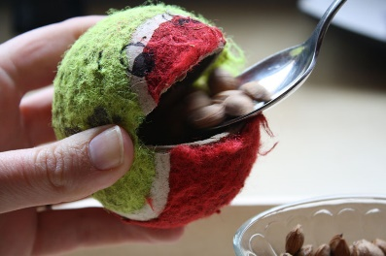  Resources:  Tennis balls with pre made slits.  Bowls of pasta.  Teaspoons.  Challenge:  Choice of fingers or spoon used.  How many can you do in a minute? | Monster Feeding:  Children are to each have a tennis ball with a slit inside they are to feed their monster ball pieces of pasta either using their fingers to pick up the pasta or a teaspoon (trickier)  Resources:  Tennis balls with pre made slits.  Bowls of pasta.  Teaspoons.  Challenge:  Choice of fingers or spoon used.  How many can you do in a minute?
Physical – Playdough | Skeleton playdough  Resources:  White playdough for joints  Cotton buds  Straws  Laminated black paper
EAD – Art / Craft | Funnybones scissor skills/connecting  Resources:  Scissors  Funnybones sheet  Ways join/connect - split pins, glue |  |  | Use shape cotton buds or white straws to create simple skeletons on paper. Compare long and short bones using sticks, tubes or cardboard.  Resources:  Cotton buds  Straws  Black paper
Maths | Matching puzzles  Resources:  Print out of pictures for children to sort - funnybones
EAD – Role play | Home corner

Music | Classical painting
Resources | Paint, paper, brushes (varying sizes), classical music
Development Matters Statements | Listen attentively, move to and talk about music, expressing their feelings and explore use and refine a variety of artistic effects to express their ideas and feelings (EAD), understand how to listen carefully and why listening is important (COMM & LANG)
Skills | Represent ideas, listening
Plan | Sing hello song together while clapping - Hello (child’s name), hello (child’s name) hello everyone it’s time to say hello (wave). Repeat until you have said all the child’s names.  Put on some classical music. Ask the children to listen to the music and draw along to it?  Tell me about your drawing? How did the music make you feel when you were painting? What did the paintbrush do? What colours did you choose and why? Did you end up painting fast or slow – why?  Goodbye song – Goodbye, so long my friends, goodbye, so long, farewell, we’ll see you soon my friends again, so goodbye, so long, farewell.
Success Criteria: Can children express their thoughts and feelings through music? |  | Key vocabulary: big, small, marks, colours, why, feel, emotions, speed -fast and slow, relaxed, steady, loud, quiet

PSED | Story Hats
Resources | Story telling hat.
Development Matters Statements | Develop storylines in their play (EAD), understand how to listen carefully and why listening is important, learn new vocabulary, connect one idea to another using a range of connectives (COMM & LANG).
Characteristics of Effective Learning | Making links between ideas, make independent choices
Plan | Explain we are going to create a story together, start the story and each child can add a little bit as they go around wearing the hat. Are you happy with the story?
Success Criteria: Can children continue an idea to add to a story? |  | Key vocabulary: continue, add, next, before, then, after, story, happen, idea, choice

CL - Guess the instrument
Resources | Musical instruments
Intent | Pay attention to more than one thing at a time, develop listening skills, use a wider range of vocabulary, distinguish between sounds.
Implement | Check children know the names of the instruments by saying hello to each instrument. Hide one then describe one of the instruments but do not tell the children it’s name. Do you know which instrument makes that sound? Can you make the sound the instrument makes? Children take turns to be the one who describes the instrument if they wish to. Repeat with different instruments. This activity can be done outside in a quiet area as well as inside.
Impact | Can children repeat; hello and instrument names?  Can children guess which instrument it might be?  Can children attempt to make noises the instruments make?  Can children describe an instrument?

