Weekly Plan – Autumn 1 Reception W.B. 06.10.25 Week A
Sapphire | Emerald | MONDAY |  | TUESDAY | WEDNESDAY | THURSDAY  Library | FRIDAY
8:45 – 9.00 |  | Register /  Name recognition |  | Register /  Name recognition | Register /  Name recognition | Register /  Name recognition | Register /  Name recognition
9:00 – 9:30 |  | Dough Disco – PJ & Duncan – Let’s Get Ready to Rumble  Change for PE |  | Dough Disco – PJ & Duncan – Let’s Get Ready to Rumble  Level 2 – a | Dough Disco – PJ & Duncan – Let’s Get Ready to Rumble  Level 2 – t | Dough Disco – PJ & Duncan – Let’s Get Ready to Rumble  Level 2 - p | Dough Disco – PJ & Duncan – Let’s Get Ready to Rumble  Level 2 – satp recap
9.30 – 9.35 |  |  |  | Movement Break | Movement Break | Movement Break | Movement Break
9.30 -11.30 |  | PE 9:30- 10:00  Level 2 - s  Story  UOW – pumpkins / Halloween  EAD – colour mixing to make orange  Model Afternoon Challenge | Level 1 Week 4 – Pets  PE 10:00 – 10:30  Story  UOW – pumkins / Halloween  EAD – colour mixing to make orange  Model Afternoon Challenge | Discovery  WCR Pumpkin Soup – Pre Teach | Story and Game with Amy and Sonia 9:20-9:50 Team Meeting  Discovery  Level 1 Week 4 – Pets | Discovery  PSED – Treasure | PSHE - input 4  Discovery  Level 1 Week 4 – Pets
11.30 – 12:30 |  | Go to lunch hall @ 11.20 Lunch |  | Go to lunch hall @ 11.20 Lunch | Go to lunch hall @ 11.20 Lunch | Go to lunch hall @ 11.20 Lunch | Go to lunch hall @ 11.20 Lunch
12:30 – 12:35 |  | Register / afternoon challenge |  | Register / afternoon challenge | Register / afternoon challenge | Register / afternoon challenge | Register / afternoon challenge
12:35 – 12:50 |  | Level 1 Week 4 – Pets |  | Maths – Match Sort and Compare L5  Months of Year | Maths – Match Sort and Compare L6  Days of the Week | Maths – Match Sort and Compare L7  5 little ducks | Subitising – dice game  Show me this many fingers
 |  | Discovery |  | Discovery | Discovery | Discovery | Discovery
2:15 |  | Tidy up 2:00  Snack  Home things  Assembly 2:30 |  | Tidy up  Music - Where is…? | Tidy up  WCR Pumpkin Soup – Retrieval | Tidy up  CL – Nature Walk  Level 1 Week 4 – Pets | Tidy up  WCR Pumpkin Soup – Inference  Try pumpkin soup
2:25 – 3.15 |  | Story Time / End of Day |  | Story Time / End of Day | Story Time / End of Day | Story Time / End of Day | Story Time / End of Day

Daily Rotational Afternoon Challenges
Bumblebees | Snails | Caterpillars | Ladybirds | Butterflies
1 - Cutting sheets | 2 – Making hedgehogs out of playing  Resources:  Brown playdough  Matchsticks  Googly eyes | 3 – Colour mixing to make orange  Resources:  Yellow and red pain  Colour mixing poster | 4 – Pattern Control on clipboards | 5 – Interactive game on whiteboard  Level 1 phonics
5 – Interactive game on whiteboard  Level 1 phonics | 1 - Cutting sheets | 2 – Making hedgehogs out of playing  Resources:  Brown playdough  Matchsticks  Googly eyes | 3 – Colour mixing to make orange  Resources:  Yellow and red pain  Colour mixing poster | 4 – Pattern Control on clipboards
4 – Pattern Control on clipboards | 5 – Interactive game on whiteboard  Level 1 phonics | 1 - Cutting sheets | 2 – Making hedgehogs out of playing  Resources:  Brown playdough  Matchsticks  Googly eyes | 3 – Colour mixing to make orange  Resources:  Yellow and red pain  Colour mixing poster
3 – Colour mixing to make orange  Resources:  Yellow and red pain  Colour mixing poster | 4 – Pattern Control on clipboards | 5 – Interactive game on whiteboard  Level 1 phonics | 1 - Cutting sheets | 2 – Making hedgehogs out of playing  Resources:  Brown playdough  Matchsticks  Googly eyes
2 – Making hedgehogs out of playing  Resources:  Brown playdough  Matchsticks  Googly eyes | 3 – Colour mixing to make orange  Resources:  Yellow and red paint  Colour mixing poster | 4 – Pattern Control on clipboards | 5 – Interactive game on whiteboard  Level 1 phonics | 1 - Cutting sheets

Outdoor Provision Plan
Pasta sorting and comparing into different trays/types of pasta | Potion making | Autumn tuff tray set up  Resources:  Magnifying glasses  Autumnal leaves, conkers, sticks  Clipboards  Autumn books | Big art  Resources:  Powder paint(red, brown yellow)  Easel  Paintbrushes  Mats  Clipboards | Conker Smash  Resources:  Hammers  Conkers in tuff tray

Area to enhance | Indoor Provision Plan
Area to enhance | Monday | Tuesday | Wednesday | Thursday | Friday
Mark Making | Create a potion, write a list of ingredients.  Resources:  Potion pictures  Example in menu stand
Phonics | ‘s’ Snake Paint  Practise forming ‘s’ and orally segmenting words containing ‘s’.  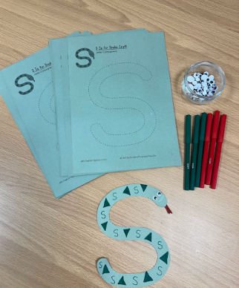 | ‘a’ Apple Stamps  Practise forming ‘a’.  ‘a’ Ant Adventure  Practise hearing the sound ‘a’ at the beginning of words.  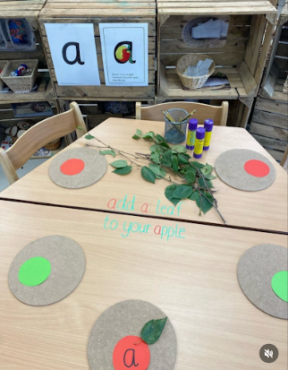 | ‘t’ Ties  Practise forming ‘t’.  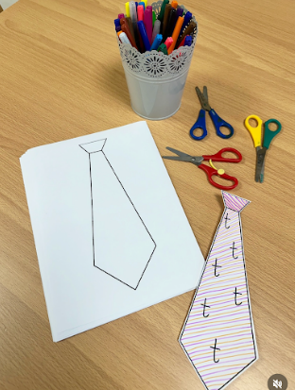 | ‘p’ Pasta of the ‘p’s  Practise forming ‘p’. | 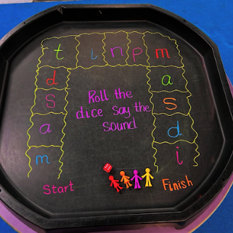
Physical – Fine Motor | Making Chains.  Children choose to either make a chain using the plastic links or paper clips (trickier).  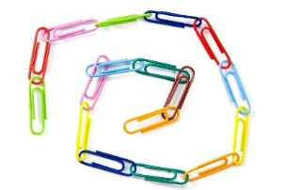  Resources:  Plastic links and pot of paper clips for children to choose their level of challenge.  Challenge:  Choice of resource.  How long can you make your chain in the time given? | Making Chains.  Children choose to either make a chain using the plastic links or paper clips (trickier).    Resources:  Plastic links and pot of paper clips for children to choose their level of challenge.  Challenge:  Choice of resource.  How long can you make your chain in the time given? | Making Chains.  Children choose to either make a chain using the plastic links or paper clips (trickier).  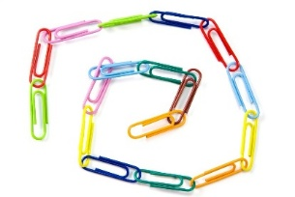  Resources:  Plastic links and pot of paper clips for children to choose their level of challenge.  Challenge:  Choice of resource.  How long can you make your chain in the time given? | Cutting Skills.  Children use scissors to cut along the lines drawn on the strips of paper.  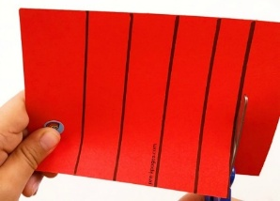  Resources:  Strips of paper with lines to cut or paint charts. Scissors  Challenge:  Choice of scissors used. | Cutting Skills.  Children use scissors to cut along the lines drawn on the strips of paper.  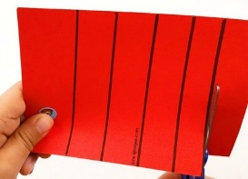  Resources:  Strips of paper with lines to cut or paint charts. Scissors  Challenge:  Choice of scissors used.
Physical – Playdough | Make your school or your house  Resources:  Orange playdough  Pumpkins
EAD – Art / Craft | Pumpkin observational drawing  Resources:  Pumpkins  Range of mediums, collaging, oil pastels, paint, pencils
Maths | Matching puzzles  Resources:  Print out of pictures for children to sort
EAD – Role play | Home corner

PSED | Treasure
Resources | Treasure and blindfolds.
Development Matters Statements | Understand how to listen carefully and why listening is important, articulate ideas in well-formed sentences (COMM & LANG), show resilience and perseverance in the face of challenge (PSED), use language of position, route and location (M).
Characteristics of Effective Learning | Keep on trying when things are difficult, solve real problems.
Plan | Blindfold game in which one partner guides the other one using only verbal directions towards a 'pot of treasure' or another target.
Success Criteria: Can children give verbal directions to a friend? Can children listen and follow the directions given to them? |  | Key vocabulary: blindfold, treasure, towards, forwards, backwards, left, right, around, turn, over, under, through, step, up, down, face

CL - Nature Walk
Resources | Clipboard and pen, blindfolds, access to woodland area
Intent | Develop listening skills, distinguish between different sounds, use a wide range of vocabulary, understand why questions, use longer sentences, represent a point of view, hold a conversation.
Implement | Explain that you will be listening for sounds in a woodland area which is safe. Suggest wearing blind folds to help the ears to listen. Model listening in wonder and ask open questions starting with what, where, how, why, when...for example, Why do you think it makes that sound? Model drawing on the clipboard the pictures of things you think make the sounds you can hear and encourage children to draw pictures if appropriate.
Impact | Can children hear different sounds? Do children answer questions? Can children draw a picture?

Music | Where is…?
Resources | None
Development Matters Statements | Listen attentively, move to and talk about music, expressing their feelings and responses, improvise a song they know (EAD), continue to develop their movement skills (PD), understand how to listen carefully and why listening is important (COMM & LANG)
Skills | Body awareness, hand eye coordination, listening
Plan | Sing ‘Where is…? To the tune of Frere Jacques  Gather children in a circle and sing “Where is… Where is… please stand up, please stand up. Run/jump/walk (choose one action) around the circle. Run/jump/walk (choose one action) around the circle . Then sit down. Then sit down”  What is your idea/suggestion? How can we make that action? Show me how…  Goodbye song – Goodbye, so long my friends, goodbye, so long, farewell, we’ll see you soon my friends again, so goodbye, so long, farewell.
Success Criteria: Can children join in with repetitive rhymes? Can children listen and move to an instruction? |  | Key vocabulary: clap, tap, run, walk, hop, jump, move, choice, wave, shake, roll, sound, wiggle, up, down, forwards, backwards, repeat, circle, action, copy, idea, suggestion

