Early Learning Goals
Children at the expected level of development will:
Personal, Social and Emotional Development - ELG: Managing Self
- understand the importance of healthy food choices
Physical Development - ELG: Fine Motor Skills
- Hold a pencil effectively in preparation for fluent writing – using the tripod grip in almost all cases
- Use a range of small tools, including scissors, paint brushes and cutlery
- Begin to show accuracy and care when drawing.
Expressive Arts and Design - ELG: Creating with Materials
- Safely use and explore a variety of materials, tools and techniques, experimenting with colour, design, texture, form and function
- Share their creations, explaining the process they have used

Key Stage 1
When designing and making, pupils should be taught to:
Design
- design purposeful, functional, appealing products for themselves and other users based on design criteria
- generate, develop, model and communicate their ideas through talking, drawing, templates, mock-ups and, where appropriate, information and communication technology
Make
- select from and use a range of tools and equipment to perform practical tasks [for example, cutting, shaping, joining and finishing]
- select from and use a wide range of materials and components, including construction materials, textiles and ingredients, according to their characteristics
Evaluate
- explore and evaluate a range of existing products
- evaluate their ideas and products against design criteria
Technical knowledge
- build structures, exploring how they can be made stronger, stiffer and more stable
- explore and use mechanisms [for example, levers, sliders, wheels and axles] in their products

Key Stage 2
When designing and making, pupils should be taught to:
Design
- use research and develop design criteria to inform the design of innovative, functional, appealing products that are fit for purpose, aimed at particular individuals or groups
- generate, develop, model and communicate their ideas through discussion, annotated sketches, cross-sectional and exploded diagrams, prototypes, pattern pieces and computer-aided design
Make
- select from and use a wider range of tools and equipment to perform practical tasks [for example, cutting, shaping, joining and finishing], accurately
- select from and use a wider range of materials and components, including construction materials, textiles and ingredients, according to their functional properties and aesthetic qualities
Evaluate
- investigate and analyse a range of existing products
- evaluate their ideas and products against their own design criteria and consider the views of others to improve their work
- understand how key events and individuals in design and technology have helped shape the world
Technical knowledge
- apply their understanding of how to strengthen, stiffen and reinforce more complex structures
- understand and use mechanical systems in their products [for example, gears, pulleys, cams, levers and linkages]
- understand and use electrical systems in their products [for example, series circuits incorporating switches, bulbs, buzzers and motors]
- apply their understanding of computing to program, monitor and control their products

 | Reception | 1 | 2 | 3 | 4 | 5 | 6
Project 1 | Junk modelling  Pumpkin Soup  Gingerbread men  Hole punching tools | Easter Cards (Mechanisms): (cross curricular link RE)  Outcome: To create an Easter card using a slider or lever mechanism.  Skills and Knowledge:  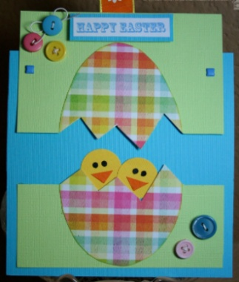  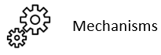 | 3D Tudor Houses (Structures): (cross curricular link History and Maths)  Outcome:  To create a 3D Tudor House from 1666.  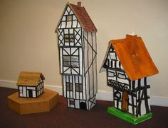  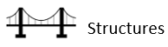  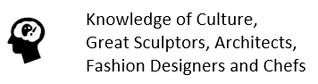  Skills and Knowledge: | 3D Volcanoes (Structures): (cross curricular link Geography, Science and Maths)  Outcome: To create a 3D model volcano.  Skills and Knowledge:  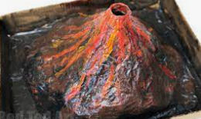 | 3D Iron Man (Structures and Electrical Systems): (cross curricular link English, Science and Maths)  Outcome:  To create a 3D Iron Man with an electrical system.  Skills and Knowledge:    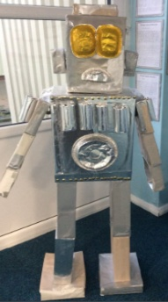 | Morris’ Protective Pouch (Textiles): (cross curricular link English)  Outcome: To sew a felt pouch for treasured belongings.  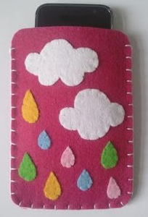    Skills and Knowledge: | 3D Victorian Bridge (Structures): (cross curricular link History and Maths)  Outcome:  To create a 3D model of a bridge.  Skills and Knowledge:  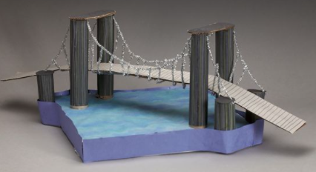
Project 2 | Dough disco  Sandwiches  Creative zone | Puppets (Textiles): (cross curricular link English and History)  Outcome:  To sew a puppet.  Skills and Knowledge:    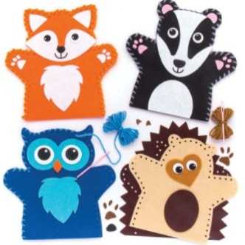 | Moving Rainforest Animal (Mechanisms): (cross curricular link Geography)  Outcome:  To create a moving rainforest animal using a lever mechanism.  https://www.robives.com/project/lever/  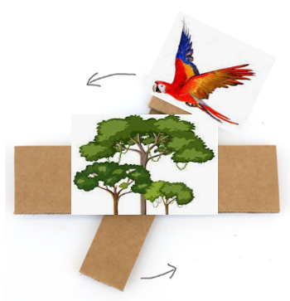  Skills and Knowledge: | Stone Age Jewellery (Textiles): (cross curricular link History)  Outcome:  To create a salt dough piece of jewellery to wear.  Skills and Knowledge:  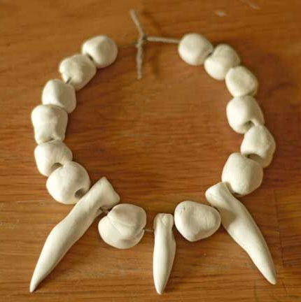 | Moving River Scene (Mechanisms): (cross curricular link Geography)  Outcome:  To create a moving river scene using a cam mechanism.  https://www.instructables.com/Fish-Automata/  Skills and Knowledge:  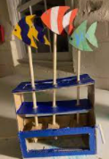 | Pneumatic Moving Dragonhead (Mechanisms): (cross curricular link History and Maths)  Outcome:  To create a mechanical moving dragonhead.  https://www.tts-group.co.uk/blog/2019/04/16/creating-a-moving-monster-dt-class-kit.html  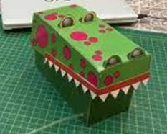  Skills and Knowledge:
Project 3 | Healthy Eating (Cooking and Nutrition): (cross curricular link PE)  Outcome:  To make banana pancakes to serve with strawberries grown  https://www.bbcgoodfood.com/recipes/easy-banana-pancakes  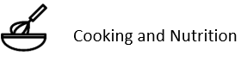  Skills and Knowledge: | Healthy Eating (Cooking and Nutrition): (cross curricular link PE)  Outcome:  To make lettuce bruschetta  https://www.myfussyeater.com/kid-friendly-pea-hummus/  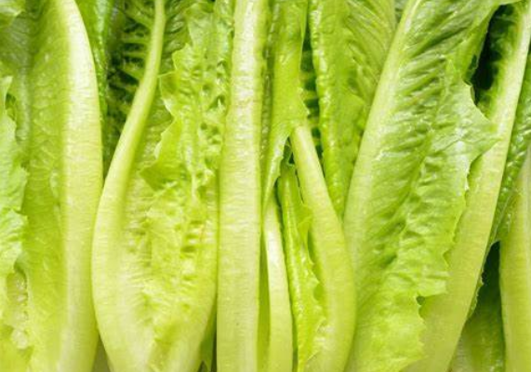  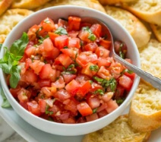  Skills and Knowledge: | Healthy Eating (Cooking and Nutrition): (cross curricular link PE)  Outcome:  To make a veggie slaw  https://www.bbc.co.uk/food/recipes/kids_veggie_slaw_73791  Skills and Knowledge:  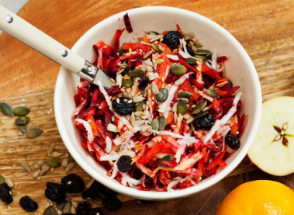 | Healthy Eating (Cooking and Nutrition): (cross curricular link PE)  Outcome:  To make muffin frittatas  https://hemsleyandhemsley.com/recipe/muffin-frittatas/  Skills and Knowledge:  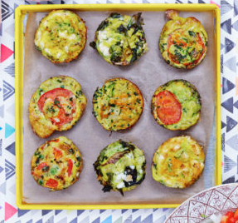 | Healthy Eating (Cooking and Nutrition): (cross curricular link PE)  Outcome:  To make veggie nachos  https://www.jamieoliver.com/recipes/vegetable-recipes/buddy-s-veggie-nachos/  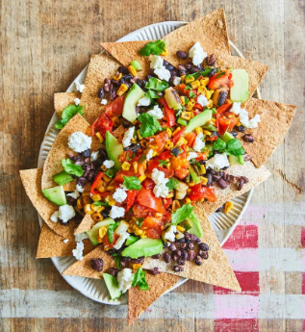  Skills and Knowledge: | Healthy Eating (Cooking and Nutrition): (cross curricular link PE)  Outcome:  To make a healthy pizza  Growing at Langshott\Healthy Eating Recipes  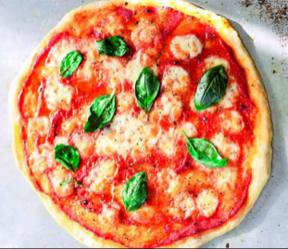  Skills and Knowledge: | Healthy Eating (Cooking and Nutrition): (cross curricular link PE)  Outcome:  To make courgette fries  https://www.gousto.co.uk/cookbook/vegetarian-recipes/courgette-fritters  Skills and Knowledge:  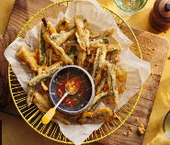
Resources | Project 3  Strawberry seeds  Self-raising flour  Eggs  Baking powder  Vanilla extract  Milk  Oil | Project 1  Coloured card  PVA glue  Project 2  Felt  Thread  Plastic needles  Fabric scissors  Project 3  Tomato seeds  Lettuce seeds  Fresh Basil  Lemon juice  Garlic  Water  Salt & pepper | Project 1  Cardboard boxes (no £)  White paper  Black paper  Paint  Straw  Project 2  Coloured card  Split pins  Project 3  Beetroot seeds  Radish seeds  Sunflower seeds  Carrots  Apples  Olive oil  Orange  Pepper | Project 1  Newspaper (no £)  PVA glue  Cardboard boxes (no £)  Paint  Project 2  Plain flour  Salt  Water (no £)  Natural twine  Project 3  Courgette seeds  Pea seeds  Eggs  Salt & pepper  Spring onion  Garlic  Cheddar cheese  Dried oregano  Fresh parsley  Butter | Project 1  Cardboard boxes (no £)  Tin foil  Light up eyes  Yellow tissue paper  Project 2  Cardboard boxes (no £)  Paint  Hot glue gun  Hot glue  Wooden dowels  Project 3  Tomato seeds  Bell pepper seeds  Radish seeds  Sweetcorn  Spring onions  Limes  Olive oil  Whole-wheat tortillas  Black beans  Avocado  Feta cheese | Project 1  Felt  Thread  Needles  Pins  Fabric scissors  Project 2  Syringes x 60  Balloons  Plastic tubing  Cardboard boxes (no £)  Split pins  Paint  Project 3  Tomato seeds  Bell pepper seeds  Courgette seeds  Flour  Baking powder  Salt  Oil  Water  Sweetcorn  Tomato puree  Mozzarella  Fresh basil | Project 1  Cardboard boxes (no £)  Wire  Wire cutters  Paint  Project 2  Old clothes (no £)  Thread  Needles  Pins  Fabric scissors  Measuring tapes  Project 3  Courgette seeds  Eggs  Garlic  Breadcrumbs  Flour
Resources | Whole School  Textiles equipment – needles (plastic and metal), thread  Construction equipment – saws, glue guns and hot glue, wire cutters, goggles  Cooking equipment – chopping boards, wooden spoons, cutlery, cookers or hot plates, mixing bowls, handheld blenders, baking trays, cake tins, peelers, spatulas, graters, sieves/strainer, frying pans  Cooking ingredients – salt & pepper, olive oil, dried mixed herbs

Progression of Knowledge and Skills Breakdown
 | Reception | 1 | 2 | 3 | 4 | 5 | 6
  Knowledge of Culture, Great Sculptures, Architects, Fashion Designers and Chefs |  | Puppet Designer Jim Henson (Kermit the Frog)  - To discuss and explore the puppet designer Jim Henson  - To understand how Jim Henson helped shape the toy industry by creating Kermit the Frog  Junior Bake Off Winner 2024 11-Year-old Austin  - To Discuss and explore Junior Bake Off  - To Understand how Junior Bake Off helps shape baking, cooking and healthy eating | Architect Norman Foster (The Gherkin)  - To discuss and explore the architect Norman Foster  - To understand how Norman Foster helped develop and shape modern day architecture by designing The Gherkin  Chef Nadiya Hussain  (Great British Bake Off)  - To discuss and explore the chef Nadiya Hussain  - To understand how Nadiya Hussain helped develop and shape baking, cooking and healthy eating | Jeweller Harry Winston  - To discuss and explore the jeweller Harry Winston  - To understand how Harry Winston helped develop and shape innovative jewellery within the fashion industry  Chef Hemsley Sisters (Hemsley + Hemsley)  - To discuss and explore the chefs Hemsley + Hemsley  - To understand how the Hemsley Sisters helped develop and shape cooking and healthy eating | Animator Walt Disney  - To discuss and explore the animator Walt Disney  - To understand how Walt Disney helped develop and shape animation within the visual entertainment industry  Chef Jamie Oliver  (Jamie’s School Dinners)  - To discuss and explore the chef Jamie Oliver  - To understand how Jamie Oliver helped develop and shape cooking and healthy eating | Costume Designer Julie Taymor (The Lion King)  - To discuss and explore the costume designer Julie Taymor  - To understand how Julie Taymor helped develop and shape innovative set design and costumes within theatrical productions  Chef Gino D’Acampo  (Gino’s Italian Escape)  - To discuss and explore the chef Gino D’Acampo  - To understand how Gino D’Acampo helped develop and shape cooking and healthy eating | Engineer Isambard Brunel (Clifton Suspension Bridge)  - To discuss and explore the engineer Isambard Brunel  - To understand how Isambard Brunel helped develop and shape engineering and construction by designing the Clifton Suspension Bridge  Chef Joe Wicks  (Lean in 15)  - To discuss and explore the chef Joe Wicks  - To understand how Joe Wicks helped develop and shape cooking and healthy eating
  Textiles |  |   - To plan and sketch simple ideas for a puppet  - To design a functional puppet and communicate ideas through talking and simple drawings  - To experiment using a running stitch    - To select and use a range of tools and equipment to cut, shape and sew a puppet  - To select and use a range of materials to make a functional puppet    - To explore and evaluate the design and make process through discussions  - To make suggestions for future improvements |  | - To plan and sketch realistic ideas for a purposeful piece of jewellery  - To design and develop an appealing and functional stone age piece of jewellery with annotated drawings  - To successfully make salt dough  - To accurately shape and mould the various parts of the jewellery piece  - To make a functional stone age piece of jewellery with aesthetic qualities  - To evaluate the positive stages of the design and make process  - To evaluate the challenges of the design and make process  - To make suggestions for future improvements |  | - To plan and sketch innovative ideas for a protective pouch  - To design and develop a purposeful and functional protective pouch with explanations and annotated diagrams  - To experiment using a running and blanket stitch  - To accurately design and cut out a template pattern piece  - To sew with accuracy and control  - To make a functional protective pouch with aesthetic qualities  - To consider the views of others to make improvements  - To evaluate the positive stages of the design and make process  - To evaluate the challenges of the design and make process  - To make suggestions for future improvements
Vocabulary |  | 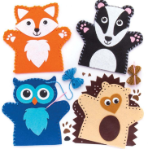  Design Make Evaluate Fabric Functional Needle Eye Thread Knot Running stitch  Textiles Puppeteer |  | 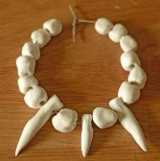  Design Make Evaluate  Functional Purposeful  Chain Clasp Embellishment  Textiles Aesthetic  Jeweller |  | 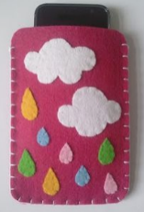  Design Make Evaluate Functional Purposeful Innovative Textiles Needle Eye Thread Knot Fabric Pattern pieces Blanket stitch Running stitch Aesthetic
Structures      Electrical Systems |  |  | - To plan and sketch simple ideas for a three-dimensional Tudor House  - To select a range of appropriate materials to represent a Tudor House  - To design a purposeful house and communicate ideas through talking and simple drawings  - To discuss and use mathematical knowledge of nets of cubes and cuboids  - To select and use a range of tools and equipment to cut, shape and join a structure  - To select and use a range of materials to make a purposeful house  - To know how to make a freestanding three-dimensional structure stronger, stiffer and more stable  - To explore and evaluate the design and make process through discussions  - To make suggestions for future improvements | - To plan and sketch realistic ideas for a functional, exploding three-dimensional volcano  - To design and develop a lifelike volcano with annotated drawings and diagrams  - To discuss and use mathematical knowledge of nets of pyramids  - To successfully use paper-mache to build a three-dimensional structure  - To accurately shape and mould the volcano to construct a strong, stable structure  - To make a functional three-dimensional volcano with aesthetic qualities  - To test the exploding chemical reaction  - To evaluate the positive stages of the design and make process  - To evaluate the challenges of the design and make process  - To make suggestions for future improvements | - To plan and sketch realistic ideas for a three-dimensional Iron Man  - To design and develop a purposeful and functional Iron Man with explanations and annotated drawings  - To discuss and use mathematical knowledge of nets of cubes and cuboids  - To understand and explain electrical systems linked to science  - To successfully build a three-dimensional structure  - To accurately cut, shape and join the Iron Man to construct a strong, stable structure  - To use an electrical system to create light-up eyes  - To make a functional three-dimensional Iron Man with aesthetic qualities  - To test the electrical system  - To evaluate the positive stages of the design and make process  - To evaluate the challenges of the design and make process  - To make suggestions for future improvements |  | - To create a design brief for the construction of a three-dimensional bridge, through peer discussions and research  - To plan, design and sketch innovative ideas for a purposeful bridge with annotated and pictorial representations  - To develop and apply mathematical knowledge of nets  - To select the appropriate shapes, materials and components to build a three-dimensional structure  - To accurately cut, shape and join the bridge to construct a strong, stable structure  - To make a purposeful three-dimensional bridge with aesthetic qualities  - To continually evaluate and modify the product to match the initial design  - To evaluate the positive stages of the design and make process  - To evaluate the challenges of the design and make process  - To make suggestions for future improvements
Vocabulary |  |  | Design Make Evaluate  Purposeful  Three-dimensional  Structure Freestanding  Cut Join Shape Nets Cube Cuboid  Architect | Design Make  Evaluate Functional  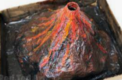  Purposeful Construct Nets Pyramid  Shape Mould Structure Three-dimensional  Chemical reaction Aesthetic | 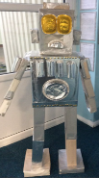  Design Make  Evaluate Functional  Structure Purposeful  Nets Cube Cuboid  Cut Shape Join  Three-dimensional  Electrical system  Construct Aesthetic |  | Design Make  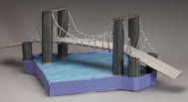  Evaluate Functional  Structure  Purposeful  Nets Cut Shape Join  Construct Innovative  Three-dimensional  Components Modify Aesthetic  Civil engineer
  Mechanisms |  | - To plan and sketch simple ideas for a moving Easter card  - To design a functional Easter card and communicate ideas through talking and simple drawings  - To experiment using sliders and levers  - To select and use a range of tools and equipment to cut, shape and make a mechanism  - To select and use a range of materials to make a mechanism  - To test the moving mechanism  - To explore and evaluate the design and make process through discussions  - To make suggestions for future improvements | - To plan and sketch simple ideas for a moving rainforest animal  - To design a functional rainforest animal and communicate ideas through talking and drawings  - To experiment using levers and pivots  - To select and use a range of tools and equipment to cut, shape and make a purposeful mechanism  - To select and use a range of materials to make a functional mechanism  - To test the moving mechanism  - To explore and evaluate the design and make process through discussions  - To make suggestions for future improvements |  | - To plan and sketch realistic ideas for a moving river scene  - To design and develop a purposeful and functional river scene with explanations and annotated drawings  - To discuss and explore the use of wheels, cams, axles and axle holders  - To successfully build a moving river scene using a cam mechanism  - To accurately cut, shape and join a moving river scene  - To make a functional moving river scene with aesthetic qualities  - To test the moving mechanism  - To evaluate the positive stages of the design and make process  - To evaluate the challenges of the design and make process  - To make suggestions for future improvements | - To plan and sketch innovative ideas for a moving dragon head  - To design and develop a purposeful and appealing dragon head with explanations and annotated diagrams  - To experiment using a pneumatic mechanism  - To explore and distinguish between fixed and loose pivots  - To develop and apply mathematical knowledge of nets  - To select the appropriate shapes, materials and components to build a pneumatic moving dragon head  - To accurately cut, shape and join the dragon head  - To make a functional pneumatic moving mechanism with aesthetic qualities  - To test the moving mechanism  - To consider the views of others to make improvements  - To evaluate the positive stages of the design and make process  - To evaluate the challenges of the design and make process  - To make suggestions for future improvements
Vocabulary |  | 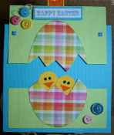  Design Make Evaluate  Functional  Mechanism  Slider Lever  Cut Shape | 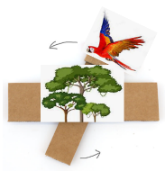  Design Make  Evaluate Functional Purposeful  Mechanism Lever Pivot  Cut Shape |  | Design Make  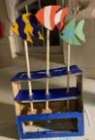  Evaluate Functional Purposeful  Mechanism Cam  Slide guide  Pivot point  Follower  Cut Shape Join Dowelling  Aesthetic Animator | Design Make  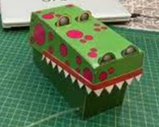  Evaluate Functional  Purposeful Pneumatic Mechanism  Net Components Fixed pivot Loose pivot  Cut Shape Join Aesthetic  Costume designer
  Cooking and Nutrition | - To grow vegetables from seed  - To understand where food comes from  - To develop an understanding of healthy and unhealthy food  - To discuss the appropriate ingredients to make a healthy beetroot oaty bar  - To follow a simple recipe  - To make a beetroot oaty bar  - To be clean and safe when cooking  - To try the food  - To describe what the food tastes like  - To explore and evaluate the food through discussions | - To grow vegetables from seed  - To understand where a variety of food comes from  - To have a basic understanding of a healthy and varied diet  - To discuss the appropriate ingredients to make a healthy pea hummus  - To follow a simple recipe  - To make pea hummus  - To be clean and safe when cooking  - To try the food  - To describe what the food tastes like  - To explore and evaluate the food through discussions  - To make suggestions for future improvements | - To grow vegetables from seed  - To understand where a variety of food comes from  - To understand the basic principles of a healthy and varied diet, including how fruit and vegetables are part of The Eatwell Plate  - To select and consider the appropriate ingredients to make a healthy veggie slaw  - To follow a recipe  - To make a veggie slaw  - To be clean and safe when cooking  - To try the food  - To describe what the food tastes like  - To explore and evaluate the food through discussions  - To make suggestions for future improvements | - To grow vegetables from seed  - To know where a range of fresh and processed ingredients, appropriate to the recipe, come from  - To understand the principles of a healthy and varied diet, including how fruit and vegetables are part of The Eatwell Plate  - To select and consider the appropriate ingredients to make healthy muffin frittatas  - To follow a recipe using the appropriate utensils  - To make muffin frittatas  - To be hygienic and safe when cooking  - To try the food  - To evaluate the positives of the cooking and tasting process  - To evaluate the challenges of the cooking process  - To make suggestions for future improvements | - To grow fruit and vegetables from seed  - To know where a range of fresh and processed ingredients, appropriate to the recipe, come from  - To begin to understand the positive and negative impact of different food groups  - To select and consider the appropriate ingredients to make healthy veggie nachos  - To follow a recipe using the appropriate utensils and cooking techniques  - To make veggie nachos  - To be hygienic and safe when cooking  - To try the food  - To evaluate the positives of the cooking and tasting process  - To evaluate the challenges of the cooking process  - To make suggestions for future improvements | - To grow fruit and vegetables from seed  - To know where food is sourced and the impact it has on the environment  - To understand seasonality in relation to food products  - To select and consider the appropriate ingredients to make a healthy pizza  - To follow a recipe using the appropriate utensils and cooking techniques  - To make a healthy pizza  - To be hygienic and safe when cooking  - To try the food  - To evaluate the positives of the cooking and tasting process  - To evaluate the challenges of the cooking process  - To consider the views of others to make improvements  - To make suggestions for future improvements | - To grow vegetables from seed  - To understand the importance and nutritional value of different food groups  - To understand the impact different foods can have on the human body  - To select and consider the appropriate ingredients to make healthy courgette fritters  - To follow a recipe using the appropriate utensils and cooking techniques  - To make courgette fritters  - To be hygienic and safe when cooking  - To try the food  - To evaluate the positives of the cooking and tasting process  - To evaluate the challenges of the cooking process  - To consider the views of others to make improvements  - To make suggestions for future improvements
Vocabulary | 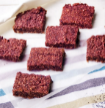  Make Bake  Evaluate  Healthy Varied  Ingredients  Equipment Recipe  Growing Choosing Mixing  Sensory vocabulary  eg. soft sticky sweet  Clean | Prepare Make Evaluate  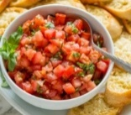  Healthy Varied  Ingredients  Equipment  Recipe  Growing Choosing Blending  Cutting  Sensory vocabulary  eg. soft smooth crunchy Clean | 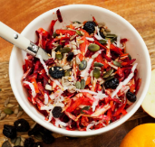  Prepare Make  Evaluate  Healthy diet Varied diet  Ingredients  Produce  Equipment Recipe  Growing Harvesting Grating Chopping  Sensory vocabulary eg. crunchy crisp zesty  Clean | 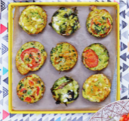  Prepare Make  Evaluate  Healthy diet Varied diet  Ingredients Recipe Utensils Texture  Harvesting Produce  Appearance Smell Taste  Fresh Raw Savoury Sweet  Processed  Hygiene | 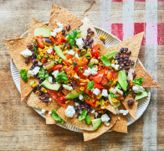  Prepare Make  Evaluate  Healthy diet Varied diet  Ingredients Recipe Utensils  Techniques Texture  Harvesting Produce Wholemeal  Fresh Processed Raw Savoury Sweet Greasy Edible  Nutrition Fats Carbohydrates Proteins Vitamins Dairy  Hygiene | 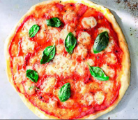  Prepare Make  Evaluate  Healthy diet Varied diet  Ingredients Recipe Utensils  Yeast Dough Spices  Seasonality Sourced Climate Nutrition Grown  Reared Free-range  Processed Air-miles Battery  Combine Knead Whisk Beat  Hygiene | 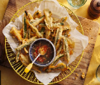  Prepare Make  Evaluate  Healthy diet Varied diet  Ingredients Recipe Utensils  Nutrition Fats Carbohydrates Proteins Vitamins Nutrients Fibre  Dairy Gluten Allergy Intolerance  Seasonality Source  Combine Knead Whisk Beat  Crumble Fold  Hygiene

