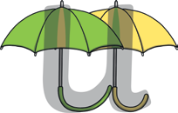

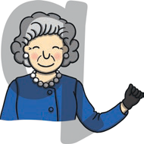
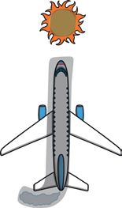
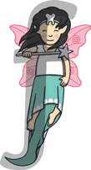
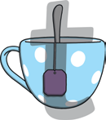
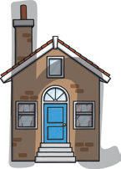

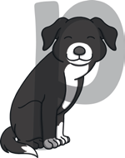
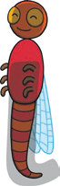
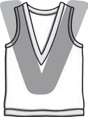
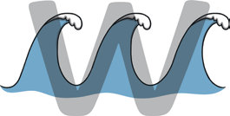
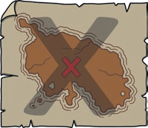
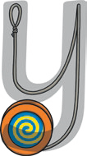
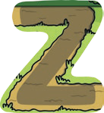
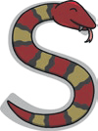
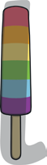
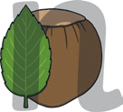
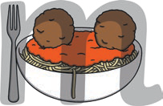
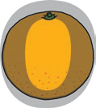
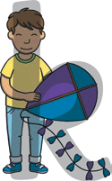
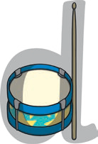
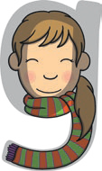
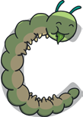
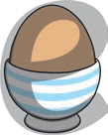
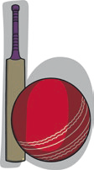
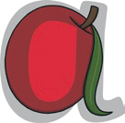
s
x

i
h
ü
â
d
c
b
a
ý
„
m
n
‹
p
q

z
þ

Þ
Ú
u
Down one umbrella handle, up and down the other and lead out.
Down the wave, up the wave, down the wave, up the wave and lead out.
Follow the neck and lead out.
Curl over the snake’s head, follow the body and lead out.
Down the teaspoon, under the teacup, lead out and across the top of the spoon.
Search the sea, search the land and lead out.
Zig, zag, path and lead out.
Follow the string, down and around the yoyo and lead out.
l
Down the bat, up and around
the ball and lead out.
Curl around Gabi’s head, wrap her scarf and lead out.
û
t
Down the insect’s body and tail, lead out and dot the head.
From the chimney and down to the floor, up and over the new front door and lead out.
Around the fairy’s head, down her dress, give her a wand and lead out.
Curl around the drum, up and down the stick and lead out.
Around the egg, under the cup and lead out.
Curl around the caterpillar and lead out.
Curl around the apple, up the stalk, down the leaf and lead out.
r

Curl around the queen’s head, down her body and lead out.
Down the robot’s body, up and over its arm and lead out.
Down the puppy’s neck and leg, up and around his head and lead out.
Curl around the orange and lead out.
Down the leaf, up and over the nut and lead out.
Down the fork, up and over the meatballs and lead out.
Down the lolly and lead out.
Down Kit, halfway up, around the kite, down its tail and lead out.
Down the jet, around its trail, lead out and dot the sun.

