
Langshott Art and Design Curriculum Map

2025-2026
Early Learning Goals
Children at the expected level of development will:
Physical Development - ELG: Fine Motor Skills
- Hold a pencil effectively in preparation for fluent writing – using the tripod grip in almost all cases
- Use a range of small tools, including scissors, paint brushes and cutlery
- Begin to show accuracy and care when drawing
Understanding the World – ELG: The Natural World
- Explore the natural world around them, making observations and drawing pictures of animals and plants
Expressive Arts and Design - ELG: Creating with Materials
- Safely use and explore a variety of materials, tools and techniques, experimenting with colour, design, texture, form and function
- Share their creations, explaining the process they have used

Key Stage 1
Pupils should be taught:
- To use a range of materials creatively to design and make products
- To use drawing, painting and sculpture to develop and share their ideas, experiences and imagination
- To develop a wide range of art and design techniques in using colour, pattern, texture, line, shape, form and space
- About the work of a range of artists, craft makers and designers, describing the differences and similarities between different practices and disciplines, and making links to their own work

Key Stage 2
Pupils should be taught:
- To develop their techniques, including their control and their use of materials, with creativity, experimentation and an increasing awareness of different kinds of art, craft and design.
- To create sketch books to record their observations and use them to review and revisit ideas
- To improve their mastery of art and design techniques, including drawing, painting and sculpture with a range of materials [for example, pencil, charcoal, paint, clay]
- About great artists, architects and designers in history

 | Reception | 1 | 2 | 3 |  | 4 | 5 | 6
Whole School September Art Project | Natural Self-Portraits: curricular link to well-being, SDP plan and transition to new year group)  Outcome: To use natural materials to create a self- portrait.  Skills and Knowledge:  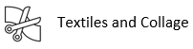  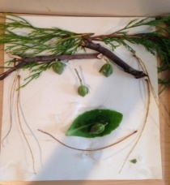 | Painted Self-Portraits: (cross curricular link to well-being, SDP plan and transition to new year group)  Outcome: To paint a self-portrait using colour mixing.  Skills and Knowledge:    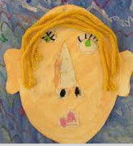 | 3D Clay Pablo Picasso Inspired Self-Portraits: (cross curricular link to well-being, SDP plan and transition to new year group)  Outcome: To sculpt a self-portrait inspired by Pablo Picasso.  Skills and Knowledge:    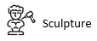  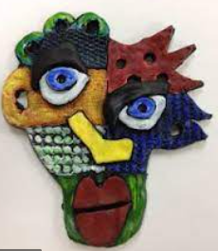 | Andy Warhol Pop Art Inspired Self-Portraits: (cross curricular link to well-being, SDP plan and transition to new year group)  Outcome: To produce a self-portrait inspired by Andy Warhol.  Skills and Knowledge:    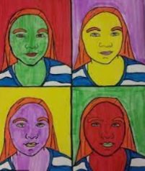 |  | Greek inspired head and shoulders Self-Portraits: (cross curricular link to History, well-being, SDP plan and transition to new year group)  Outcome: To sculpt a self-portrait inspired by the Greeks.  Skills and Knowledge:  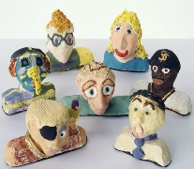 | Ink Self-Portraits: (cross curricular link to well-being, SDP plan and transition to new year group)  Outcome: To create a self-portrait using ink.  Skills and Knowledge:    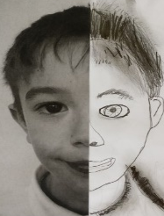 | Digital Self-Portraits: (cross curricular link to Computing, well-being, SDP plan and transition to new year group)  Outcome: To create a digital self-portrait.  Skills and Knowledge:    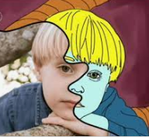
Christmas Cards Project | Christmas Card – Robin Handprint: (cross curricular link to RE - Christianity / Christmas unit)  Outcome: To create a Christmas Card using finger painting.  Skills and Knowledge:    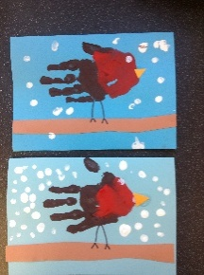 | Christmas Card – Sleigh Scene: (cross curricular link to RE - Christianity / Christmas unit)  Outcome: To create a Christmas Card using finger painting.  Skills and Knowledge:  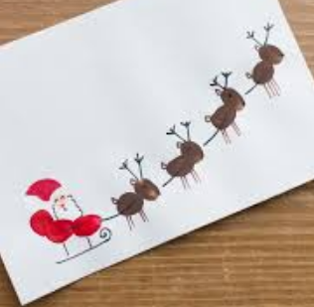 | Christmas Card – Tree Collage: (cross curricular link to RE - Christianity / Christmas unit)  Outcome: To create a Christmas Card using collaging.  Skills and Knowledge:  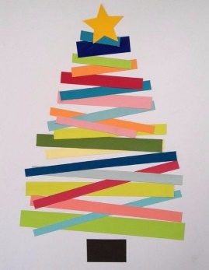 | Christmas Card – Tree Collage: (cross curricular link to RE - Christianity / Christmas unit)  Outcome: To create a Christmas Card using paint and collage.  Skills and Knowledge:  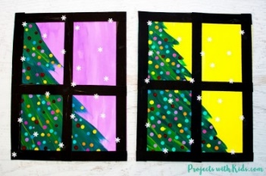 |  | Christmas Card – Winter Tree Scene: (cross curricular link to RE - Christianity / Christmas unit)  Outcome: To create a Christmas Card using wax crayons and watercolour.  Skills and Knowledge:  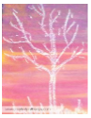 | Christmas Card – Baubles: (cross curricular link to RE - Christianity / Christmas unit)  Outcome: To create a Christmas Card using a handmade stencil and watercolours.  Skills and Knowledge:  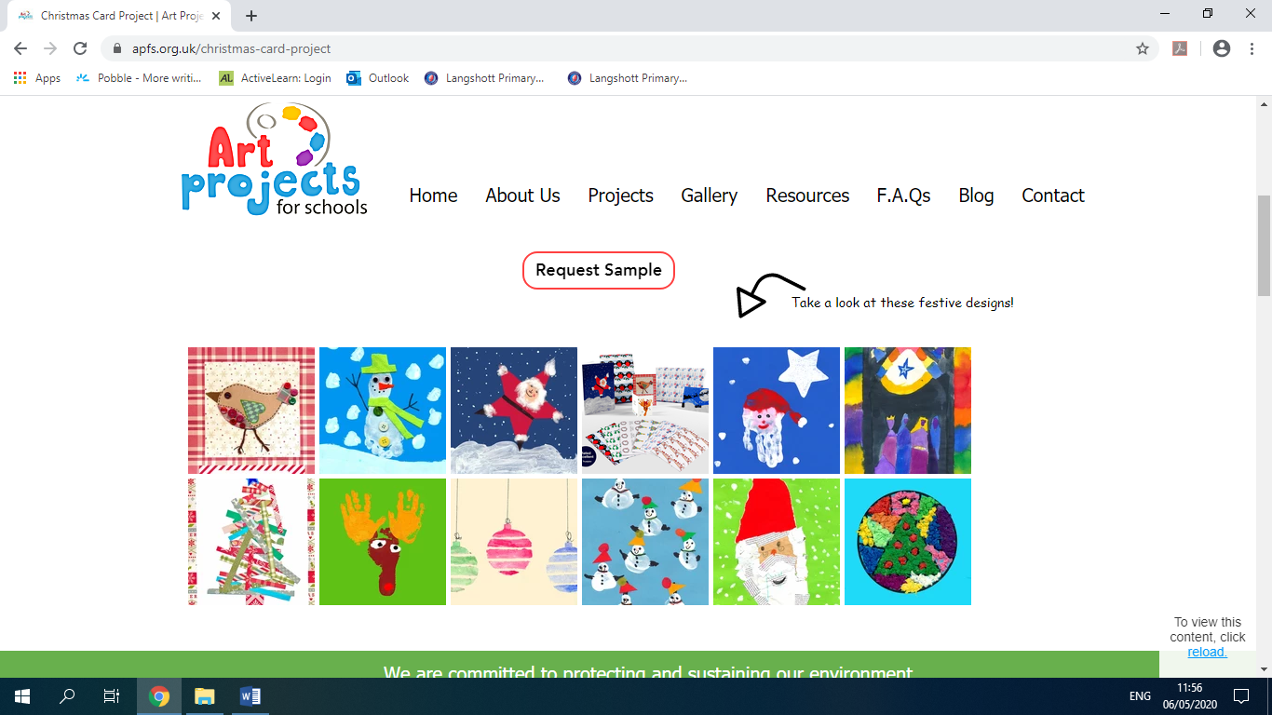 | Christmas Card – Christmas trees: (cross curricular link to RE - Christianity / Christmas unit)  Outcome: To create a Christmas Card using ink.  Skills and Knowledge:  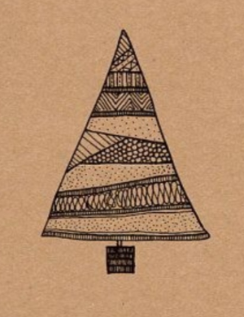
Project 1 | Diwali art  Drawing club | Wassily Kandinsky Inspired Seasonal Trees: (cross curricular link to Science)  Outcome: To take inspiration from Kandinsky’s tree art to represent seasonal changes using mixed media.  Skills and Knowledge:  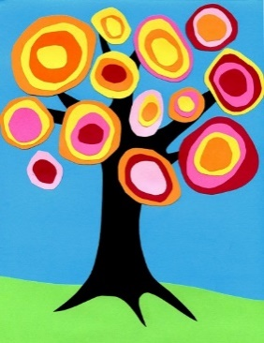 | Great Fire of London Collage: (cross curricular link to History)  Outcome: To produce a collage of Pudding Lane.  Skills and Knowledge:  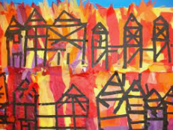 | Observational Landscape Study: (cross curricular link to Geography).  Outcome: To observe and sketch a natural landscape.  Skills and Knowledge:  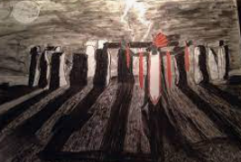 |  | Oil Pastel Greek Pots: (cross curricular link to History)  Outcome: To draw a Greek pot and use mixed media to replicate traditional Greek patterns.  Skills and Knowledge:  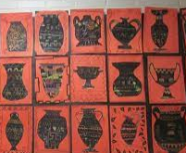 | Paul Klee Inspired Landscape Scene: (cross curricular link to English)  Outcome: To create a tonal painting using oil pastel and watercolour in the style of Paul Klee.  Skills and Knowledge:  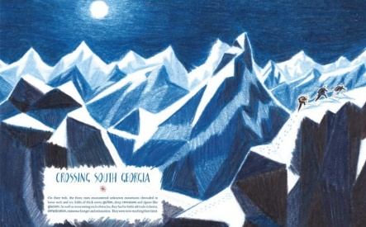 | 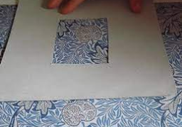  William Morris Pattern Experiment: (cross curricular link to History)  Outcome: To use a viewfinder to create a detailed drawing in the style of William Morris.  Skills and Knowledge:  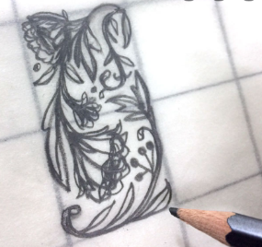
Project 2 |  | Vincent Van Gogh Inspired Sunflowers: (cross curricular link to Science)  Outcome: To recreate Vincent Van Gogh’s Sunflowers Painting.  Skills and Knowledge:  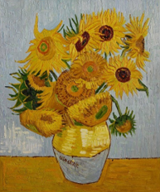 | Georgie O’Keeffe Inspired Plant Observation: (cross curricular link with Science)  Outcome: To use a choice of mixed media to produce a flower inspired by Georgie O’Keeffe.  Skills and Knowledge:  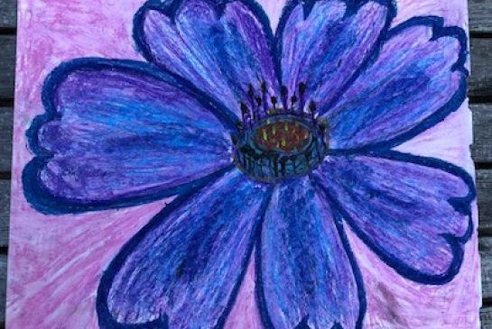 | Cave Paintings: (cross curricular link to History)  Outcome: To create a Stone Age repeating pattern.  Skills and Knowledge:  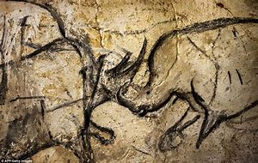 |  | Katsushika Hokusai Inspired Waterfall: (cross curricular link to Geography)  Outcome: To take inspiration from Hokusai and create a piece of art that experiments with texture.  Skills and Knowledge:  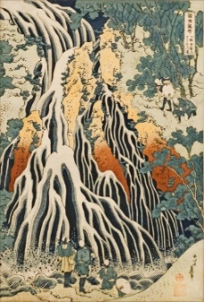  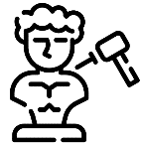 | 3D Clay Viking Dragon Eye: (cross curricular link to History)  Outcome: To experiment with pattern, line, texture and detail to create a Viking dragon eye out of clay.  Skills and Knowledge:  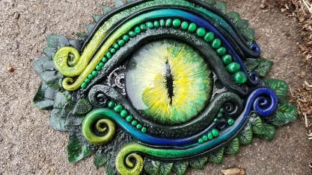
Project 3 |  | Alfred Wallis Inspired Collage: (cross curricular link to History)  Outcome: To use a range of materials to create a pirate ship at sea collage inspired by Alfred Wallis.  Skills and Knowledge:  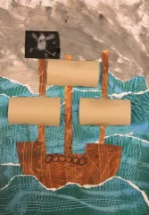 | Edward Tingatinga Inspired Dot Work: (cross curricular link to Geography)  Outcome: To take inspiration from Tingatinga dot work to paint a native animal from Costa Rica.  Skills and Knowledge:  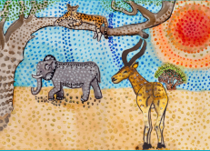 | Egyptian Soap Sculpture: (cross curricular link to History)  Outcome: To create an Egyptian soap sculpture.  Skills and Knowledge:  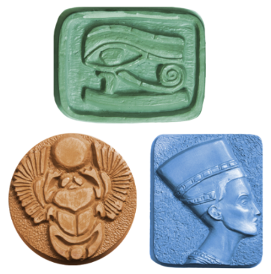 |  | Collaborative Roman Mosaic: (cross curricular link to History)  Outcome: To collaborate with others to create a large scale Roman mosaic using tiles and grout.  Skills and Knowledge:  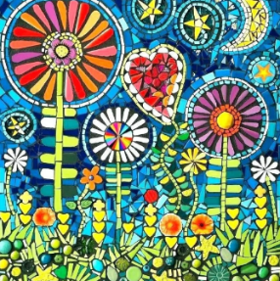 | Maya Masks:  (cross curricular link to History)  Outcome: To create a Maya inspired mask.  Skills and Knowledge:  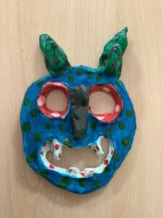 | Banksy Inspired Street Art: (cross curricular link to Geography)  Outcome: To paint in a graffiti style inspired by Banksy.  Skills and Knowledge:  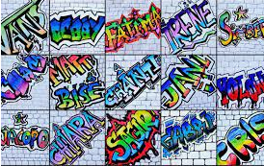
Resources | WS  Paper  Woodland resources (no £)  CC  Coloured card – blue  Paint | WS  White card  Paint  Sawdust  Pasta  Lentils  Rice  CC  Blue Card  Paint  Project 1  Oil pastels  Tissue paper  Cardboard box (no £)  String  Shading pencils  Project 2  Watercolours  Project 3  Paper  Natural resources (no £)  Paint | WS  Clay  Poster Paint  Clay tools inclu. cutter  CC  Thin coloured card  Project 1  Tissue paper  Black paper  Project 2  Shading pencils  Paint  Oil pastels  Project 3  Paint  Cotton buds  Sticks (no £) | WS  Paint  CC  Black paper  Paint  Project 1  Shading pencils  Project 2  N/A  Project 3  Bars of Soap x 30  Cutting tools  Cocktail sticks |  | WS  Clay  Paint  Clay tools  CC  Watercolours  White oil pastels  Project 1  Chalk  Black Paint  Cocktail sticks  Project 2  Oil pastels  Paint  Natural resources (no £)  Project 3  Square paper  Grout  Mosaics – Tiles  Wood | WS  Clay  Paint  Clay tools  CC  Watercolours  White oil pastels  Project 1  Sketching pencils  Project 2  Watercolours  Project 3  Masks  PVA glue  Paint  Newspaper | WS  N/A  CC  Black writing pens  Project 1  Card  Project 2  Acrylic Paint
Resources | Whole School  Display inclu. writing strips  Cupboard resources  Classroom resources  Cartridge paper  Cartridge Paper Sketch Books |  |  |  | Classrooms  Brushes  Paint  Pallets  Pots  Glue spreaders  PVA glue

Progression of Knowledge and Skills Breakdown
 | Reception | 1 | 2 | 3 | 4 | 5 | 6
  Knowledge of Culture, Great Art and Artists |  | Wassily Kandinsky (Squares in Concentric Circles)  - To discuss and explore the artist Wassily Kandinsky  - To express thoughts and feelings about ‘Squares in Concentric Circles’  Vincent Van Gogh (Sunflowers)  - To discuss and explore the artist Vincent Van Gogh  - To express thoughts and feelings about ‘Sunflowers’  Alfred Wallis (The Blue Ship)  - To discuss and explore the artist Alfred Wallis  - To express thoughts and feelings about ‘The Blue Ship’ | Pablo Picasso (The Weeping Woman)  - To discuss and explore the artist Pablo Picasso  - To express thoughts and feelings about ‘The Weeping Woman’  Georgia O’Keeffe (Black Iris)  - To discuss and explore the artist Georgie O’Keeffe  - To express thoughts and feelings about ‘Black Iris’  Edward Tingatinga (Leopard)  - To discuss and explore the artist Edward Tingatinga  - To express thoughts and feelings about ‘Leopard’ | Andy Warhol (Marilyn Monroe)  - To discuss and explore the artist Andy Warhol  - To express thoughts and feelings about ‘Marilyn Monroe’  The Stone Age (Cave Paintings)  - To discuss and explore art from The Stone Age  - To compare art from The Stone Age to modern art  The Egyptians (Hieroglyphics)  - To discuss and explore art from The Egyptians  - To compare art from The Egyptians to modern art | The Greeks (Busts and Pots)  - To discuss and explore art from The Greeks  - To compare art from The Greeks to modern art  Katsushika Hokusai (Waterfalls)  - To discuss and explore the artist Katsushika Hokusai  - To express thoughts and feelings about ‘Waterfalls’  The Romans (Mosaics)  - To discuss and explore art from The Romans  - To compare art from The Romans to modern art | Paul Klee (Resting Ships)  - To discuss and explore the artist Paul Klee  - To express thoughts and feelings about ‘Resting Ships’  The Vikings (Dragon Eye)  - To discuss and explore art from The Vikings  - To compare art from The Vikings to modern art  David Edgar (Red Tailed Flying Shark)  - To discuss and explore the artist David Edgar  - To express thoughts and feelings about ‘Red Tailed Flying Shark’ | Roy Lichtenstein (Girl with Hair Ribbon)  - To discuss and explore the artist Roy Lichtenstein  - To express thoughts and feelings about ‘Girl with Hair Ribbon’  William Morris (Strawberry Thief)  - To discuss and explore the artist William Morris  - To express thoughts and feelings about ‘Strawberry Thief’  Modern Art (Graffiti)  - To discuss and explore Graffiti  - To express thoughts and feelings about Graffiti
Drawing   |  |  |  | 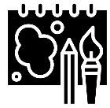  - To experiment with sketching  - To explore different gradient pencils  - To explore different tones through cross-hatching, hatching and stippling  - To experiment with texture, shape, form and space  - To take inspiration from a natural landscape in the moment  - To record and sketch ideas from first hand observations as realistically and as true to life as possible  - To draw with accuracy, control and to scale  - To reflect on the sketch and discuss observational drawings |  | - To plan, design and sketch ideas for a self-portrait with annotated and pictorial representations  - To experiment drawing different halves of the face  - To experiment with pattern, texture, line, shape, form, proportion and space  - To use a viewfinder to focus on detailed facial features  - To use a range of patterns, textures, lines, shapes, forms, proportion and space in a self-portrait  - To review and revisit sketchbook ideas to support the final piece and choose the appropriate techniques for facial features  - To draw with accuracy, control and to scale | - To experiment with sketching and copying patterns  - To plan, design and select ideas with annotated and pictorial representations  - To experiment with pattern, texture, line, shape, form, proportion and space  - To use a viewfinder to focus on detailed patterns  - To use a range of patterns, textures, line, shape and form  - To develop an awareness of composition and scale  - To review and revisit sketchbook ideas to support the final piece and choose the appropriate drawing techniques  - To draw with accuracy, control and to scale  - To reflect and compare the final piece with William Morris’ artwork
Vocabulary |  |  |  | 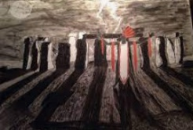  Observe  Observations  Draw Sketch  Still life Line  Shape Size  Texture Detail Cross-hatching  Hatching Tonal Stippling  Proportion Scale Form Space  Experiment Accuracy Control |  | 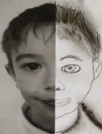  Portrait Design  Medium Sketch  Proportion Pattern  Texture Line Shape  Space Experiment  Form Accuracy Control  Photography Viewfinder  Detail Cross-hatching Hatching Tonal Stippling Scale | 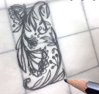  Design Scale Space  Medium Sketch  Proportion Pattern  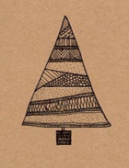  Texture Line Shape  Composition Form Accuracy Experiment  Viewfinder Detail Cross-hatching Control  Tonal Stippling Hatching
  Painting |  | - To practise drawing features of faces/plants using mirrors/sight and printed pictures  - To plan and sketch a self-portrait/still life  - To experiment with primary colours and mixing  - To experiment using different size and types of brushes  - To choose the appropriate colours, brush strokes and textures to paint a self-portrait/still life  - To show accuracy and care when painting |  |  |  |  | - To research Argentinian street art  - To plan and sketch various fonts, writing techniques and styles  - To experiment with bold, contrasting colours using acrylic paints  - To experiment with a dripping effect  - To experiment with pattern, texture, shape, form, and space  - To develop an individual style of graffiti  - To mix colours, shades and tones with confidence building on previous knowledge  - To review and revisit sketchbook ideas to support the final piece and choose the appropriate painting techniques  - To show accuracy, control and confidence when painting
Vocabulary |  | 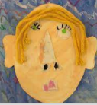  Design Portrait  Still life Drawing  Sketch Line Proportion  Painting Colour Texture  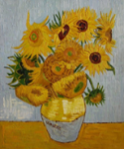  Mix Colour wheel  Primary colours  Secondary colours  Warm colours  Cool colours Accuracy |  |  |  |  | 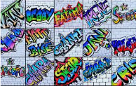  Design Drawing  Sketch Fonts Styles  Techniques Bold  Contrasting Dripping  Pattern Texture Shape Form Space  Shades Tones Accuracy Control
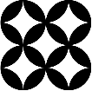  Printing | - To recognise and name different colours  - To develop simple patterns by using objects  - To investigate colour and hand printing  - To share and explain the final piece  - To select the appropriate colours  - To use print to make a Christmas card  - To begin to show accuracy and care when printing | - To explore printing simple pictures with a range of materials  - To develop repeating patterns by using a variety of objects  - To investigate colour and hand printing  - To share and explain the final piece  - To select the appropriate colours  - To use equipment correctly to produce a clean printed image  - To use print to make a Christmas card  - To show accuracy and care when printing | - To observe native animals of Costa Rica  - To plan and sketch native animals of Costa Rica  - To experiment using different size and types of printing tools  - To experiment with tones, texture, patterns and dot work  - To choose the appropriate colours, shapes and textures to paint a native animal of Costa Rica  - To use equipment correctly to produce a clean printed image  - To show accuracy and control when printing | - To explore printing simple pictures with chalk  - To develop repeating patters by using different types of printing tools  - To experiment with tones, texture and patterns.  - To choose the appropriate colours, shapes and textures for a stone age cave painting |  | - To experiment creating an ombre effect using watercolour paint  - To make a stencil out of paper  - To experiment using the stencil  - To experiment with tone, colours and layers  - To adapt and amend the stencil if required  - To select the appropriate colours and tones to make a three-dimensional print  - To use the stencil correctly to produce a clean printed image  - To use print to make an effective Christmas card  - To show accuracy, control and proportion when printing
Vocabulary | 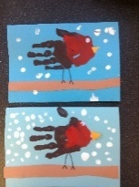  Design  Texture  Medium  Colour Form  Arrange  Layers Printing Patterns | 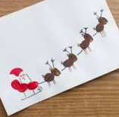  Design  Medium Accuracy  Colour  Clean Arrange  Layers Printing  Repeating Patterns | 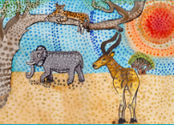  Design Drawing  Proportion Mix  Colour Printing  Patterns Texture Lighter Darker Dot work Tones Primary colours Secondary colours Accuracy Control |  |  | Design Texture  Medium Printing  Repeating Patterns  Colour Ombre Tones  Form Proportion Stencil Clean Layers Accuracy Control
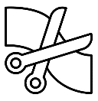  Textiles and Collage | - To investigate self-portraits made using natural materials  - To discuss appropriate natural materials  - To plan and sketch ideas for a self-portrait  - To experiment with form, texture and layers  - To gather natural materials  - To use natural materials creatively to make a self-portrait  - To begin to show accuracy and care when collaging  - To share and explain the final piece | - To look at and discuss the shapes of pirate ships and the sea  - To discuss and explore collaging  - To begin to identify different types and textures of fabric and materials for collage  - To select the appropriate colours, size, form and shapes  - To select the appropriate materials and equipment  - To use collage to make a pirate ship at sea, inspired by Alfred Wallis  - To show accuracy and care when being creative | - To discuss appropriate materials for a collage  - To experiment with a combination of materials by cutting, tearing and gluing  - To experiment with a variety of materials varying in texture  - To plan and sketch a collage  - To select, gather and arrange materials in preparation for the final piece  - To select the appropriate colours, size, form and shapes  - To create a collage from imagination, experience and observation  - To show accuracy and control when being creative
Vocabulary | 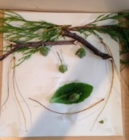  Portrait Design  Texture Natural  Medium  Sketch  Colour Form  Arrange Sort  Layers Attach Collage | 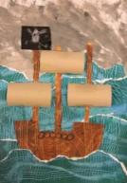  Design  Texture  Materials  Colour Form Size  Shape Arrange  Layers Equipment Cut  Tear Stick Accuracy Collage | 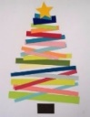  Design Texture Colour  Craft Attach Arrange  Layers Silhouette  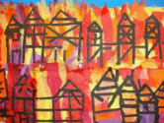  Combination  Create Form Cut  Tear Glue Control  Accuracy Collage
Sculpture |  |  | - To investigate self-portraits made from clay  - To take inspiration from Cubism  - To discuss and experiment with clay sticking and moulding techniques  - To plan and sketch ideas for a self-portrait  - To use the score, slip and blend techniques to sculpt and mould the clay correctly  - To select the appropriate pattern, texture, line, shape and form to reflect Cubism  - To paint using bold and striking colours for maximum effect  - To show accuracy and control when sculpting | - To take inspiration from Egyptian hieroglyphics  - To discuss and experiment with soap and moulding tools  - To experiment with different patterns, depths, strengths and movements to create a variety of textures  - To plan and sketch ideas for an Egyptian soap sculpture  - To carefully and safely sculpt the soap  - To select appropriate textures, patterns and shapes  - To create an Egyptian soap sculpture  - To show accuracy, precision and control when sculpting | - To take inspiration from The Greeks/The Romans  - To plan and sketch ideas for a three-dimensional clay self-portrait/ mosaic  - To choose and plan appropriate colour palettes  - To discuss and experiment with clay sticking and moulding techniques/ mosaics and grout  - To select, gather and arrange materials in preparation for the final piece  - To select the appropriate colours, pattern, texture, lines, shapes and form, to reflect The Greeks/ The Romans  - To use the score, slip and blend techniques to sculpt and mould the clay correctly/ glue and grout to secure the tiles  - To work as a successful team  - To show accuracy, precision and control when sculpting | - To take inspiration from The Vikings/ David Edgar  - To discuss and experiment with clay sticking and moulding techniques/ recycled and manmade materials to create a sculpture  - To plan, design and select ideas with annotated and pictorial representations  - To show increasing confidence to carve and mould the clay/ using a variety of materials  - To select appropriate textures, patterns and shapes  - To add paint and embellishment/ To work as a successful team  - To create a dragon’s eye/ collaborative plastiquarium inspired by The Vikings/ David Edgar  - To show accuracy, precision and control when sculpting
Vocabulary |  |  | 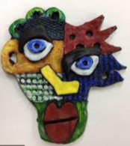  Portrait Design  Cubism Medium  Sketch Clay  Sculpt Mould  Score Slip Blend  Layer Pattern  Texture Line Shape Form  Bold Striking Accuracy Control | 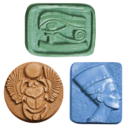  Design Sculpture  Mould Techniques  Patterns Depth  Strengths  Movements  Textures Sculpt Shapes  Precision Accuracy Control | 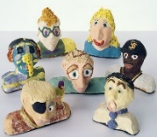  Portrait Design  Bust Medium  Three-dimensional  Sketch Clay Sculpt  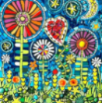  Layer Pattern Mould  Score Slip Blend  Texture Line Shape Form Accuracy Control  Tiles Glue Grout Mosaic | 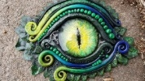  Design  Medium Sketch Clay  Sculpt Mould Attach  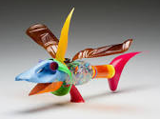  Score Slip Blend  Layer Pattern Texture Score Embellishment  Line Shape Form  Bold Precision Accuracy Control
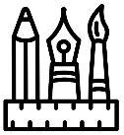  Mixed Media |  | - To go on a seasonal walk identifying the colours of the leaves on the trees during each season  - To discuss appropriate colours for their abstract seasonal tree  - To practice drawing concentric circles within a square  - To experiment with a variety of mediums  - To select the most appropriate colours and mediums  - To use mixed media to make a selection of abstract seasonal trees, inspired by Kandinsky  - To show accuracy and care when being creative | - To observe and sketch a variety of plants  - To experiment with a variety of mediums  - To discuss and experiment using a bold and striking colour palette  - To investigate texture, surface patterns and rubbings using natural materials  - To select the most appropriate colours and mediums  - To use a range of textures, shapes and lines  - To use mixed media to create a flower inspired by Georgia O’Keeffe  - To show accuracy and control when being creative | - To investigate a range of Pop Art portraits  - To discuss and experiment using a bold and striking colour palette  - To plan and sketch ideas for a self-portrait/ Christmas scene  - To experiment with tracing paper to repeat the pattern  - To select the most appropriate colours and mediums  - To use mixed media to make a selection of self-portraits/a Christmas scene  - To use a range of contrasting colours for maximum impact  - To show accuracy and control when being creative | - To experiment with black paint and chalk/ oil pastels and watercolours to make an oil pastel resist  - To experiment with different grades of pencil to suggest tone  - To experiment with complimentary and contrasting colours for effect  - To plan, design and sketch ideas for a variety of Greek pots/ waterfalls  - To select the most appropriate colours and mediums  - To use a range of textures, tones, shades, shapes and lines  - To use mixed media to make a selection of Greek pots/ a waterfall scene inspired by Katsushika Hokusai  - To show accuracy and control when being creative | - To experiment with oil pastels and watercolours to make an oil pastel resist  - To understand how to create a background using a wash  - To experiment using tones and tints, light and shade  - To consider the use of colour for mood and atmosphere  - To plan, design and select ideas with annotated and pictorial representations  - To use a monochrome colour palette  - To use a range of abstract shapes and lines  - To use mixed media to create an Antarctic landscape inspired by Paul Klee  - To show accuracy, precision and control when being creative
Vocabulary |  | 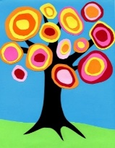  Design Drawing  Mixed media  Sketch Proportion  Colour wheel  Primary colours  Secondary colours  Warm colours Cool colours  Concentric circles Experiment  Accuracy Medium Abstract | 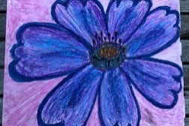  Design  Mixed media  Observe  Mediums  Bold Striking  Colour palette Texture Rubbings Surface patterns  Shapes Lines Accuracy Control | 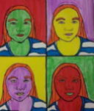  Portrait Design  Mixed media Pattern  Medium Sketch  Pop art Abstract Layer  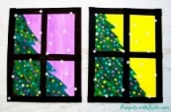  Proportion Subject  Background  Control Foreground  Colour palette  Bold Striking Experiment Accuracy | Design  Mixed media  Oil pastel resist  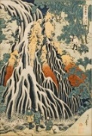  Grades Tones Shades  Complimentary  Contrasting Mediums  Texture Shapes  Lines Accuracy Control | 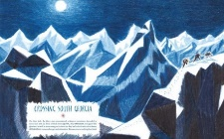  Design  Mixed media  Oil pastel resist  Wash  Tones Tints Light Shade Monochrome Mood Atmosphere Abstract Shapes Lines Accuracy Precision Control
Digital |  |  |  |  |  |  | - To plan, design and sketch innovative ideas for a digital self-portrait with annotated and pictorial representations  - To experiment using digital and editing software  - To use a camera to take a photograph  - To use digital software to edit a photograph  - To use appropriate, line, shape, form, proportion, colour and space  - To experiment with layers and ordering  - To review and revisit sketchbook ideas to support the final piece
Vocabulary |  |  |  |  |  |  | Portrait Design  Composition Digital Software  Tonal contrast  Proportion Form Layers Silhouette  Texture Accuracy Control Order  Edit Format Pop art

