

Level 4

Music- Piano skills
Outcome: To further enhance children’s ability to read and perform music using new rhythmic values three-finger chords, arpeggios and chord progressions.

Prior skills:
Prior skills from Level 3
- Understand the notes of the piano, including reading treble and bass clef
- Differentiating between major and minor chords
- Knowledge of constructing two/three finger chords in root position

- Treble and bass clef
- Major and minor chord
- Two/three finger chords in root position
- Melodic and rhythmic notation
- Dynamics, technique, rhythmic accuracy, melodic accuracy
- Melodies
- Rhythms
Vocabulary:

Ideas and inspiration: 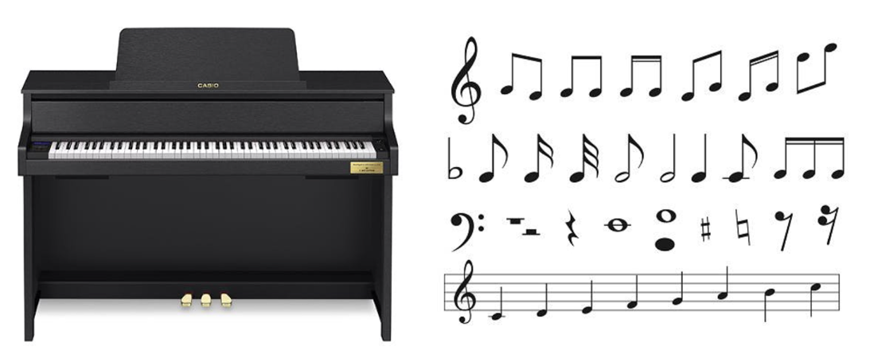

Developing Knowledge:
Knowledge |  | Working Towards | Within | Expected | Above
 | - Understanding of new rhythmic values, such as quaver rests and dotted minims.  - Familiarity with reading and performing music from both the treble and bass clefs.  - Enhanced understanding of major and minor chords, chord progressions, and arpeggios.
Developing skills:
Skills |  | Working Towards | Within | Expected | Above
  Musicianship and performance | - Performing music using both hands, reading from treble and bass clefs simultaneously.  - Mastery of three-finger chords and the application of arpeggios in musical pieces.  - Improved coordination and timing when playing pieces with more complex rhythms.
  Composition | - Introduction to creating musical phrases that incorporate chord progressions.  - Exploration of arpeggios and their use in developing melodic lines.
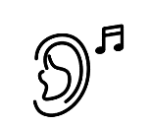  Listening | - Training in aural recognition of major and minor chords and chord progressions.  - Development of the ability to identify rhythmic patterns such as quaver rests and minims.  - Improved listening skills through peer performances and group evaluations.
Evaluate |  | Working Towards | Within | Expected | Above
 | - Engaging in self and peer evaluation focusing on dynamics, rhythm, technique and melody. class performances and evaluating peer performances.  - Providing feedback on dynamics, technique, rhythmic accuracy, and melodic accuracy.
Highlights: ___________________________________________________________________________________

_____________________________________________________________________________________________

