

Level 1

Music- Ukulele
Outcome: To further enhance children’s ability to read and perform music using new rhythmic values three-finger chords, arpeggios and chord progressions.

Prior skills:
Prior skills from Reception:
- To confidently recognise some tuned and un-tuned instruments
- To develop a basic understanding of tuned instruments
- To identify preferences in music

Vocabulary:
- ukulele
- rhythm
- strumming
- tablature
- open strings
- fret notes
- chords
- chord progression
- riffs
- accompanying

Ideas and inspiration:

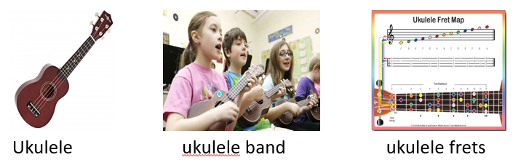

Developing Knowledge:
Knowledge |  | Working Towards | Within | Expected | Above
 | - Understanding the anatomy of the ukulele, including proper holding and strumming techniques.  - Familiarity with finger numbers and how to read tablature.  - Knowledge of open strings and their corresponding notes on the ukulele.
Developing skills:
Skills |  | Working Towards | Within | Expected | Above
  Musicianship and performance | - Developing fine motor skills for playing the ukulele.  - Building the ability to fret notes with the left hand and play chords.  - Practicing changing between chords and accompanying other instruments in a pop song.  - Playing riffs and chords simultaneously within a song.
  Composition | - Applying knowledge of chords and fretted notes to create new chord progressions.  - Incorporating different strumming patterns and rhythmic values in playing.
  Listening | - Analysing existing music from various genres to identify melodic hooks, instrumentation, and emotional content.  - Developing an ear for different chord progressions and their impact on the overall sound.
Evaluate |  | Working Towards | Within | Expected | Above
 | - Participating in peer evaluations and discussions, providing feedback on dynamics, technique, and overall performance.
Highlights: ___________________________________________________________________________________

_____________________________________________________________________________________________

