

Level 1- KS2

Music- Percussion
Outcome: To build foundational rhythm skills and develop ensemble playing, listening and music expression. As well as exploring the cultural roots and social functions of each style of percussion, building a deeper appreciation of global music traditions.

Prior skills:
Prior skills from Reception:
- To confidently recognise some tuned and un-tuned instruments
- To develop a basic understanding of untuned instruments
- To identify preferences in music

Vocabulary:
- Samba bands
- African drum circles
- crotchet
- quavers
- semiquavers
- rests
- rhythm
- body percussion
- Djembe
- ensemble

Ideas and inspiration:
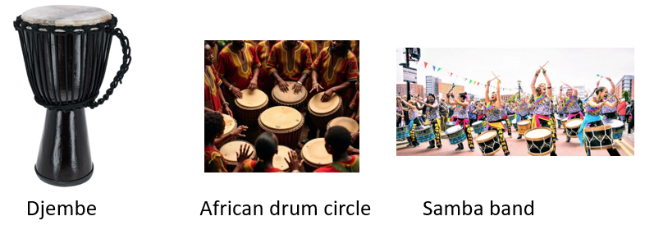

Developing Knowledge:
Knowledge |  | Working Towards | Within | Expected | Above
 | - Understand the cultural origins and purposes of Samba, African, and Dhol drumming  - Learn about the construction and traditional roles of percussion instruments from Brazil, West Africa, and India  - Recognise the role of rhythm in social, ceremonial, and celebratory contexts  - Explore the use of Portuguese, Swahili, and Punjabi terms in musical communication
Developing skills:
Skills |  | Working Towards | Within | Expected | Above
  Musicianship and performance | - Play rhythms accurately on Samba, Djembe, and Dhol drums using correct hand/stick techniques  - Perform in percussion ensembles, maintaining pulse and following group dynamics  - Lead and follow in call and response structures and during conducted performances  - Master structured grooves including intros, breaks, and main rhythm sections
  Composition | - Create and perform original rhythmic phrases using taught structures  - Arrange rhythm sections using intro, main groove, and break formats  - Experiment with layering rhythms in call and response settings  - Use spoken language elements (e.g. rhythm words or cultural phrases) to guide rhythm composition
  Listening | - Listen and respond to cues in ensemble settings  - Recognise rhythmic patterns, tempo changes, and group coordination  - Distinguish between different world drumming styles through active listening  - Internalise complex rhythms through repetition and peer performance
Evaluate |  | Working Towards | Within | Expected | Above
 | - Reflect on individual and group rhythmic performances giving feedback on timing, technique and teamwork and assessing ensemble co-ordination and rhythmic accuracy. Discuss how cultural understanding influences performance.
Highlights: ___________________________________________________________________________________
____________________________________________________________________

