

Level 1

Music- Percussion
Outcome: To build foundational rhythm skills and develop ensemble playing, listening and music expression.

Prior skills:
Prior skills from Reception:
- To confidently recognise some tuned and un-tuned instruments
- To develop a basic understanding of untuned instruments
- To identify preferences in music

Vocabulary:
- Samba bands
- African drum circles
- crotchet
- quavers
- semiquavers
- rests
- rhythm
- body percussion
- Djembe
- ensemble

Ideas and inspiration:
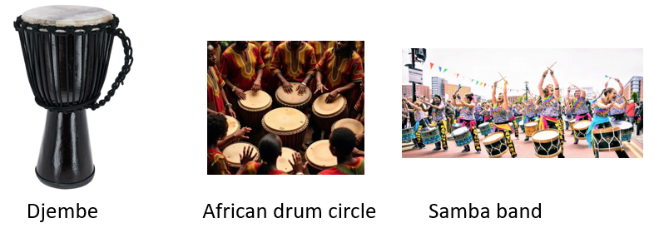

Developing Knowledge:
Knowledge |  | Working Towards | Within | Expected | Above
 | - Understand the cultural origins of Samba (Brazil) and African drumming (West Africa)  - Learn the structure and instruments used in Samba bands and African drum circles  - Recognise basic rhythmic values (crotchets, quavers, semiquavers, rests)  - Explore music-related phrases in Portuguese and Swahili
Developing skills:
Skills |  | Working Towards | Within | Expected | Above
  Musicianship and performance | - Create and perform rhythms using body percussion (claps, stomps, etc.)  - Play Samba and African rhythms using traditional percussion instruments  - Use proper Djembe techniques: tone, bass, and slap  - Perform in ensembles, following a conductor and maintaining group timing
  Composition | - Compose simple rhythmic phrases using taught time values  - Create group rhythm patterns using body or instrumental percussion  - Experiment with combining different percussion sounds  - Use rhythm words to structure and memorise patterns
  Listening | - Compose simple rhythmic phrases using taught time values  - Create group rhythm patterns using body or instrumental percussion  - Experiment with combining different percussion sounds  - Use rhythm words to structure and memorise patterns
Evaluate |  | Working Towards | Within | Expected | Above
 | - Reflect on individual and group rhythmic performances giving feedback on timing, technique and teamwork and assessing ensemble co-ordination and rhythmic accuracy.
Highlights: ___________________________________________________________________________________

_____________________________________________________________________________________________

