

Level 1

Song writing and Composition
Outcome: To develop composing skills and ability to arrange music for a range of instruments knowing how to make songs interesting and catchy through use of dynamics, texture and timbre.

Prior skills:
Prior skills
- Singing nursery rhymes and familiar songs
- Rhythm and rhyme time

Vocabulary:
- dynamics
- texture
- timbre
- genre
- lyrics
- digital audio workstation
- composition
- contemporary
- triadic chord sequences
- chord chart
- melodic hooks
- emotional impact

Ideas and inspiration:
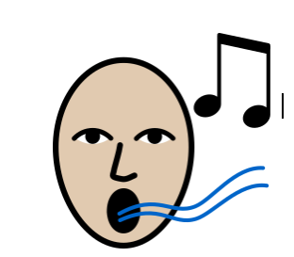

Singing tone/ singing structure Good posture

Developing Knowledge:
Knowledge |  | Working Towards | Within | Expected | Above
 | - Understand the role of a songwriter in different creative settings  - Explore successful songwriting partnerships  - Learn the structure of popular songs and common contemporary genres  - Study effective writing techniques and lyrical/rhyming schemes
 |  | Working Towards | Within | Expected | Above
  Musicianship and performance | - Compose and perform original songs  - Develop melody creation and vocal/ instrumental skills  - Record using a digital audio workstation (DAW)  - Perform compositions in a contemporary style
  Composition | - Analyse and apply genre-specific techniques  - Write lyrics expressing emotions and personal experiences  - Compose melodies to backing tracks  - Create original songs using triadic chord sequences and chord charts
  Listening | - Evaluate songs across genres  - Discuss melodic hooks, instrumentation, emotional impact, and techniques
 |  | Working Towards | Within | Expected | Above
 | - Sharing of original compositions in a peer-setting review and engaging in self-reflection.
Highlights: ___________________________________________________________________________________

____________________________________________________________________________________________

