




DT – Healthy Eating Recipe (Reception)

Outcome: To make beetroot oaty bars.

Vocabulary:
- prepare
- make
- evaluate
- healthy
- varied
- ingredients
- equipment
- recipe
- growing
- choosing
- mixing
- sensory vocabulary
eg. soft sticky sweet
- clean
Ideas and inspiration:

Growing from seed:
beetroot

Final recipe

https://www.bbc.co.uk/newsround/37440527 https://www.sneakyveg.com/beetroot-and-poppy-seed-oaty-bars/

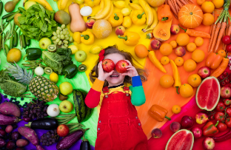
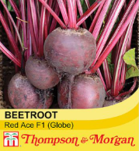
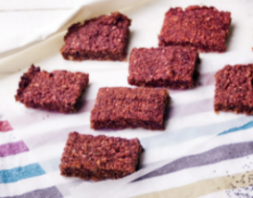

Knowledge: |  | Emerging | Expected
 | - Discuss and explore healthy foods
 | - Understand how to make healthy choices
Design: |  | Emerging | Expected
 | - Grow vegetables from seed
 | - Understand where food comes from
 | - Discuss the appropriate ingredients to make a healthy beetroot oaty bar
Make: |  | Emerging | Expected
   | - Follow a simple recipe
 | - Make a beetroot oaty bar
 | - Be clean and safe when cooking
Evaluate: |  | Emerging | Expected
 | - Try the food
 | - Describe what the food tastes like
 | - Explore and evaluate the food through discussions

