

DT – Healthy Eating Recipe (Year 6)

Outcome: To make courgette fries.

Prior Knowledge and Skills
Cooking:
 | - Understand seasonality in relation to food products
 | - Follow a recipe using the appropriate utensils and cooking techniques
 | - Make a healthy pizza
Ideas and inspiration: https://www.womenshealthmag.com/uk/food/a707781/joe-wicks-recipes/

Growing from seed: beetroot,
courgettes and lettuce Chef Joe Wicks

Final recipe

Vocabulary:
- prepare
- make
- evaluate
- healthy diet
- varied diet
- ingredients
- recipe
- utensils
- nutrition
- fats
- carbohydrates
- proteins
- vitamins
- nutrients
- fibre
- dairy

- gluten
- allergy
- intolerance
- seasonality
- source
- combine
- knead
- whisk
- beat
- crumble
- fold
- hygiene

Developing Knowledge and Skills
Knowledge: |  | Working Towards | Within | Securely Within | Above
 | - Discuss and explore the chef Joe Wicks
 | - Understand how Joe Wicks helped develop and shape cooking and healthy eating
Design: |  | Working Towards | Within | Securely Within | Above
 | - Grow vegetables from seed
 | - Understand the importance and nutritional value of different food groups
 | - Understand the impact different foods can have on the human body
 | - Select and consider the appropriate ingredients to make healthy courgette fries
Make: |  | Working Towards | Within | Securely Within | Above
 | - Follow a recipe using the appropriate utensils and cooking techniques
 | - Make courgette fries
 | - Be hygienic and safe when cooking
Evaluate: |  | Working Towards | Within | Securely Within | Above
 | - Try the food
 | - Evaluate the positives of the cooking and tasting process
 | - Evaluate the challenges of the cooking process
 | - Consider the views of others to make improvements
 | - Make suggestions for future improvements
Before cooking, I must___________________________________________________________________________________________________________
_____________________________________________________________________________________________________________________________________
I would like to use my cooking skills to make ___________________________________________________________________________________
Highlights__________________________________________________________________________________________________________________________
_____________________________________________________________________________________________________________________________________

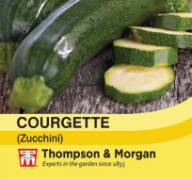
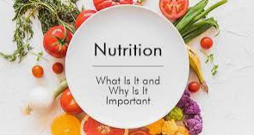
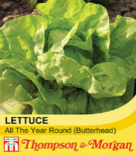
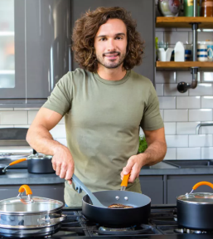
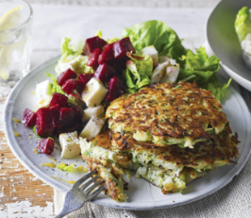

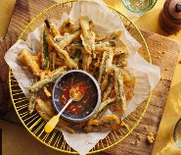

Courgette fries recipe - BBC Food

