Prior Knowledge and Skills
Cooking:
 | - Begin to understand the positive and negative impact of different food groups
 | - Follow a recipe using the appropriate utensils and cooking techniques
 | - Make veggie nachos


DT – Healthy Eating Recipe (Year 5)

Outcome: To make a healthy pizza.

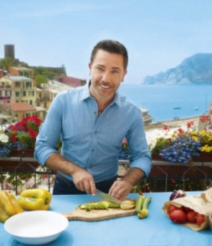
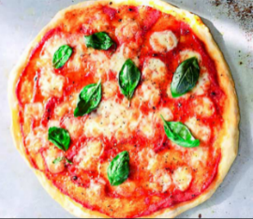
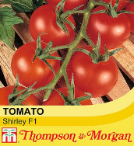
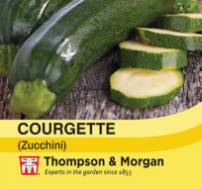
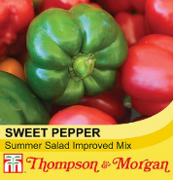
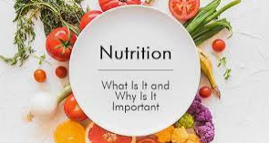
Vocabulary:
- prepare
- make
- evaluate
- healthy diet
- varied diet
- ingredients
- recipe
- utensils
- yeast
- dough
- spices
- seasonality
- sourced
- climate

Ideas and inspiration:
Growing from seed: tomatoes,
courgettes and peppers Chef Gino D’Acampo

Final recipe

https://ginodacampo.com/biography/

https://www.bbcgoodfood.com/recipes/pizza-margherita-4-easy-steps

- nutrition
- grown
- reared

free-range

processed

air-miles

battery

combine

knead

whisk

beat

hygiene
Developing Knowledge and Skills
Knowledge: |  | Working Towards | Within | Securely Within | Above
 | - Discuss and explore the chef Gino D’Acampo
 | - Understand how Gino D’Acampo helped develop and shape cooking and healthy eating
Design: |  | Working Towards | Within | Securely Within | Above
 | - Grow fruit and vegetables from seed
 | - Know where food is sourced and the impact it has on the environment
 | - Understand seasonality in relation to food products
 | - Select and consider the appropriate ingredients to make a healthy pizza
Make: |  | Working Towards | Within | Securely Within | Above
 | - Follow a recipe using the appropriate utensils and cooking techniques
 | - Make a healthy pizza
 | - Be hygienic and safe when cooking
Evaluate: |  | Working Towards | Within | Securely Within | Above
 | - Try the food
 | - Evaluate the positives of the cooking and tasting process
 | - Evaluate the challenges of the cooking process
 | - Consider the views of others to make improvements
 | - Make suggestions for future improvements
Before cooking, I need to remember__________________________________________________________________
________________________________________________________________________________________________
Next time, I would like to use my cooking skills to make _________________________________________________
Highlights: ______________________________________________________________________________________
_______________________________________________________________________________________________

