Prior Knowledge and Skills
Cooking:
 | - Understand the basic principles of a healthy and varied diet, including how fruit and vegetables are part of The Eatwell Plate
 | - Follow a recipe using the appropriate utensils
 | - Make muffin frittatas


DT – Healthy Eating Recipe (Year 4)

Outcome: To make veggie nachos.

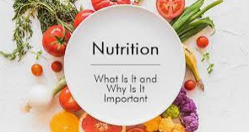
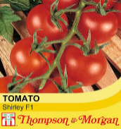
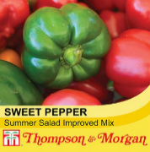
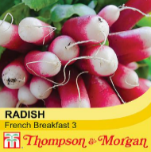
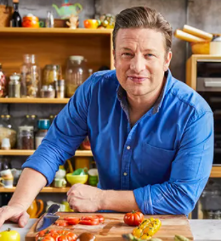
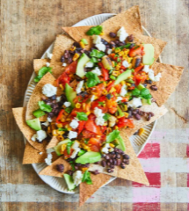

- savoury
- sweet
- greasy
- edible
- nutrition
- fats
- carbohydrates
- proteins
- vitamins
- dairy
- hygiene

Vocabulary:
- prepare
- make
- evaluate
- healthy diet
- varied diet
- ingredients
- recipe
- utensils
- techniques
- texture
- harvesting
- produce
- wholemeal
- fresh
- processed
- raw

Ideas and inspiration:

Growing from seed: tomatoes,
peppers and radishes Chef Jamie Oliver

Final recipe

https://www.britannica.com/biography/Jamie-Oliver

https://www.jamieoliver.com/recipes/vegetable-recipes/buddy-s-veggie-nachos/

Developing Knowledge and Skills
Knowledge: |  | Working Towards | Within | Securely Within | Above
 | - Discuss and explore the chef Jamie Oliver
 | - Understand how Jamie Oliver helped develop and shape cooking and healthy eating
Design: |  | Working Towards | Within | Securely Within | Above
 | - Grow fruit and vegetables from seed
 | - Know where a range of fresh and processed ingredients, appropriate to the recipe, come from
 | - Begin to understand the positive and negative impact of different food groups
 | - Select and consider the appropriate ingredients to make healthy veggie nachos
Make: |  | Working Towards | Within | Securely Within | Above
 | - Follow a recipe using the appropriate utensils and cooking techniques
 | - Make veggie nachos
 | - Be hygienic and safe when cooking
Evaluate: |  | Working Towards | Within | Securely Within | Above
 | - Try the food
 | - Evaluate the positives of the cooking and tasting process
 | - Evaluate the challenges of the cooking process
 | - Make suggestions for future improvements
Before cooking, I need to remember__________________________________________________________________
________________________________________________________________________________________________

Highlights: ______________________________________________________________________________________
_______________________________________________________________________________________________

