Prior Knowledge and Skills
Cooking:
 | - Understand the basic principles of a healthy and varied diet, including how fruit and vegetables are part of The Eatwell Plate
 | - Follow a recipe
 | - Make a veggie slaw


DT – Healthy Eating Recipe (Year 3)

Outcome: To make muffin frittatas.

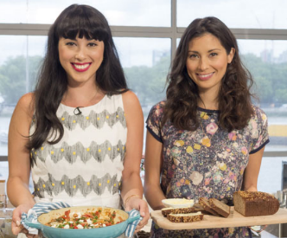
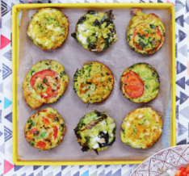
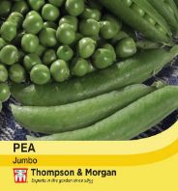
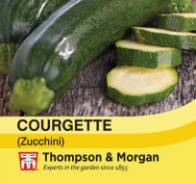
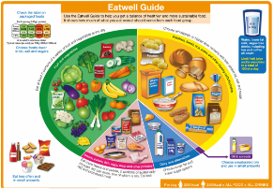
Vocabulary:
- prepare
- make
- evaluate
- healthy diet
- varied diet
- ingredients
- recipe
- utensils
- texture
- harvesting
- produce
- appearance
- smell
- taste
- fresh

- raw
- savoury
- sweet
- fresh
- processed
- hygiene
Ideas and inspiration: The Eatwell Plate

Growing from seed:
peas and courgettes
Chefs Hemsley + Hemsley

Final recipe

https://hemsleyandhemsley.com/about-us/

https://hemsleyandhemsley.com/recipe/muffin-frittatas/

Developing Knowledge and Skills
Knowledge: |  | Working Towards | Within | Securely Within | Above
 | - Discuss and explore the chefs Hemsley + Hemsley
 | - Understand how the Hemsley Sisters helped develop and shape cooking and healthy eating
Design: |  | Working Towards | Within | Securely Within | Above
 | - Grow vegetables from seed
 | - Know where a range of fresh and processed ingredients, appropriate to the recipe, come from
 | - Understand the principles of a healthy and varied diet, including how fruit and vegetables are part of The Eatwell Plate
 | - Select and consider the appropriate ingredients to make healthy muffin frittatas
Make: |  | Working Towards | Within | Securely Within | Above
 | - Follow a recipe using the appropriate utensils
 | - Make muffin frittatas
 | - Be hygienic and safe when cooking
Evaluate: |  | Working Towards | Within | Securely Within | Above
 | - Try the food
 | - Evaluate the positives of the cooking and tasting process
 | - Evaluate the challenges of the cooking process
 | - Make suggestions for future improvements
Before cooking, I need to remember__________________________________________________________________
________________________________________________________________________________________________

Highlights: ______________________________________________________________________________________
_______________________________________________________________________________________________

